Customer: Clarion Malaysia
Meeting Day : 2024.5.2 ~ 2024.5.3
Meeting Method : in A&W office
Meeting Agenda :
- A&W Company profile presentation
- Skillsets and knowledge
- Software development process (i.e: A-SPICE, software project management, Jira/Confluence)
- Software testing and quality assurance
- Data security
- Office tour
- Software schedule for CPAA library release (Dolphin+)
- Past experience on CP/AA/CarLife certification (including ITU-T and Enhanced Siri) and support coverage
- Scope of work for the development quotation (for full CP/AA/CL integration), development schedule
- Manpower involvement in the projects (for full CP/AA/CL integration)
- Future A&W roadmap (if available)

Meeting Purpose : Same as above
Whether the results of the meeting achieved the expected purpose: Yes

Participants:
- Clarion Malaysia:
  - Choy Chee Hon (Ben) - Head of Software Dept
  - Lam Chee Kok - Program Manager
Summary:
- Clarion MY is interested in Multimedia Platform and understands its value.
- Clarion MY mainly use TCC Platform to propose to their OEM customers.
- Both discussed following 5 project as follows:
- Regarding Project #5, bdSound is chosen. However, if A&W provides ECNR materials, they could use A&W ECNR since A&W SW ECNR is unknown so Clarion MY cannot propose it to OEM.

Action Items: highlighted in Blue is for A&W; Red ones for CM
- Project #5: Provide quotation by May 6
- Project #4: Provide a feasible proposal minimizing the current design.

Project Info:
- Legacy audio using SPHE8268KJ + GPM8F3003 (1-Din Audio, replacement due to EOL)
  - BT chip only
  - PX3839 : NRE 120K (PX-3839B-A.pdf)
  - PX4508 : NRE NRE 40K (“PX4208AA.pdf” the file name is not correct, but the contents are correct)
  - Scope of work:
    - MCU with Power manager.
    - BT(basic feature: HFP, A2DP, AVRCP), Radio(Silicon lab), Media Player, USB ,Siri eyes free(to be confirmed later),
    - No iPod, No CD Player, NO Aux (Confirmed)
    - Certification for BT
  - SOP:
      - PX3839: 2026 Jan
      - PX4508: 2027 Jan
  - A&W Development schedule: Milestone shall be provided later.
  - SPHE8268KJ: SunPlus MCU
  - GPM8F3003: Power MCU of Generalplus
  - H/W can be ready in 2~3 month after kick off
  - A&W will get EVB from SunPlus and GeneralPlus
  - A&W Manpower: 4~5 Engineers
  - A&W provide Official Quotation with payment term (Clarion MY’s normal term: 90days)
  - A&W Schedule: A&W initial release in around 3 months after the device ready

- Display audio using SPHE8268KJ + GPM8F3003
  - BT chip only
  - PX4216 (SoC little different as before discussion)
  - NRE USD 30K
  - SI license fee: USD 0.85/pcs
  - BT License fee : USD 0.45/pcs .
  - Spec: (Additional function based on #1, i.e display and UI Flow)
    - Need PBAP
    - AVRCP with CorverART
    - UI: color theme for UI (buttons, frame …)
    - Rearview Camera: Clarion My will provide an image(overplay)
    - Etc: may need mirroring i.e Miracast
  - Scope work: same as #1
  - SOP: around 2027
  - USB analyzer for connection speed
  - A&W Schedule: A&W initial release in around 2 months after Device #1 release
  - UI Skin and Flow: Clarion MY will provide soon or later

- Display audio + Cluster using SPHE8362UC + SPHE8268K-C + GPM8F3003 (for Proton)
  - BT/Wi-Fi Combo
  - 3 different models
    - Standard: 77,000 for 2025~2029
    - Premium: 108,000 for 2025~2029
    - Premium S: only need CP/AA; 124,000 for 2025~2029
  - SPHE8368UC: need to confirm the part number (Linux)
  - SPHE8268K-C: for Cluster(To be confirmed)
    - ROHM BU92RTF82 need to be added for safety features
    - Check if ASIL-B is supported (RTOS)
    - standard feature.
    - Watchdog need to be discussed
  - GPM8F3003: CANBUS
  - Spec:
    - CP/AA Both Wired & Wireless Mode (To be confirmed)
      - Cluster View need to be confirmed
    - BT: same as #2
      - Cluster need to be supported (Phone call, media, Navigation from IVI part)
    - iPod
    - Rearview Camera
  - SOP: TBD
  - A&W Quotation: A&W provide a price later

- CPAA solution for Linux Hypervisor VM on R Car M3(current device)
  - Only USB CP/AA
  - Even if the Module supports WPA3 , the module’s Wi-Fi driver should support Android 8; otherwise, supplicant a needs to be implemented to support WPA3
  - A&W propose a possible way minimizing change of current design.
  - Two OSes communicate via Virtual Ethernet.

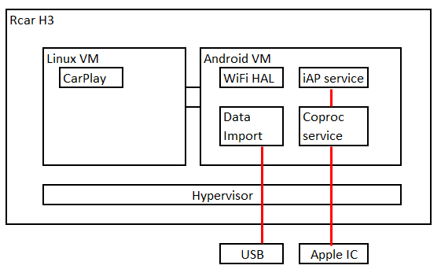

- Dolphin 5 (New project of #4) for UK
  - Spec similar to current Dolphin+
  - SDK : Price will be Provided by May 6
    - Flab + A&W
  - SI+SDK : Price will be Provided by May 6
    - A&W does SI + Clarion MY
    - FM/AM radio with UI done by Clarion MY
    - UI part will be handled by Clarion MY (Populus engine)
  - Another 3rd party ECNR will be used but A&W still can offer ECNR.
  - Spec: CP/AA/Carlife/BT/ECNR
  - Workshop for co-work regarding integration between UI and A&W MM SDK
  - Provide Sensory PPT to CM
  - A&W BT Stack API will be used.
  - SOP: 2028 Jan
  - Development due in 2026 Jan(CP/AA/Carlife cert. start )
  - Quantity: To be confirmed later
  - A&W Schedule: A&W will provide High level(rough) soon or later
  - Work scope
    - IVI + Cluster(information from IVI, I,e media, phone, turn-by-turn navigation)

