Customer: P3
Meeting Day : 2025.8.13
Meeting Method : Online
Meeting Agenda : Collaboration
Meeting Purpose : same as above
Whether the results of the meeting achieved the expected purpose: N/A

Participants:
- Telechips Singapore:
  - Marius Mailat: CTO/Managing Director
  - David Bartuseck: Team Leader of Automotive, IVI

Summary:
- Major product is SPARQ OS based on AAOS. (Please refer to attached PIC#1 )
- 2W
  - One of their customers is considering QCM/QWM 2290
  - They think our 2W solutions is very good and hope to bring it into their solution.
  - They have a SPARQ Motorcycle demo for 7-inch screen, but they don't have good BT implementation. Thus, they’d like co-work with our BT first.
  - They’re planning to join CES 2026.
- 4W
  - Their customer requirement is to connect with 4 different phones and might want to support 4 voice calls at the same time. However, their use case and requirement are not clear. They'll clarify with their customers. They said QCA 8295 already supported on QNX but not on AAOS.
  - TCS, TATA Consultancy Service used to supply IVI solutions to Nissan but now it’s P3. (Please refer to attached PIC#2)
  - Now P3 focuses on Japanese market as Mitsubishi, Mazda, Toyota, Subaru etc are all use AAOS. Their strong suit is AAOS system with GAS.
- 3PL
  - They’re the only company of which 3PL is located in EU, Tokyo Japan, Seoul Korea, and India.
Action Item:
- A&W
  - Clarify the requirement about the 4-phone connection.
  - Arrange a meeting at IAA to discuss further:
    - Opportunities for our CP/AA & ECNR.
    - Detailed features of 2W Demo (QCM 2290 may not be able to support current A2DP SRC&SNK / 2xSCO)

PIC#1
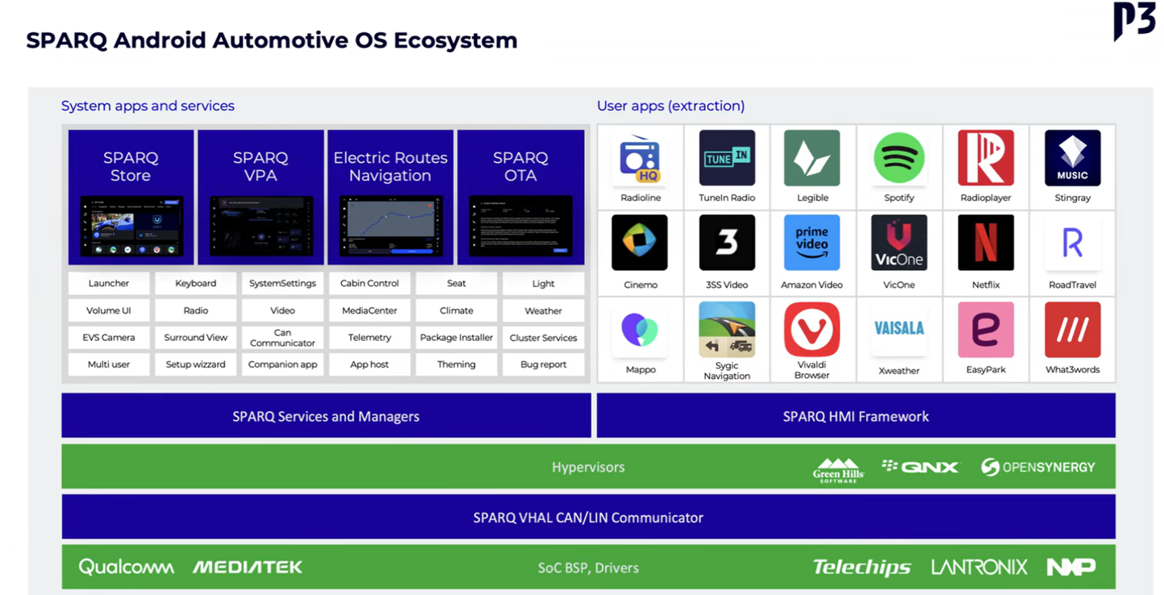

PIC#2
