TVS Meeting Minutes

Customer:TVS
Meeting Day :2025-12-18
Meeting Method :F2F
Participants:
- Customer Sudhakar Selvakanan ( SW Experience over 18 years)
Mahesh ( SW Experience over 10 years)
- A&W: Mingfa, KuoChen

Summary:
- PC Linux + Aw611 : Audio Routing POC: Success
- Current BLE Project ( i.MX8 + AW611 )
Milestone MP : Around 2026/March // Platform II MP : Around 2026/ May
TVS will use OTA to update SW that support Classic + BLE
BT Certification would include Classic+ BLE profile.
A&W has to get Classic + BLE profile QDID before 2026/01/E.
- Classic + BLE Project // Sames as BLE project platform
Spec : Connect one Mobile , one Helmet, three GoPros , two TPMS
( GoPros: 安全帽 + 胸前 + 2W 車頭 共 3 台 )
Paired Device management: Mobile , Helmet , BLE ( GoPro ) : Separate
Auto Connect / Reconnect mechanical: TVS will provide the rule to A&W
// A&W BT Stack or APP Template has to support it and provide config method
- Show 2W Demo Video (Audio routing , Intercom , Audio switch ) : Done
Explain: Command line / app template solution and “ BT Stack vs BT Complete Type “
MUC Solution 不在這邊負責. Mahesh 也不清楚
Sudhakar :最急是要看的POC ,是在目前的i.MX Platform整合CPAA solution且能Audio Routing
也會想要Support LE Audio , 若我們 POC Ready , 可以 show 給他們看
- Wind Noise Reduction : TVS said : 目前都是BT headset / helmet 自帶, 沒特別注意此需求

Action Item:
TVS:
Pass IOP test file around 2026/01/B
Auto Connect / Reconnect mechanical : TVS will provide the rule to A&W
A&W:
- A&W提供 PC 版 BT Stack ( Lib ) + App Template ( code ) , TVS 也希望能先用 PC 開發
- POC : i.MX Platform 整合 CPAA solution 且能 Audio Routing
// 可能同Jack提的“Negotiation with another CP/AA supplier has already commenced, however, we could try offering more competitive price to secure this opportunity.”
- POC: Classic + BLE + LE Audio
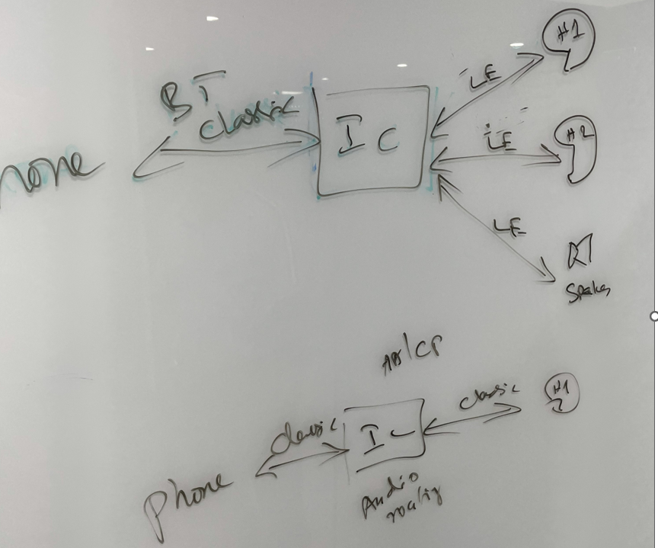

ORG: Handle Linux // Android Platform 有另外部門 ( ? )
Sudhakar ( Manager: Handle BT Connectivity )
SW Experience over 18 years

Sharon (Mr.):
iPhone ( AMS , ANCS )
Pooja (Miss):
GoPro ,
A2DP
BLE
Ramya (Miss):
HFP
TPMS
BLE
Audio Routing
Experience(3) : Media : 1.5
BT : 1.5
4444
Mahesh ( Manager: Handle BT Connectivity )
SW Experience over 10 years

