Customer: Silex
Meeting Day : 2023-02-07
Meeting Method : Web
Meeting Agenda : AlphaTheta project and scanner project
Meeting Purpose : Explain status of AlphaTheta project and get info about the scanner project

Participants:
- Customer : Kuwana san, Sawada san
- A&W : Araki
Summary:

[AlphaTheta Project]
= AlphaTheta schedule is delayed. Original is Feb.6.

Original feature includes BT A2DP SRC, A2DP SNK, SBC, AAC. Audio output is okay. Robust playback. Pairing. Query. Connecting.
A&W doesn't know schedule details. A&W asks to share the entire schedule.

= Current status

We apologize for the delay in responding. We will try to respond within the day. Please wait for our update.

Additional explanation;

#50. If A&W insists that the current procedure is best, please let them know the details. Because Silex needs to convince AlphaTheta.
#37. Is A&W testing A2DP SINK?
#55. Does A&W test A2DP SRC? A&W supports WAV file playback. Silex prepares fs=44.1kHz WAV. Silex plays then audio output on BT speaker. The playback speed is 5 times in some speakers. Silex provides snoop log.
#52. Can A&W provide how to test some APIs?

Also, A&W needs to answer all remaining questions which due date is Feb.6 and 7.

[Scanner project]
= Scanner or MFP -> A small scanner like the Flat Scanner
= Use case detail -> We are not able to share detailed customer use cases at this time.
A&W is trying to estimate the schedule. However, it is not actual. We will update after RFQ.
= Contract
A&W makes the 1st draft revision contract for the scanner project.
= Prepayment. A&W insists on the same.
= Silex will hold tel-conf with scanner customer until Feb 15th. They will update information to A&W.

Action Item :
- A&W : A&W needs to answer questions (due date is Feb.6 and 7) by Feb.7.
- Silex: Silex will update information about the scanner project until Feb.15.

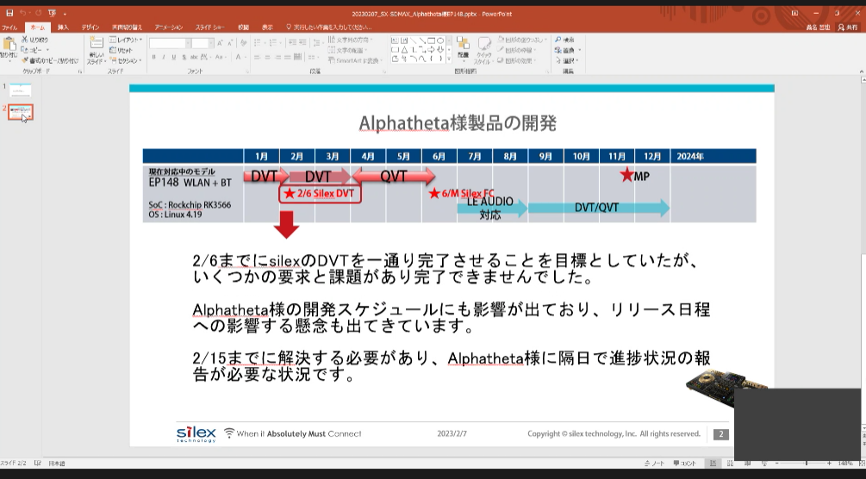
Silex cannot keep the schedule. The original schedule is Feb.6.
It make bad effect to AlphaTheta's schedule.
Silex needs to solve the delay of schedule until Feb.15. They need to report bi-days to AlphaTheta.

