Customer: JKC
Meeting Day : 2023-04-21
Meeting Method : F2F
Meeting Agenda : A&W promotion
Meeting Purpose : A&W promotion

Participants:
- Customer : Yasuichi Matsumoto san (Group leader), Suehira san (Group leader)
- A&W : Mingfa san, Suzuki san, Araki
Summary:

[STA2]
A&W explain that we pass email to ST person. However, we are not sure he is right person of JKC issue or not. A&W answer will be delay.
A&W requests to JKC as;
- Please let A&W knows what ST needs to contact.
- Please JKC try to ask STForge for ST issue.
Unfortunately, JKTS doesn’t disclose info of STForge to JKC.
JKC takes over JKTS portion (BE). And, Suehira san faces ST issue. So, he would like to ask ST via A&W. JKC tries to ask ST Singapore to recover STForge. (However, 1 or 2 % to be success). Suzuki san will ask STJ also.
Anyway, JKC understands current A&W status.
STA2 DA switch to Telechips one.
A&W Q: Do you have a plan to replace 1DIN? No. 1DIN will disappear.

[Sunplus]
A&W Q: Do you have any complain Sunplus software? Matura is good now.
A&W Q: Do you have any new plan Sunplus SoC? Yes.
A&W Q: Where target of Sunplus platform? NorthAmerica, Europe, Japan.
A&W Q: Will does JKC keep to use Shinwa module? Yes.
A&W Q: Will does JKC support LE audio. Now JKC has no plan however they feel to support.
A&W Q: Which is Sunplus for aftermarket or D-op? Aftermarket now.
A&W Q: Will does JKC support Alexa in Sunplus? Alexa is difficult. So, current JKC give up integration.
A&W Q: Will does JKC support Miracast? JKC would like to support it in future model.
A&W Q: What does Sunplus use ECNR? Highend use JKC. Sunplus model use ECNR in SDK.

[Organization]

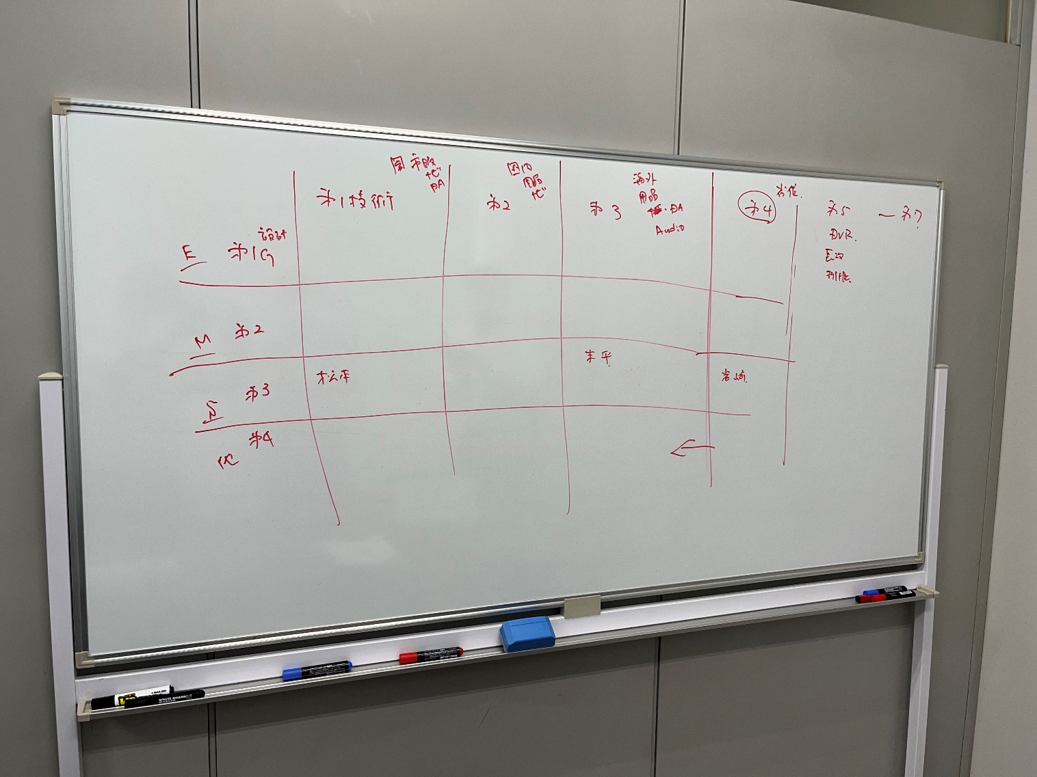
Yasuichi Matsumoto san (Group leader) is section 1 and group 3.
Suehira san (Group leader) is section 3 and group 3.
Iwasa san (Manager) is section 4 and group 3.
Nagasaka san and Yanagibori san is section 4.

Action Item :
- A&W : Suzuki san will contact STJ to check ST Singapore status.
- A&W : A&W wait for ST reply and forward it to JKC.

