Customer: FF
Meeting Day : 2023-06-01
Meeting Method : F2F
Meeting Agenda : Update current status of LE Audio
Meeting Purpose : Update current status of LE Audio

Participants:
- Customer : Imamura san (Engineer)
- A&W : Mingfa san, Kevin san, Suzuki san, Araki
Summary:

[Discussion]
We got the block diagram. FF has a possibility for using BT Classic/BLE/LE audio.
LE audio: ROM 120k, RAM 100k. We need to discuss defining total ROM, and RAM.
FF needs to confirm BT module can have LC3 codec with Infineon. Because their SoC has only 1 I2S I/F. And, FF will consider that the Audio codec chip can decode/encode LC3.
The driver needs to finish within Y23. FF will start certification Y24.
1st: We can define the spec.
2nd: If FF can provide HW, A&W can start development as soon as possible.
We already answered the development schedule is around 8 weeks. Anyway, A&W can provide an effective version to meet milestones.

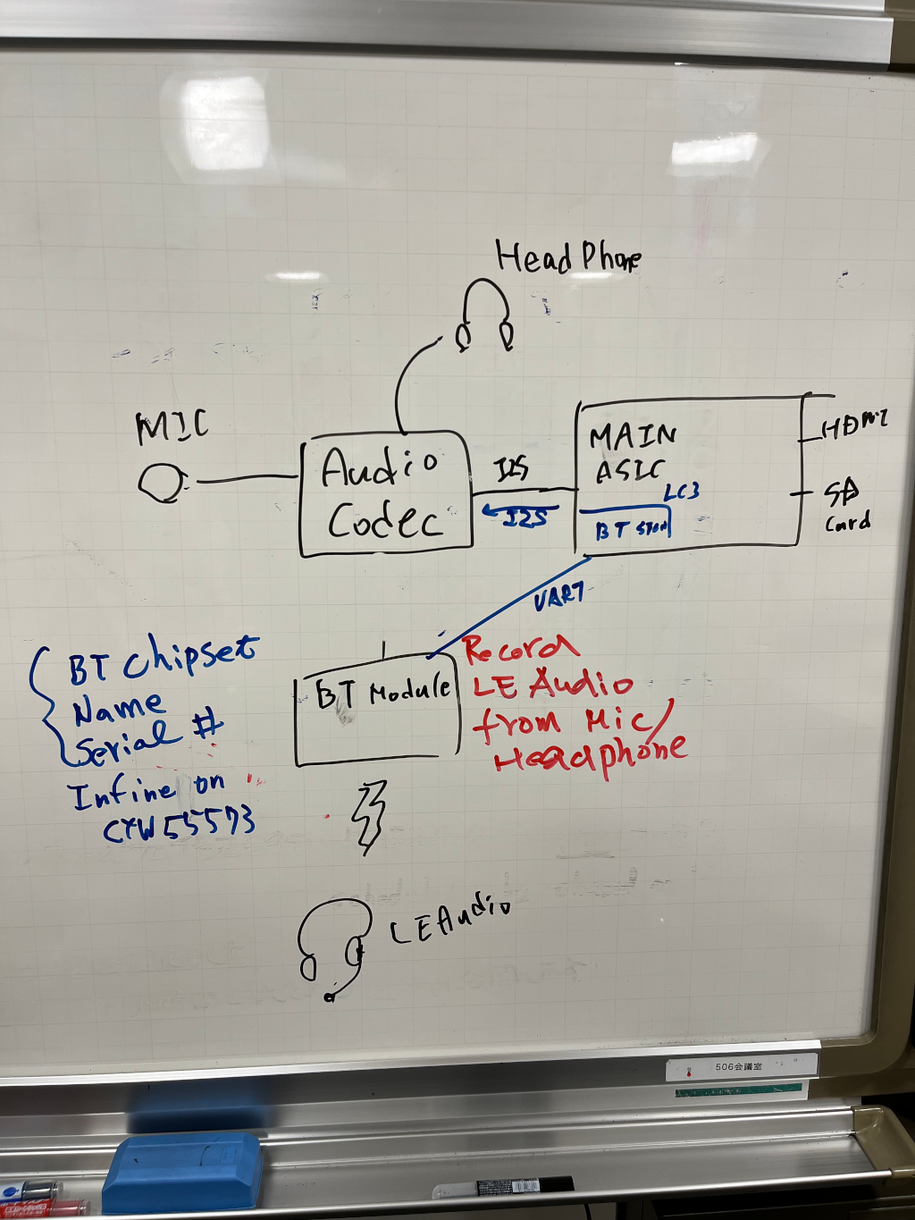

Action Item :
- FF: FF will action to A&W to define spec by end of Jun.

