Customer: Renesas Electronics Corporation
Meeting Day : 2025.03.18
Meeting Method : Web conferencing
Meeting Agenda : Pioneer requested support for the POC development of an external amplifier for Apple that supports high-resolution audio, and I participated in a web conference to confirm the details.
Meeting Purpose : Same as above
Whether the results of the meeting achieved the expected purpose: Yes

Participants:
- Pioneer Corporation:
  - Masaru Sasaki,
Summary :
- Pioneer is waiting until the 22nd for A&W's response regarding whether they can provide support for the B.T. portion of the external high-resolution AMP and what measures they will take.
(First, I want to know if the A&W in the red frame can be developed.)
- Mr. Sasaki said that if it is possible, he would like to know the development period and development costs.
- If A&W is able to provide support, they would like to discuss the system configuration (the H/W to be used, division of development responsibilities, etc.) as soon as possible.
Detail :
- Background :
  - Pioneer is currently presenting to Apple a product plan for the industry's first in-car external AMP (with added high-resolution audio functionality).
  - Without waiting for an official response from Apple, Pioneer plans to focus on developing the POC and would like to ask A&W for cooperation on the B.T. portion.

- Below is Pioneer's explanation of the POC Concept :
  - Pioneer is proposing to add Hi-Res Audio functionality to its external AMPs, which have a high market share, and to sell them as an official Apple product.
  - Concept of this product is that this AMP will add Hi-Res functionality (R9) to existing Display Audio and Navi systems that do not support Hi-Res (R8 specifications).
  - Apple has shown interest and is currently in internal discussions, but it will take some time to make a decision.
  - Pioneer would like to proactively develop a POC and make a presentation to Apple.
  - For the above reasons, Pioneer would like to develop a POC as soon as possible by reusing an existing product.

- Explanation of Pioneer's specifications and discussion on A&W support :
  - Below is the block diagram explained by Pioneer.
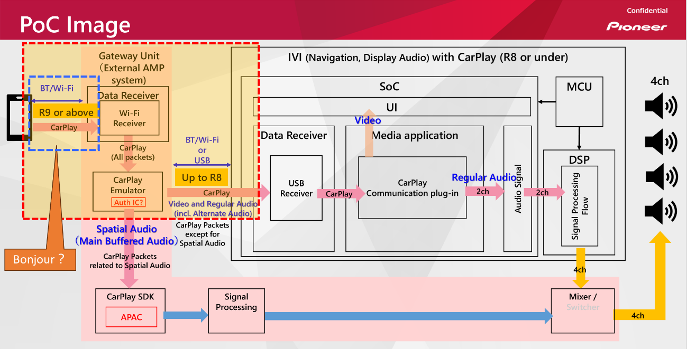
  - External DSP AMP that Pioneer is considering developing is the part hatched in red.
  - Areas where Pioneer is asking A&W for support are indicated by the red dotted lines.
  - If the CarPlay R8 function is received from the smartphone, the POC will pass it through to the IVI.
  - If the CarPlay R9 function (Hi-Res Audio) is received from the smartphone, the POC will process it in Hi-Res using the DSP inside the POC and output it to the speaker.
  - Pioneer is looking for a proposal from A&W that can be implemented as quickly as possible to realize the above POC.
  - HQ understood that Pioneer would develop the CarPlay SDK and Hi-Res processing, and that A&W's main processing would be to separate B.T's R9 vs R8.
  - HQ promised to discuss within RD and respond with A&W's support and I/F proposal.
  - I asked about the system's H/W configuration.
  - Pioneer is currently using Telechips' Dolphin Plus for its existing IVI.
  - Can the A&W support part be implemented as one task in the above IVI?
  - Or, if A&W has the optimal H/W in the SDK, they would like to use it.
  - Pioneer requested to consult with A&W about what kind of H/W configuration they would need, since their existing external DSP AMP does not have an I/F such as USB.

Action Item:
- A&W
  - HQ will review the A&W-compatible portion of the POC above and respond with a response as to whether it can be supported (by Tuesday) and, if possible, discuss further detailed configuration.
- Pioneer
o Pioneer continues to consider the POC's hardware configuration and awaits A&W's response.

