Customer: KagaFei
Meeting Day : 2025.7.15
Meeting Method : Visit & Web(HQ) Conference
Meeting Agenda : Two-wheeled Demo Development Request Meeting for CES2026
Meeting Purpose : same as above
Whether the results of the meeting achieved the expected purpose: N/A

Participants:
- KAGA FEI:
  - Satoshi Tobe – Assistant manager/Technical Marketing Dept. (H/W Engineer)
  - Takuya Terada – Project Manager/Technical Marketing Dept. (Engineer)
  - Makoto Nishikata – Manager/Technical Marketing Dept. (Tobe san’s boss)
  - Noboru Takahashi – UI/UX Business Dept. (Engineer)
  - Hajime Adachi
Summary:
- Kaga FEI explained their request for an update to the two-wheeled DEMO using GENIO510SDK, targeted for 2026 CES (targeting completion by mid-November). (6 updates in total)
- Kaga FEI made the following three requests to A&W.
- A&W's actions are as follows
1. Key FOB support
A&W: Check with RD and propose key FOB support
2. Reduce CP startup time (reduced from 30 seconds to 6-8 seconds)
A&W: Obtain logs (at 30 seconds) and consider reducing time
3. AA- support
- GENIO510SDK H/W has not changed from the H/W used in the previous Demo.
- Kaga FEI's update request this time was a careful selection of essential functions based on the results of interviews with two-wheeled manufacturers.
- Kaga FEI has adopted "IntelliGo" voice recognition, and NR has already been supported by the SDK.
- Kaga FEI has requested that A&W review the above requirements and then hold another meeting within this month to discuss whether or not development is possible.

Detailed discussion:
- Mr. Tobe explained the background to the request for additional two-wheeled DEMO specifications in the document below.
- Mr. Tobe introduced the STEP 1 Demo(Completed at the end of December) to the customer, compiled the feedback he received into the document below, and created the SETP2 specifications.
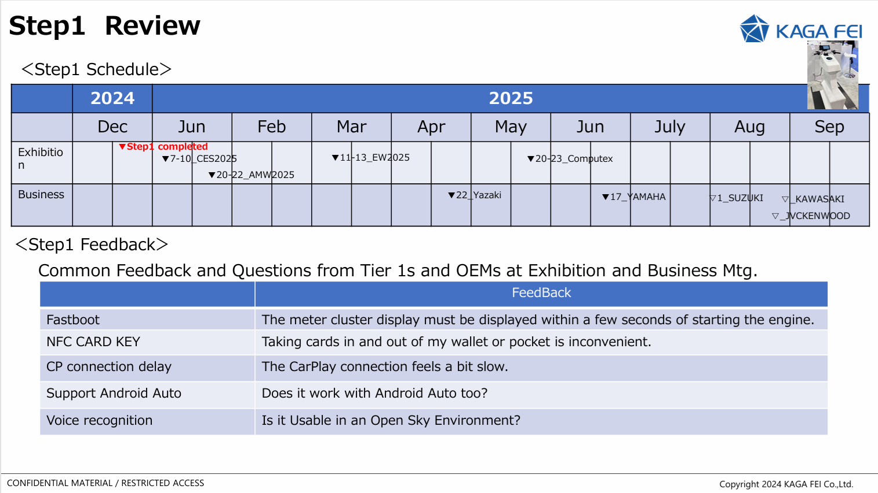
- Mr. Tobe explained the details of the specifications he would like to add in STEP 2 in the document below.
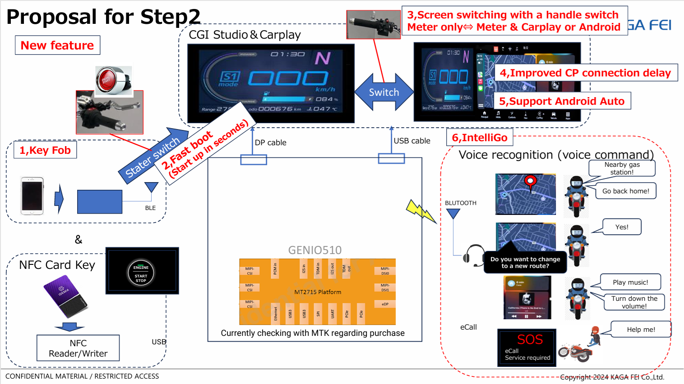
- Below is the configuration diagram for STEP 2.
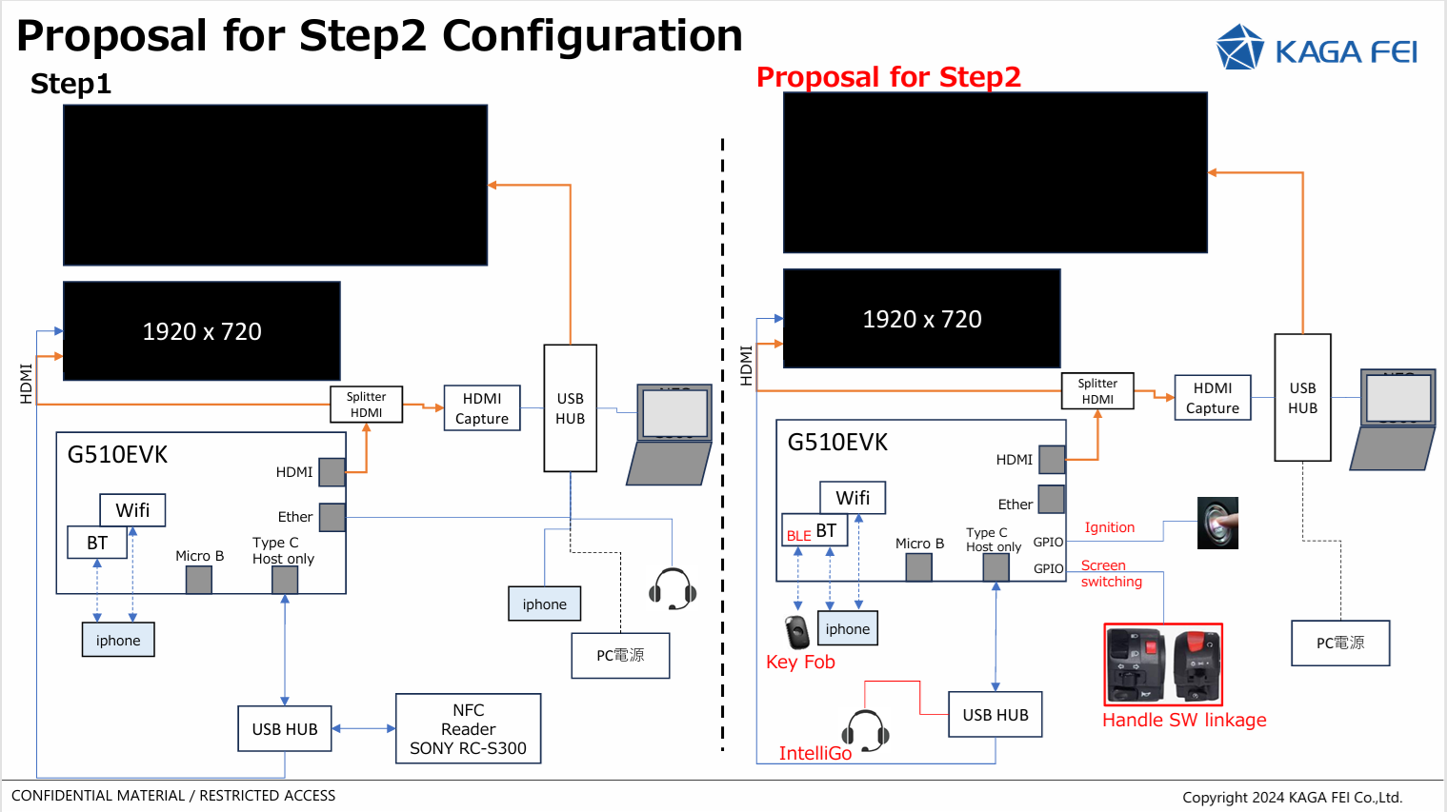
- Tobe explained that the items he would like A&W to develop for this additional specification are 1, 4, and 5.
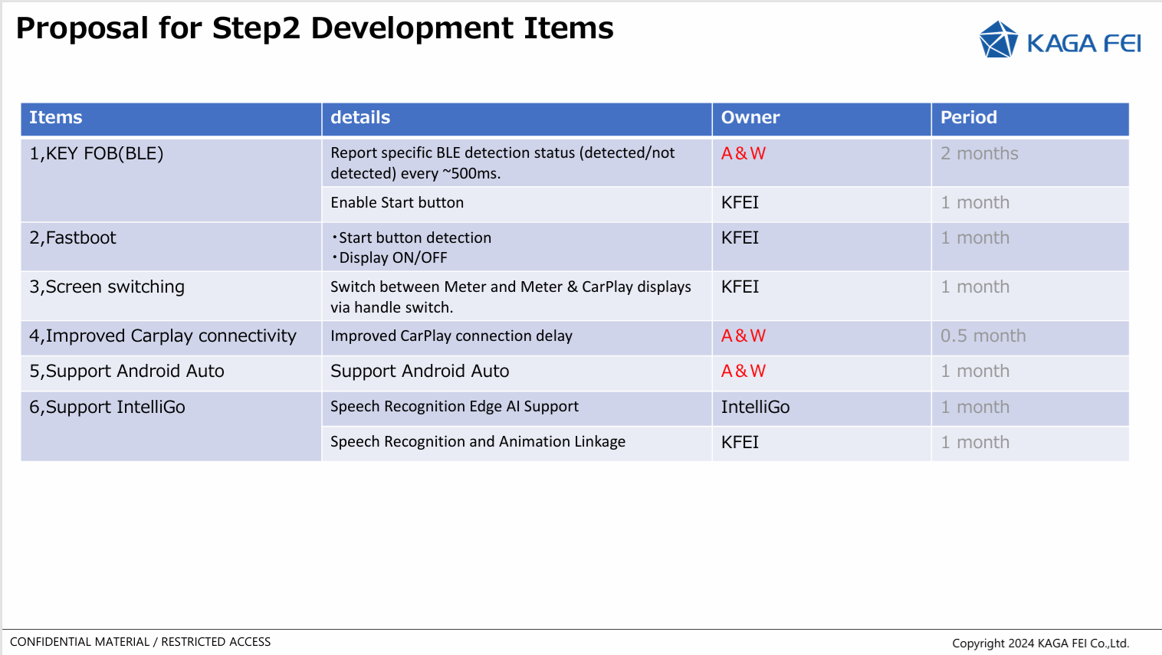
- Mr. Tobe explained the proposed specifications for the KEY FOB in the following document.
- However, he requested that the KEY FOB specifications be proposed based on A&W's most recommended specifications.
- Perry replied that there would be no problem in supporting 4 and 5 on the GENIO510 Platform.
- Perry promised to present a proposal for the KEY FOB specifications in item 1 after consulting with the RD department.
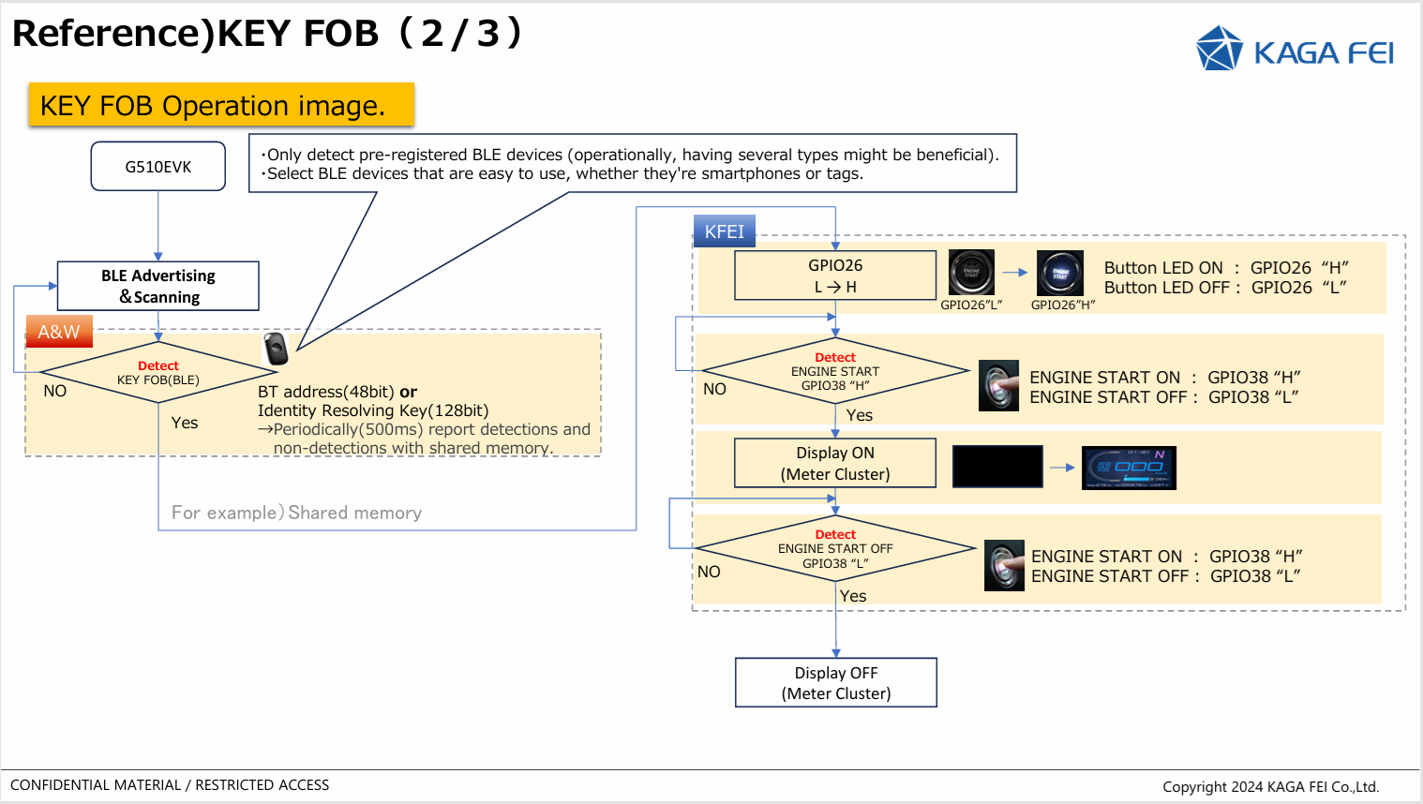
- I asked whether it was necessary for the KEY FOB to support BLE channel sounding.
- Mr. Tobe replied that since this was a DEMO, the channel sounding function was not a must.
- Mr. Tobe said he would leave it up to A&W to choose whether to use a BT tag or a smartphone for the KEY FOB.
- According to Mr. Tobe, since the GENIO EVK supports BLE advertising and scanning, A&W asked them to develop the detection process after BT connection.
- Perry proposed that A&W also control BLE advertising and scanning processing, and Mr. Taba agreed.
- In the document below (startup log), Mr. Tabe requested item 4, speeding up the CarPlay startup time.
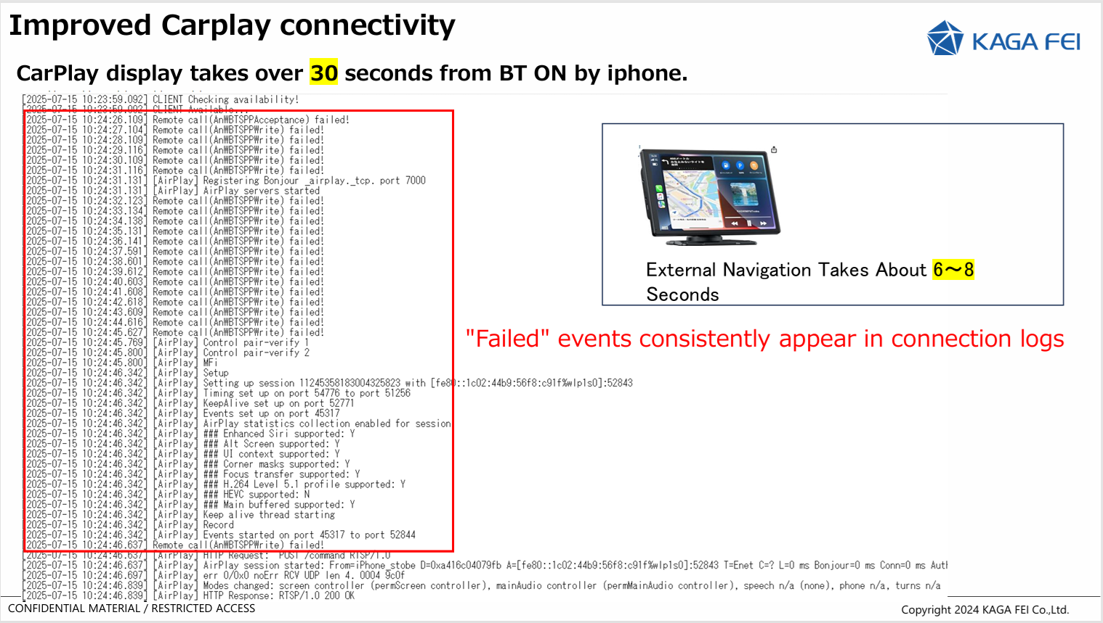
- Currently, STEP1 Demo takes 30 seconds, and he would like this shortened to 6-8 seconds for STEP2.
- Perry promised to analyze this log with RD and look into ways to speed up startup.
- Perry asked if this log file was only for the first boot or if BT was already connected.
- Mr.Tabe answered that BT was already connected.
- Regarding item 6 (voice recognition), Perry asked where noise reduction is performed.
- Mr. Tobe answered that it is performed in the IntelliGo module.
- Perry asked whether CarPlay would only connect via Wifi/BT and therefore did not require USB.
- Mr. Tobe answered that USB was not required.
- Mr. Tobe explained the required development schedule using the document below.
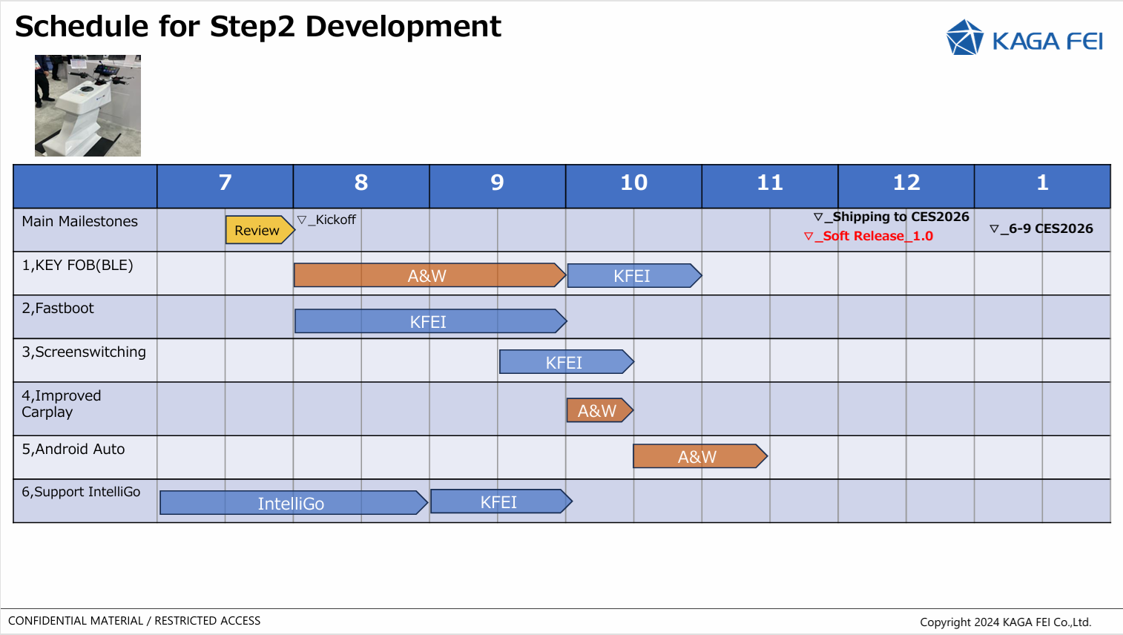
- Mr. Tobe requested to discuss the details of the specifications again within this month.
- Mr. Tobe said that if A&W were to attend CES2026, it would be possible to lend them one of the demos.
- Perry replied that it was not yet certain whether A&W would attend CES2026.

Action Items
<KAGA FEI>
- Provide explanatory materials to A&W (already obtained)
- STEP 1 Provide log files when CarPlay is started to A&W (already obtained)

<A&W>
- We will consider the STEP 2 development request and propose the KEY FOB
- If the development is outsourced, we will hold detailed specification discussions within this month.

