Customer: KagaFei
Meeting Day : 2025.8.06
Meeting Method : Visit & Web(HQ) Conference
Meeting Agenda : Two-wheeled Demo Development Request Meeting for CES2026
Meeting Purpose : same as above
Whether the results of the meeting achieved the expected purpose: N/A

Participants:
- KAGA FEI:
  - Satoshi Tobe – Assistant manager/Technical Marketing Dept. (H/W Engineer)
  - Takuya Terada – Project Manager/Technical Marketing Dept. (Engineer)
  - Makoto Nishikata – Manager/Technical Marketing Dept. (Tobe san’s boss)
  - Hajime Adachi
Summary:
- Ting-san and JR-san from HQ explained Kaga FEI's 3 additional development requests with materials.
Request 1. Key FOB support
A&W: Kaga FEI approved A&W's proposal.
Request 2. Reduce CP startup time (reduced from 30 seconds to 6-8 seconds)
A&W: A&W promised to respond.
Request 3. AA- support
A&W: A&W promised to respond.
- Kaga FEI requested that the RSSI judgment of the KEY FOB be made variable, and HQ agreed.
- Kaga FEI was satisfied with A&W's response and approved the proposed specifications.
- HQ will respond with a development schedule for the three points by the 20th.
- Kaga FEI confirmed the development schedule response on the 20th and requested a regular meeting after the 20th.
- ※2-Wheels Demo (STEP 1) was on display next to the reception desk at Kaga FEI's office

Detailed discussion:
- HQ JR-san explained the KEY FOB specifications in the following document.
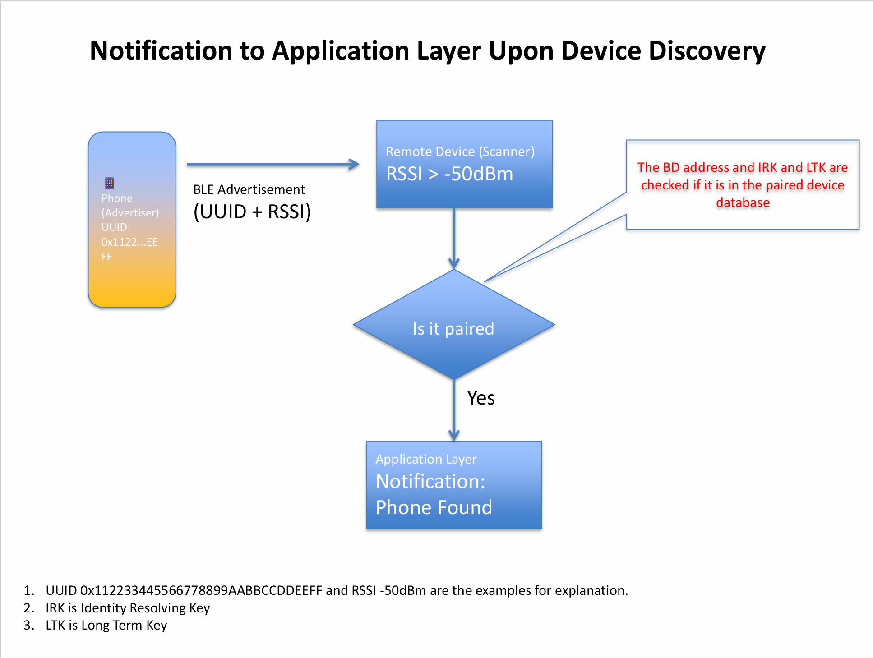
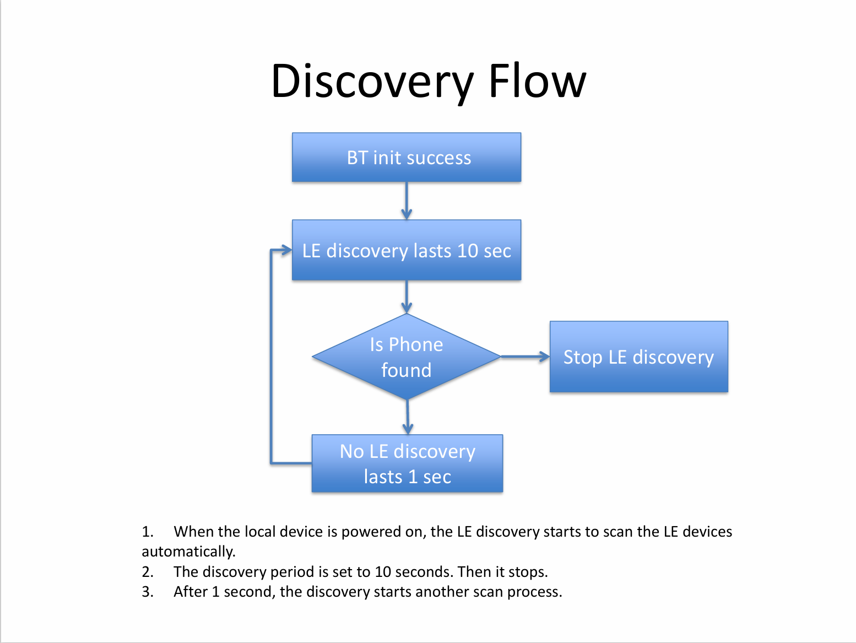
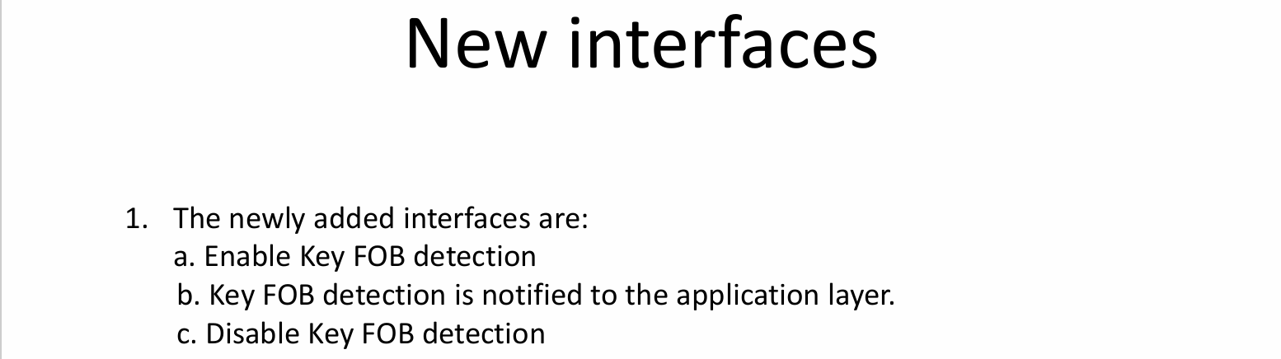
- Kaga FEI understood and approved the proposed KEY FOB specifications.
- Tobe-san requested that the RSSI judgment be variable, rather than fixed at -50dBm, and HQ agreed. (This is OK only when setting the initial value.)
- HQ explained in the following document that they had approved the development of requests 2 and 3.
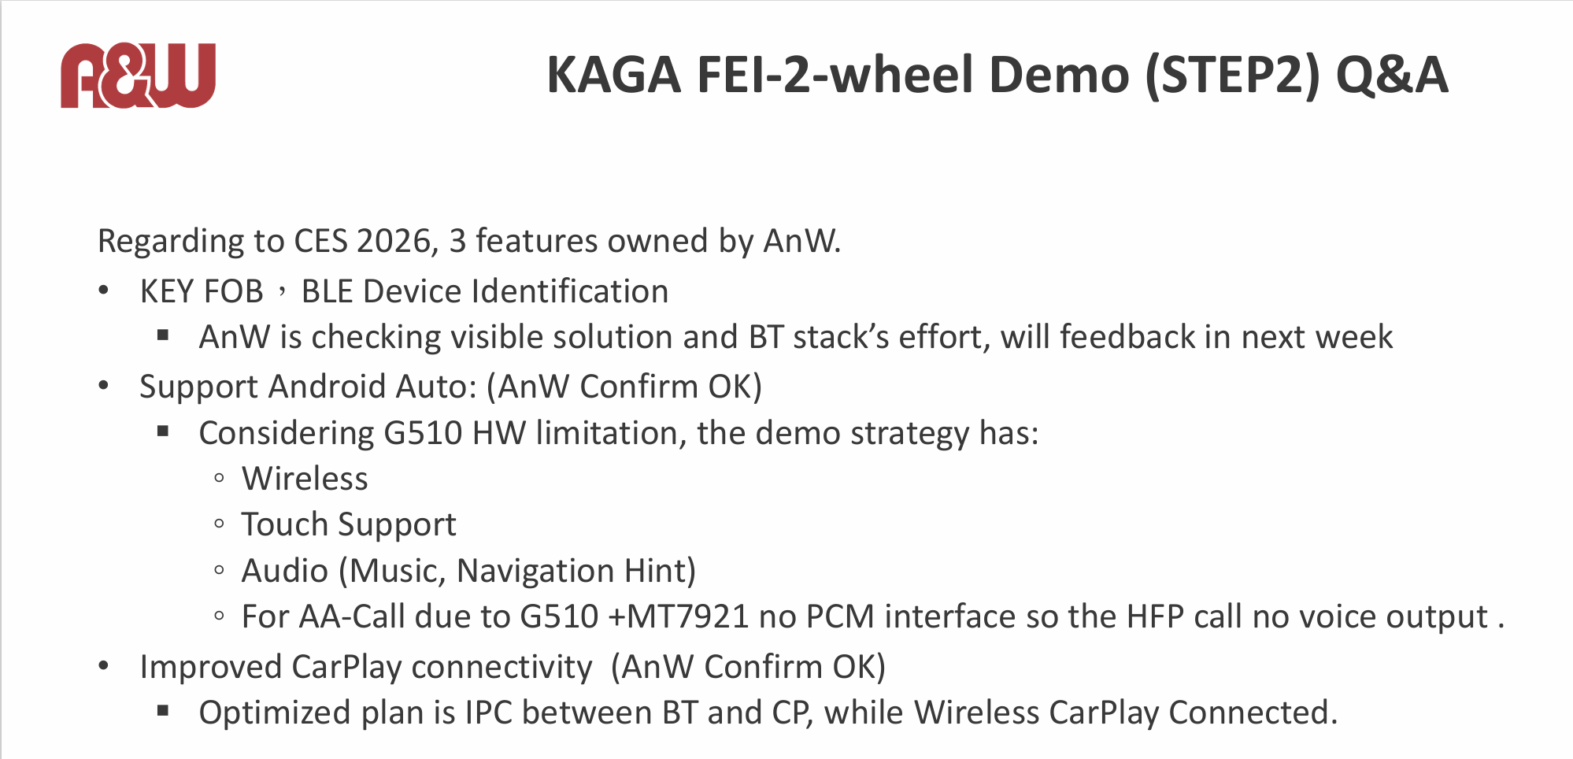
- Tobe-san asked if there were any problems with the development schedule he had requested last time below.
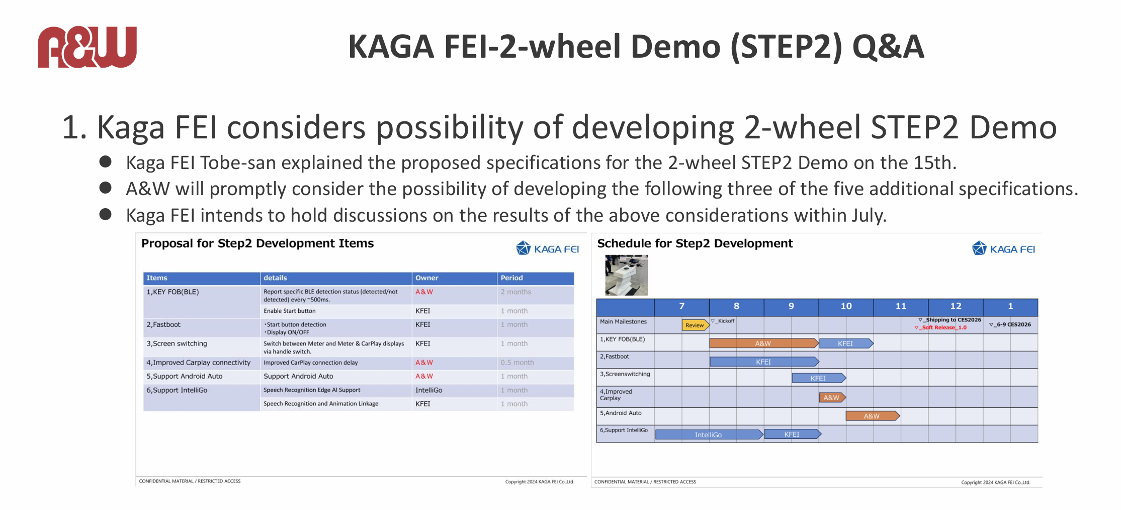
- HQ Ting-san has promised to reconsider the matter internally based on the current specifications and provide an answer regarding the development schedule by the 20th.
- Ting-san asked when the second MTK evaluation board would arrive at HQ.
- Tobe-san replied that it was scheduled to be shipped after the 18th, and would arrive by the end of August at the latest.
- Ting-san requested that if A&W exhibits at CES 2026 and wishes to display the Kaga FEI demo, they should contact him as soon as possible.

Action Items
<KAGA FEI>
- Kaga FEI will send the demo board to A&W headquarters as soon as possible after August 18th.
- Kaga FEI hopes to hold regular progress meetings after receiving a response regarding the development schedule on the 20th.

<A&W>
- A&W will respond to Kaga FEI on the 20th regarding the schedule for this demo development.

