Customer: NTT QONOQ Devices Inc.
Meeting Day : 2025.08.01
Meeting Method : Visit Conference
Meeting Agenda : Alango Smart Glasses Solution Demo Request
Meeting Purpose : Same as above
Whether the results of the meeting achieved the expected purpose: Yes

Participants:
- NTT QONOQ Devices Inc :
Design & Development Department
- Yohichiroh Tatsuki : Manager
- Yamaoka-san

Summary:
1.NTT QONOQ released their first smart glasses last year.
MiRZA XRD-T01 | 株式会社NTTコノキューデバイス ｜ NTT QONOQ Devices, Inc.
※SOC uses Qualcomm's AR2 and features two microphones on each side.
2. NTT QONOQ is very interested in Alango's smart glasses solution and would like to confirm its performance by mid-August. (A demo of the actual device would be best)
※Most interesting thing about NTT QONOQ is its support for "Vibration Voice Sensors."
※NTT QONOQ has two goals for the Alanogo Solution:
Case1 Extract only the voice of the person wearing the glasses in a noisy environment.
Case2. Extract only the voice of a specific person in a noisy environment
(including removing the person's own voice).
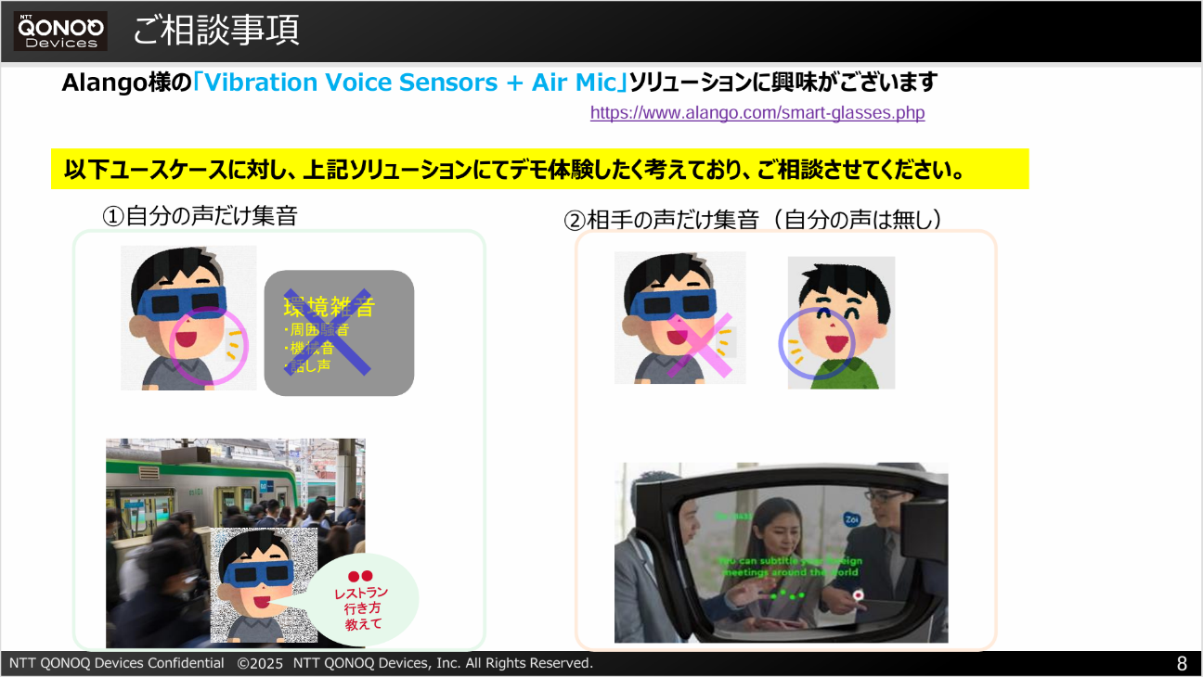
3. NTT QONOQ urgently needs to know the technical information available for the Alango smart glasses solution(microphone position, vibration voice sensors specifications, etc.) and whether there are any restrictions on provision.
4. NTT QONOQ is also interested in whether the Alango smart glasses solution has already been adopted by a smart glasses vendor.
5. If NTT QONOQ determine that the expected performance is achievable, he would like to discuss specific technical details and terms of provision (royalties, etc.) in the next step.
6. NTT QONOQ is planning to launch smart glasses (second wave) in the fall of 2026, and intends to adopt the Alango smart glasses solution if conditions are right.
7. NTT QONOQ understands that A&W can provide the BT Stack.
8. NTT QONOQ hopes to receive a response next Wednesday.

Detailed discussion :
- Tachiki-san began by introducing the NTT QONOQ device using a handout.
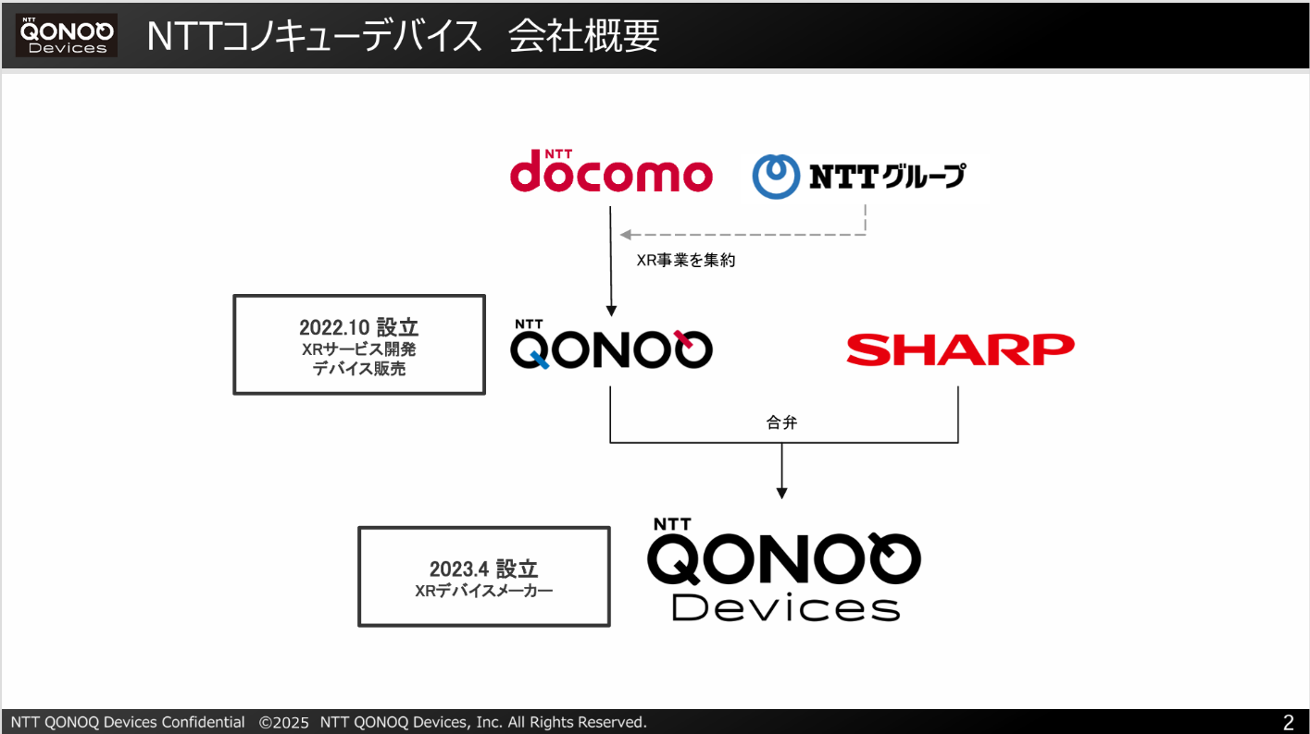
NTT QONOQ Devices is a joint venture between NTT QONOQ and Sharp, established in April 2023.
All three people who participated in the meeting are seconded from Sharp.
Tachiki-san is in charge of software development in Tokyo, while the other two are in charge of hardware development in Hiroshima.
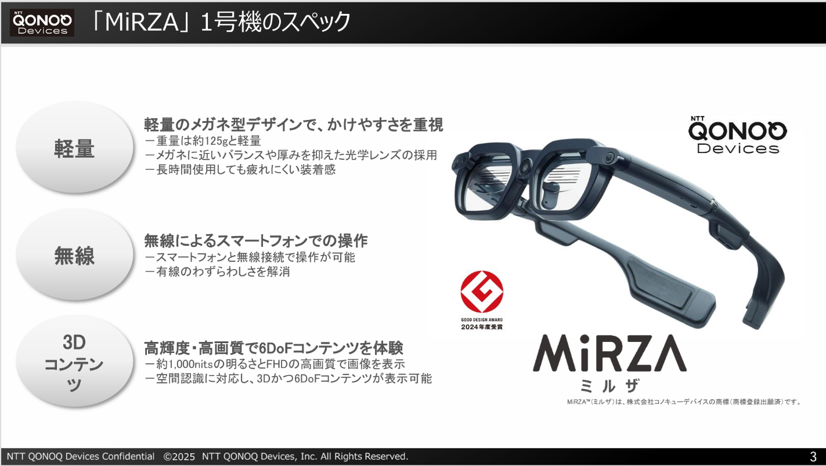
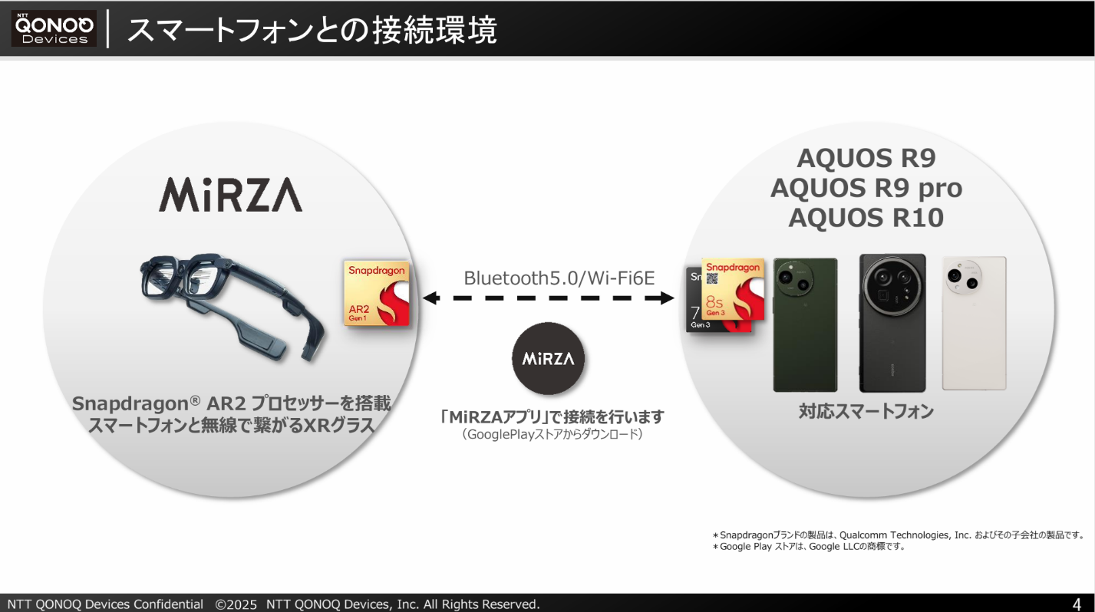
NTT QONOQ Devices is very interested in Alango's smart glasses solution.
If Alango's smart glasses solution has the performance to achieve the following two points, they would like to consider adopting it in their next product.
Case1 Extract only the voice of the person wearing the glasses in a noisy environment.
Case2. Extract only the voice of a specific person in a noisy environment
(including removing the person's own voice).
NTT QONOQ Device Tachiki-san said that since Alango's Solution supports "Vibration Voice Sensors", it would be very attractive if he could pick up his own voice with greater accuracy through bone conduction rather than picking up his voice from the Air.
Tachiki-san from NTT QONOQ Devices said he wanted to try out Alango's "Vibration Voice Sensors" to experience their performance and experience them for himself, so he wanted to try out a demo.

- Alango Solution detailed information
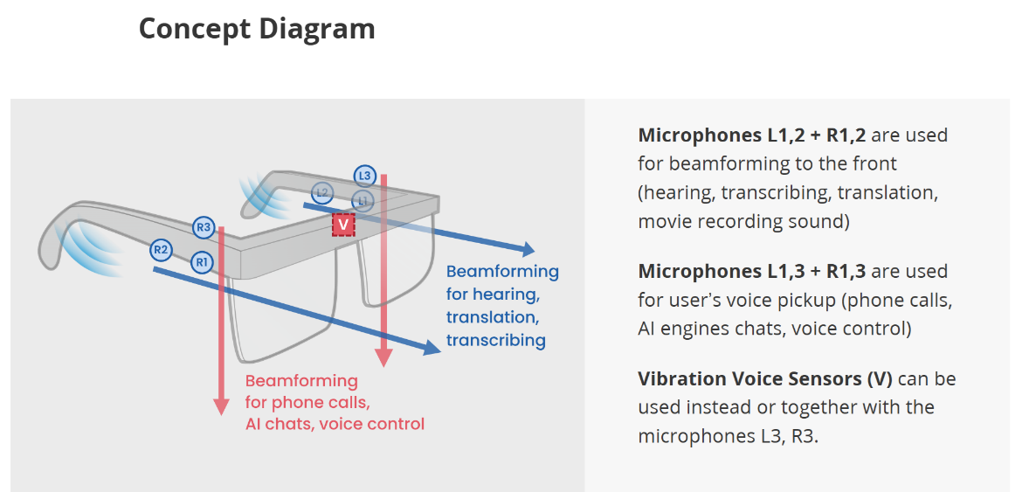
Tachiki-san said he wanted to know the number of microphones and their installation locations, as well as the detailed specifications of the "Vibration Voice Sensors" in the Alango Smart Glasses Solution.
I checked to see if QONOQ's MiRZA already supports the above solution.
Tachiki-san said that it is already supported, but the performance is not good.
Tachiki-san said that the above solution is supported by four microphones, two on each side, and that there are no "Vibration Voice Sensors"
I asked if there were any specifications regarding the microphone configuration of the next product.
Tachiki-san said that he would first like to consider the number and placement of microphones specified in Alango's smart glasses solution.
Tachiki-san said he would like to know if there are any restrictions on providing Alango's smart glasses solution.

- Future Prospects
Tachiki-san said that there is not enough time to incorporate it into the next product, and that he would like to proceed with the consideration in the following SETP.
STEP1 : Tachiki-san says he would like to receive answers to the following questions before the summer holidays (hopefully by the 6th).
Tachiki-san said he would like answers to the following questions before the summer holidays (hopefully by the 6th).
Q1: Provide data on a live demo of the bone conduction microphone system or experience data.
I understand that there are currently no conditions, such as exclusive to other companies.
Q2: What are the minimum microphone requirements (number of microphones, placement, etc., as envisioned by Alango)?
Q3: What SoCs are expected to be supported (such as the two companies' glasses mentioned today)?
STEP2：Discussion of development costs and royalties
STEP3 : If feasibility and business requirements are met, we would like to discuss in detail specific development.
Tachiki-san says he would like to complete each of the above steps in about a month.

- Introducing A&W BT Solution
I introduced A&W's BTsolution to tachiki-san, who said he would consider it if it was introduced at the same time as the Alango implementation.

Action Item:
- NTT QONOQ Devices
  - Today's NTT QONOQ device introduction and requirements document will be provided to A&W.
- A＆W
  - Answer the questions in STEP 1 to 3 to the NTT QONOQ device by the deadline.

