Customer: PIONEER CORPORATION
Meeting Day : 2025.09.11
Meeting Method : Visit
Meeting Agenda : Confirmation of selection criteria for next BT Stack business project
Meeting Purpose : Same as above
Whether the results of the meeting achieved the expected purpose: Yes

Participants:
- PIONEER CORPORATION:
Mobility Products Company, Technology Development Headquarters,
Technology Management Group, Platform Development Department 1
Masazumi Takeshita : Engineer

Summary:
- Visited Takeshita-san through an introduction from Minebea Mitsumi Kawaminami-san.
- Takeshita-san is considering developing a head unit that controls mobile phone HFP connections and Bluetooth speaker and A2DP connections in response to RFQs from OEMs for special vehicles (4-wheel buggies), agricultural trucks, and 2 Wheels. (These products require CP/AA)
(Since wired speakers are difficult to install in these vehicles, Bluetooth speakers are optimal)
- Takeshita-san will select H/W that can achieve the above for the RFQ, and Osawa-san (in charge of S/W Bluetooth) will ultimately select the optimal Bluetooth chip and stack.
- Takeshita-san stated that some manufacturers prefer standalone Bluetooth HCI modules and would like to know if A&W has experience with them.
- RFQs are requesting standalone Bluetooth HCI modules for the following products.
>In-car air conditioning control (ON/OFF, etc.)
>In-car electrical equipment control (e.g., doorstep welcome support in overseas markets)
- To recommend A&W products for the above project, Osawa-san must be the key person to confirm the details.

Detailed discussion:
[New H/U concept and target confirmation]
- I was contacted by Kawaminami-san from Minebea Mitsumi to ask if A&W BT Stack could be implemented in the below project, and I explained the situation to her.
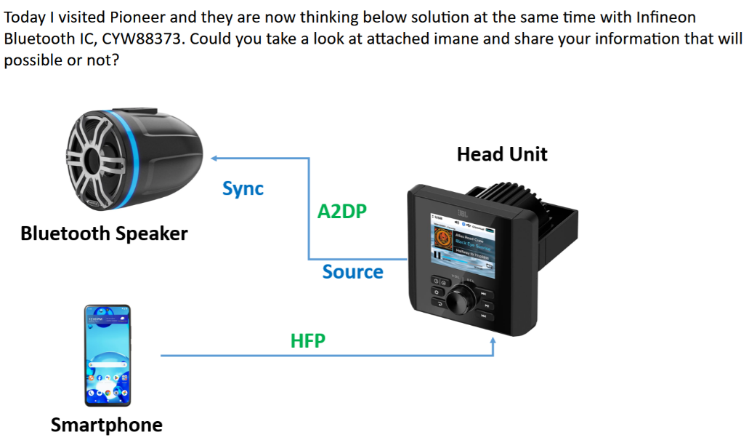
- Takeshita-san said that there is a demand for this H/U as a product to be installed on four-wheel buggy cycles and agricultural tractors.
- Takeshita-san said that the above-mentioned special vehicles have no glass or roofs, and that there is a demand for enjoying music in an open space.
- As existing in-vehicle speakers cannot be installed in the above-mentioned special vehicles, he would like to bring in a commercially available BT speaker to listen to music.
- However, the key is to stream music via the H/U.
- Takeshita-san said that he is confused because he has recently received requests from several OEMs for CP/AA support for the above-mentioned open-space vehicles.
※The vehicles themselves are also loud, so he is unsure whether there is really demand for hands-free functionality or listening to music.
- I mentioned another project where a customer wanted to install CP/AA on a tractor.
- I mentioned that they'd recently received many inquiries about 2 Wheel.
- Takeshita-san said that PIO has already started development on 2 wheels, but hasn't yet reached mass production. (For domestic motorcycle manufacturers.)
- Takeshita-san said that CP/AA support is already in place, but output is targeted at helmets.
(Request from domestic 2 Wheels manufacturers.)
- He also said that they're developing a solution to send map data from a mobile phone to the meter.
- Takeshita-san believes that development was outsourced to PIO because 2 Wheels manufacturers lack the expertise to develop wireless CarPlay.
- I asked if the BT stack in the solution was A&W.
- Takeshita-san said that because the solution doesn't require WiFi, they used a separate standalone BT module vendor and the stack was also supplied.
- He said that map mirroring has already been achieved with this module.
- Takeshita-san said that the issue was whether the product would pass certification.
- Since A&W have development expertise and certification experience with various SOCs and Bluetooth chips, we asked them to let us know if there were any problems with the selected Bluetooth chip or stack.
- Morosita-san asked what OS the product was, and Takeshita-san said it was probably Android.
- I asked what SOC the product was, and Takeshita-san replied that he thought it was a cheaper SOC. (TCC? Sunplas?)
- I asked if buggies and tractors also use standalone Bluetooth modules, and Takeshita-san replied that they use Wi-Fi/Bluetooth combo modules.
- Takeshita-san said that a certain 2 Wheel manufacturer believes that a standalone Bluetooth module is sufficient for map mirroring only.
- Takeshita-san said that joint development has begun for 2 Wheel, but that everything else is at the RFQ stage.
- Takeshita-san said that 2 Wheel and tractor manufacturers are having trouble obtaining certification, so he thinks that if PIO can propose a way to pass the certification, they may be able to obtain commercial rights.
- Takeshita-san said that the reason there are increasing requests for CP/AA from 2 Wheels manufacturers is that Harley-Davidson has already introduced CP/AA to the market for 2 Wheels, and they seem to want to follow suit from Japanese manufacturers.
- Takeshita-san said he would like to know if A&W can introduce any stack achievements or modules for standalone BT modules.
- I asked who would select the BT stack for the above products.
- Takeshita-san said that he would select several hardware options, and that the final selection would be made by Osawa-san, the software developer.
- Takeshita-san said that Osawa-san would decide on the BT stack for all products.
- Osawa-san would also check the performance and make a decision on externally purchased BT modules and stacks.
- Takeshita-san said that one vendor mass-produces both four-wheeled buggies and two-wheeled vehicles, so he would like to select a vendor that can offer both (Kawasaki?).
- Takeshita-san said that PIO exhibited a 2 wheels demo at CSE2024 last year, and that many motorcycle manufacturers stopped by and have received inquiries.
- Takeshita-san said that he has received the following inquiries from four-wheeled vehicles for a single BT module project.
>Controlling the in-car air conditioning and electrical equipment via Bluetooth (is this a trend?)
>Welcome support (displaying an LED on the doorstep)
- Takeshita-san, as a PIO, said that since there are no standalone Bluetooth module stacks, development may be necessary in the future.
- I asked whether the standalone Bluetooth modules were domestic or overseas, and Takeshita-san answered domestic vendors.
- Takeshita-san said that recently, overseas vendors' products have been cheaper, so they always check to see if overseas parts can be used.
- Takeshita-san asked if A&W had any overseas standalone Bluetooth modules they could introduce.
- Takeshita-san said that while standalone Bluetooth modules seem to be cheaper than combo modules, standalone Bluetooth modules from domestic vendors are not cheap.

Action Item:
- A&W
  - I compile questions that come up during meetings into a Q&A sheet and ask HQ for answers.

