Customer: PIONEER CORPORATION
Meeting Day : 2025.10.06
Meeting Method : Visit
Meeting Agenda : Visit will be to check the adoption status of A&W BT Stack in the SunPlaus project and to confirm product segmentation.
Meeting Purpose : Same as above
Whether the results of the meeting achieved the expected purpose: Yes

Participants:
- PIONEER CORPORATION:
Mobility Products Company, Technology Development Headquarters,
Technology Management Group, Platform Development Department 1
Kenichi Takeda : Head of Section

Summary:
- Purpose of the visit was for Morishita-san to confirm with Takeda-san whether the continued adoption of the A&W BT Stack for Sunplus's Android Project had been confirmed.
- Takeshita-san said that while he generally intends to continue using the A&W BT Stack, a final decision has not been made due to the lack of a specific confirmed project.
- I confirmed the latest status of PIO's product development structure, which Takeda-san introduced to me during my previous visit, using the diagram below. (Before confirmation)
- Takeshita-san pointed out various issues and explained that the latest status is as follows.(After confirmation)
- Takeshita-san's revisions are as follows:
> Android products are more expensive than Linux, so there is no low-end (after-market) Android product.
>There are no cases where high-end Android products are developed entirely by PIO, and going forward, collaborative development with SI (NeuSoft) will become the norm.
>The BT stack will primarily use the A&W stack.
>ECNR could be considered as a replacement if it offers higher performance and is cheaper than the existing product.
>CP/AA is intertwined with the entire system, so replacing it as a standalone product will be difficult.
- If A&W recommends the adoption of CP/AA, they will need to explain A&W's track record with CP/AA and the rationale for its feasibility as a replacement for existing customer systems.

Detailed discussion:
[Sun Plus Product confirmation]
- Morisita-san asked if it had been confirmed that the SunPlus project would adopt the A&W BT Stack.
- Takeda-san said that he understood that the SunPlus project would basically adopt A&W.
- Morisita-san mentioned that he had heard from Ohashi-san that it had not yet been finalized.
- Takeda-san said that the SunPlus project was currently in the process of proposing to OEMs, and that it might be several years before they secured the business.
- Takeda-san said that once the business was confirmed, the BT Stack Vendor would also be confirmed.
- Takeda-san said that the first product for the SunPlus project would be Linux.
- Takeda-san said that even though the features were cheap, the product was price-conscious.
- Morisita-san asked the PIO to handle the visit, as an A&W executive from HQ would be visiting Japan next month.

[Tkakeda-san's worries]
- Tkakeda-san has been working with A&W for 10 years and would like to continue this relationship in the future.
- However, he is concerned about whether development will be able to continue as standardization progresses.
- For example, Google has previously taken away PIO's Navi business.
- He believes that if Google gets serious about Android, it could take even more business away from PIO.
- However, at the moment Google has not yet made a serious effort, so PIO's business continues.

[PIO product development allocation confirmation]
- I reconfirmed the PIO product development division of responsibilities that Takeda-san had told me about during my previous visit.
- I confirmed what Takeda-san had told me about last time by illustrating it in the diagram below.
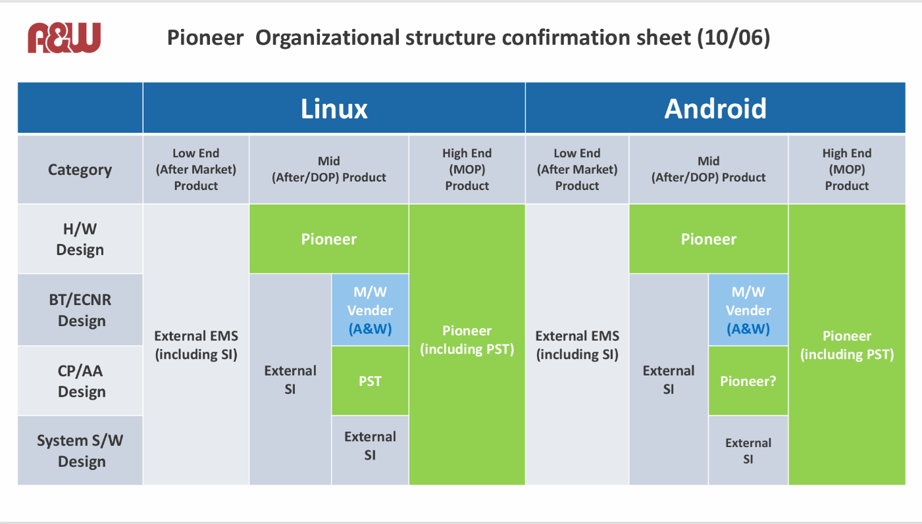
- Takeda-san pointed out several differences in understanding, and in the end, the diagram below was created.
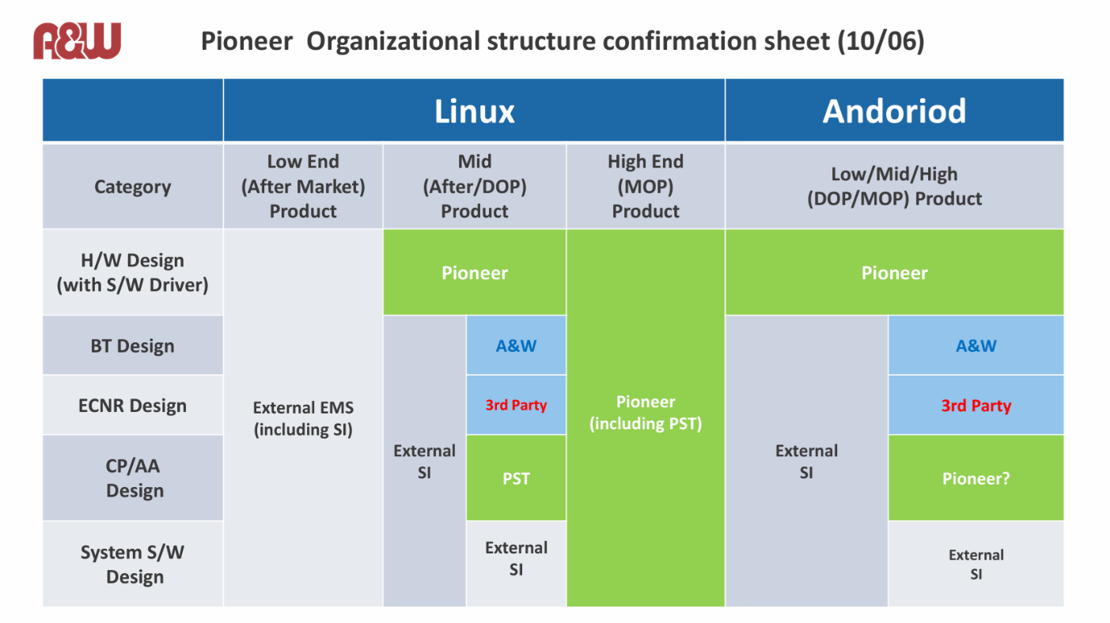
[About A&W CP/AA Solution Recruitment]
- The points Takeda-san raised are listed in the summary.
- I asked about the possibility of adopting A&W's CP/AA solution.
- Takeda-san said that the barriers to entry were high and that a proven track record would be important.
- Since I was developing Linux CP/AA at PST (Pioneer Sandai), I assumed the same would be true for Android.
- Takeda-san introduced me to Noguchi-san as a key person if A&W were to expand sales of the CP/AA solution to PIO.
- We had requested an appointment with Noguchi-san last month, but he was busy with development, so we explained that we would request another appointment soon.
- Since CP/AA had already been selected for an upcoming project, Takeda-san were recommended to promote it for the next product.
- Takeda-san said that PIO would no longer be developing all of the software in the future.
- I asked if the software for the Android MOP project would also be outsourced, and Takeda-san answered yes.
- The software for the MOP project that PIO has already adopted is external, and other IVI vendors are aware of the same situation (excluding China).
- Takeshita-san said that automakers are increasingly requesting that they develop their own application software.
- Toyota and Honda have traditionally developed their own application software.
- Mazda recently established an R&D Center in Tokyo and is considering developing its own application software.
- However, no Japanese automakers have yet achieved this feat.
- European automakers, on the other hand, have largely shifted to in-house development.
- The reason for this is the strict division of labor in product development.
- Japanese automakers do not specialize in labor, but instead focus on fine-tuning development, which has led to a lack of standardization.
- Given this background, Takeshita-san believes that in the future, it will no longer be the case that all software development will be handled by a single company.
- Takada-san said that Japanese IVI vendors are increasingly outsourcing their work.
- Takeda-san believes that both Linux and Android products will continue to be popular in the future.
- However, from a product cost perspective, Android is more expensive, so commercially available and cheaper Linux products will likely become the norm.
- I asked about Android's development for commercial products.
- Takeda-san said that commercial products are price-conscious and that Android Auto isn't necessary.
- Takeda-san said that it would be difficult to beat PST, which develops CP/AA on Linux.
- Takeda-san's thoughts are as follows:
>For commercial products, they will develop low- and mid-range products on Linux.
>OEM MOPs will develop mid-range products on Android.
(OEM high-end products will become integrated.)
- I mentioned that during my time at Renesas, I had the impression that Android was selling inexpensive IVI products in the Chinese market, and that I thought Android was inexpensive.
- Takeda-san said that Android for Chinese IVI is aimed at consumers, not automotive, and does not require certification, so he believes it can probably be developed cheaply.
- He said that PIOs must obtain certification even with Android, making it difficult to compete with Chinese products.

[PIO Confirmation of expansion into motorcycle business]
- I heard that PIO was planning to expand its business into 2Wheels in the future, so I checked with Takeda-san.
- Takeda-san recommended that we interview Sasaki-san, as he is the one who mainly talks about 2Wheels.
- Takeda-san was aware that they had begun to consider it, but said that it didn't have much of a business angle.

[PIO 4-wheel order status]
- Takeda-san is currently busy with a development project for Suzuki, which he has been ordered to carry out from this summer through to next fall, and said he is not in a phase where he can think about the future.
- AMP negotiations are also brisk in the US.
- Morosita-san introduced the adoption of A&W's CP/AA by Roxygen in Taiwan.
- Takeda-san said that while BT Stack and ECNR are easy to replace with systems on their own, CP/AA is difficult to replace because it is closely intertwined with the system.
- If they were to replace it, he said they would need to work with their outsourced partner, NeuSoft.

Action Item:
- A&W
  - I arranged a visit from Noguchi-san, a key figure in CP/AA, to introduce A&W's CP/AA.

