Customer: Alpha Theta Corporation
Meeting Day : 2025.10.10
Meeting Method : Visit
Meeting Agenda : We heard that AlphaTheta will be using the BT Complete Module in their next product, so we visited to check the situation and introduce the A&W Command Light solution.
Meeting Purpose : Same as above
Whether the results of the meeting achieved the expected purpose: Yes

Participants:
- Alpha Theta Corporation:
Software Design Management Division, Firmware Design Department 2
Controller Section
Hiroki Tokairin : Engineer
Yuusuke Ito : Engineer

Summary:
- AT has three BT solutions.
(1) BLE Stack using HCI BT Chip (A&W Stack but not compatible with LE-Audio)
(2) BT Complete Module (compatible with LE-Audio) (for budget-friendly audio-compatible products)
(3) BT/Wi-Fi Combo Module (integrated with A&W Stack provided by Company S) (for high-end products?)
- AT has decided to support LE-Audio in its next product.
- AT selected the Complete Module currently under development for LE-Audio products (3), but two actual development projects were canceled and development has not yet begun.
- AT understood the A&W proposal, but a proposal including LE-Audio (including PBP support) functionality was required, and a ROM/RAM estimate including LE-Audio (PBP) was required.
- AT also heard that A&W can support PBP, but AT would like to confirm whether Sig authentication will be included in the existing stack when the product is provided, or whether it will be provided as a separate option.
- AT understand that the Complete Module is expensive and has limited functionality, but from the customer's perspective, the Complete Module was selected due to development resources and the RAM/RAM limitations of the MCU used.
- As AT interested in A&W's proposal this time, he would like them to make another proposal (including ROM/RAM size) for Lite commands that support LE-Audio (including PBP support).
- AT was told that if A&W could make a proposal equivalent to the Complete Module, including a standalone BT HCI Chip, there would be room for internal consideration.

Detailed discussion:
[Introducing the A&W Command Light solution]
- At the beginning, Morishita-san said that he would introduce a new solution from A&W HQ.
- Parry-san's agenda instructions were for Morishita-san to check the customer's situation.
- Morishita-san checked to see if Toukairin-san could speak English, and Toukairin-san requested an explanation in Japanese.
- Morishita-san explained that the proposal was aimed at reducing the client's development resources, and that the request was received from HQ yesterday.
- Perry-san explained today's topic in English, saying that it was as follows:
- Mingufa-san said he would introduce a solution aimed at making it easy for R&D to use the A&W SDK (without the need for detailed understanding).
- Morishita-san urged me to explain it in English.
- I confirmed with HQ that Mingufa-san would explain it in English, and suggested that any questions or customer inquiries be handled in English, which HQ agreed to.
- Mingufa-san introduced A&W's new Command Line Solution using the following materials.
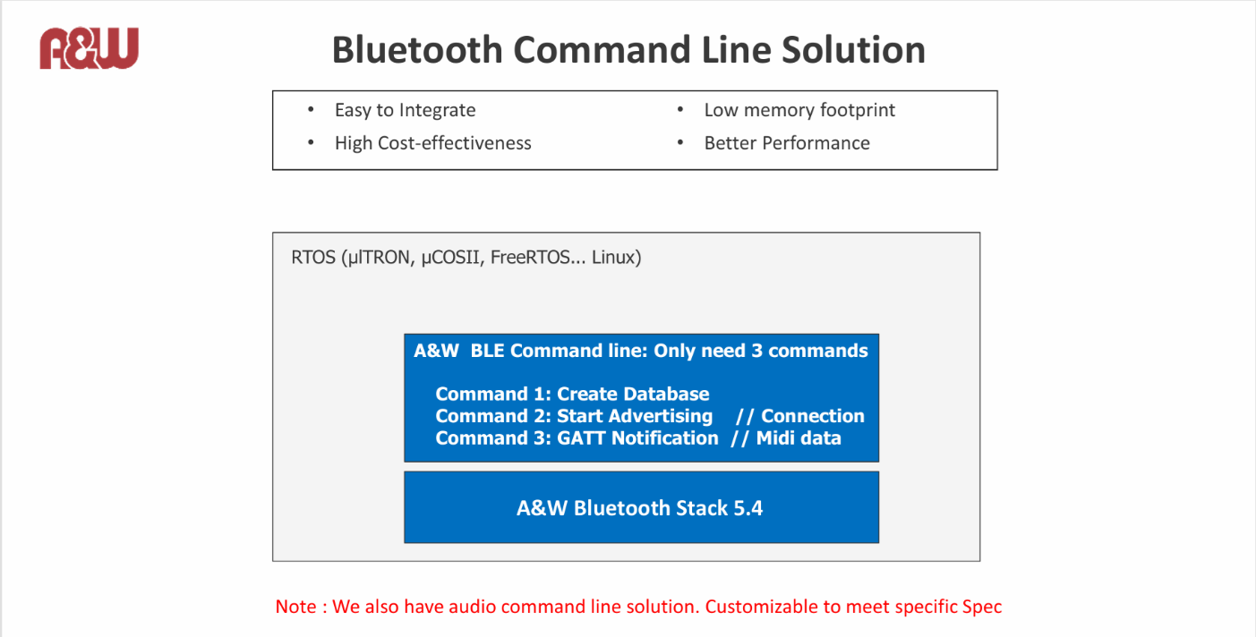
- Toukairin-san asked what the difference is between the command line I/F and the traditional Stack I/F.
- Mingufa-san explained that with traditional interfaces, it is necessary to understand the API specifications and develop control software.
- However, with the command line interface, A&W provides software that simplifies control between the user interface and the API interface, allowing users to control it using the same commands as Complete Module without having to understand the detailed API specifications.
- Mingufa-san explained that in the previous meeting, AT had considered LE-Audio, but that controlling LE-Audio is more complicated.
- A&W said that it proposed a command line interface from the customer's perspective, considering how to make control as easy as possible for customers.
- Toukairin-san requested an explanation in Japanese again, and I explained the main points and background.
- I explained that the purpose of the command line interface is to reduce the development burden on customers' R&D.
- I explained that for customers who choose Complete Module to reduce their development burden, this is a solution that offers low cost, good performance, and flexibility, allowing them to continue using HCI modules.
- Toukairin-san asked whether the BT Stack interface would become a command line interface in the future.
- I explained that the command line interface is optional.
- I explained that this solution is not for customers who have traditionally used the Stack, but for customers who use Complete Module.
- I explained that the ultimate goal of the command line interface was to enable users of Complete Module to replace it with this solution without changing their control software.
- Toukairin-san understood our proposal and said that it was a good idea given the purpose of the product.
- I deliberately played dumb and explained that AT was already using the A&W Stack, so I would like them to consider this if they wanted to use Complete Module in the future.
- I strongly recommended this proposal because the Complete Module is expensive and has limited functionality.
- Toukairin-san asked whether the command line I/F Solution could achieve the same functionality as the complete module.
- I explained that we would listen to the customer's requirements for the complete module and define the command line.
- A&W explained that the three commands proposed were sufficient, and that if the customer needed additional functionality, A&W could add it.
- I deliberately asked to confirm that this command line I/F would be sufficient if AT were to consider the Complete Module in the future.

[Alpha Theta BT Solution Confirmation]
- Ito-san intends to use the audio-related BT Complete Module in the future.
- Ito-san said that his reasoning was that the development burden would be low, as the system would only need to send commands for audio interface and stack control.
- Ito-san understands that the BT Complete Module is expensive and that it could be made cheaper if an HCI Module were used.
- However, he recognized that choosing the HCI Module would require installing the stack on the system and developing software to control it, which would be time-consuming.
- Ito-san asked whether the command line interface proposal, which combines an HCI Module and BT Stack, would be controllable from the system side in the same way as the BT Complete Module.
- I answered that this was correct.
- Ito-san also recognized that BT Complete Module vendors can provide command line control.
- If AT adopts the A&W command line, I asked whether it would be incorporated into the SOC like the BT Stack, or whether it would be separated and have the software installed on a separate MCU.
- I believe the above decision depends on the ROM/RAM size and required performance of the software, as explained by Mingfa-san on the next page.
- Morosita-san asked if the selection of the BT Complete Module was progressing.
- Ito-san said that the BT Complete Module was selected for the product in two previous projects, but the project development was canceled and development has not yet started.
- Ito-san introduced three BT solutions within AT:
(1) BLE Stack using HCI BT Chip (A&W Stack but not compatible with LE-Audio)
(2) BT Complete Module (compatible with LE-Audio) (for budget-friendly audio-compatible products)
(3) BT/Wi-Fi Combo Module (integrated with A&W Stack provided by Company S) (for high-end products?)
- Ito-san said that they plan to continue using the Combo Module (3), and that Company S will likely request LE-Audio compatibility from A&W.
- I again asked about the motivation for adopting the Complete Module in case (2).
- Ito-san said that if they adopted an existing HCI module and made it LE Audio compatible, they would need to install an audio stack and develop software to control it, and their goal was to reduce this development burden.
- According to Ito-san, there are complete modules that can be equipped with their own stack, but in those cases, the stack would still need to be developed on the AT side.
- Ito-san chose the complete module because it has a proven track record in audio products, and they thought that stack operation would be guaranteed.
- However, the LE-Audio-compatible complete module was not as inexpensive as they had expected.
- According to Ito-san, when supporting LE-Audio for the first time, they chose the complete module because it required less development effort.
- However, since the complete module is expensive from a hardware perspective, they thought it would be necessary to consider implementing it with an HCI module.
- I asked whether they agreed that A&W's command line proposal was excellent in every way, so there was no need to choose the complete module.
- Ito-san said that a large part of the complete module is that the driver software (including stack) and hardware can be supported by Company S alone.
- When supporting LE-Audio this time, it will be a combination of module (hardware) + stack + AT software, and he recognizes that each will require work from a different manufacturer.
- Morisita-san asked whether the complete audio module requires very complex requirements.
- Ito-san replied that he didn't know because he has no experience of adopting (using) a complete audio module at the moment.
- However, he understands that in terms of interface, control is easier than controlling the stack API.
- Ito-san replied that he doesn't think there will be any problems because the complete module vendor has already discussed the functions to be used in LE-Audio.
- Ito-san said that AT does not require support for LE-Audio custom profiles, and that they will support the necessary functions from the standard specifications.
- However, MIDI compatibility is a must for AT, so he said that this is under discussion. (Some vendors are available, others require outside support)
- Morishita-san mentioned that an A&W customer had mentioned a shortage of BT vendor stacks, and that A&W sometimes provides them.
- Ito-san explained that because the products using complete modules this time are in the low-price range, there are also constraints on the host SOC.
- However, for better or worse, A&W has a track record with the combo module stack provided by S company, so he said he thought the proposal was worth considering.
- Morishita-san said that HQ had continued explaining the details of the document.
- I pointed out that since the conversation had continued in Japanese for a long time, perhaps it would be necessary to explain the contents to HQ in English.
- Morishita-san replied that this was not necessary.
- Mingfa-san explained the ROM/RAM size used by the command line in the document below.
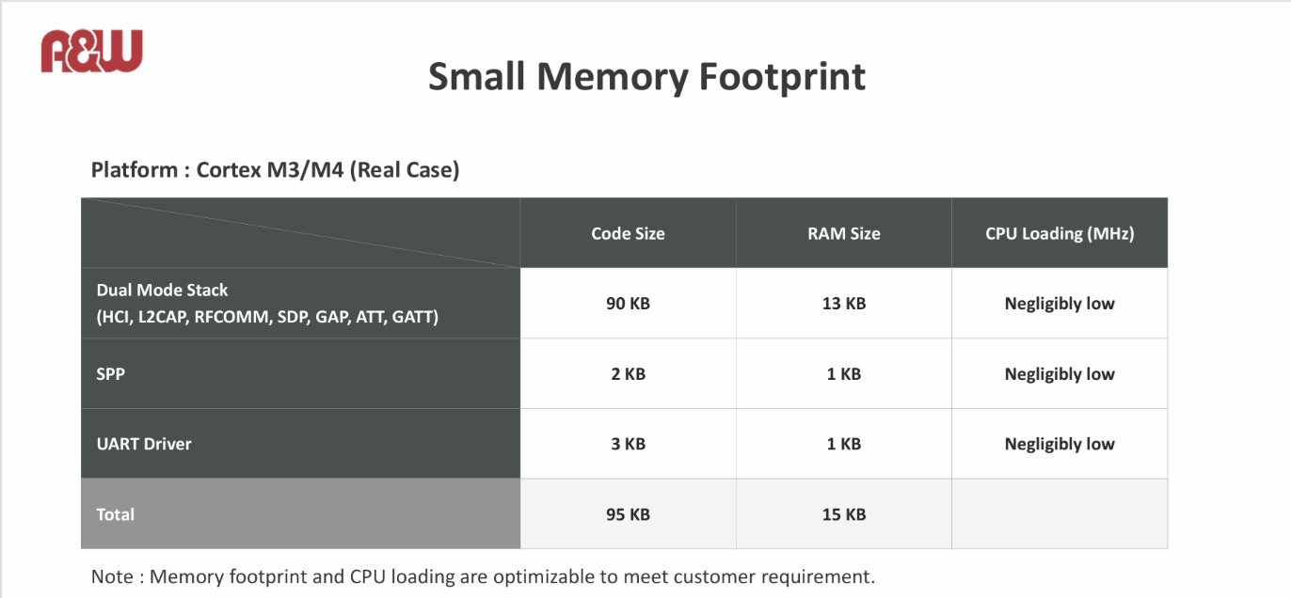
- Toukairin-san asked if this ROM/RAM size included anything other than the stack.
- I answered that it included the BT stack.
- Toukairin-san asked about the ROM/RAM size for the command line interface, and Mingfa-san replied that the SSP + UART driver was the ROM/RAM size for the command line interface.
- Ito-san pointed out that this ROM/RAM size did not include audio-related stacks.
- I confirmed the above with Mingfa-san, and Mingfa-san said it only included BLE.
- Mingfa-san said that the ROM/RAM size would increase slightly depending on the profiles the customer required.
- Mingfa-san answered that when loading the A2DP and SBC decoders, the CPU load was very low, around 30 MIPS.
- I translated the customer information (conversation in Japanese) that Mingfa-san had provided before explaining the materials into English and explained it to HQ.
- Mingfa-san understood the customer's concerns and explained that A&W could provide support at its customer service desk, including questions about the module manufacturer's hardware.
- Mingufa-san also explained that A&W could provide software support when incorporating the module into systems other than stack control, reducing the customer's development burden.
- Mingufa-san explained that other customers had the same concerns as AT, and that A&W already had a track record of supporting those customers.
- Mingfa-san said that they could also provide a command-line solution that supports LE-Audio.
- I asked if it would be possible for A&W to disclose information about the Complete Module, which is currently under consideration.
- Ito-san replied that this would be difficult as the Complete Module product is still in development and is subject to an NDA.
- Ito-san said that even if they were to consider an A&W command line I/F, they would first have to select a compatible module, since the existing HCI module does not support LE-Audio.
- Ito-san asked what the ROM/RAM size would be if the command line I/F were to support LE-Audio.
- With this information, Ito-san said, a comparison would be possible, as development of the complete module had fortunately not yet begun.
- At our previous meeting, LE-Audio support had not yet been confirmed, but I asked if LE-Audio support had been decided for AT.
- Ito-san said that it had been decided, and that the complete module would only be used if the standalone BT module supported LE-Audio.
- Ito-san said that at this point, he thought it was possible to consider A&W's proposal.
- Ito-san said that there would be no changes to the WiFi/BT combo module since the project had already started.
- I showed him a demo video of LE-Audio from HQ and explained that A&W had already achieved this. (However, no sound was heard.)
- Ito-san had previously heard that A&W did not support LE-Audio's PBP function. Is this correct?
- Morishita-san checked with Mingfa-san about the PBP support status.
- Perry-san explained the situation in Chinese.
- Morishita-san explained that PBP could be added as an optional feature starting with BT Ver. 5.4.
- Having heard the same thing last time, Ito-san asked whether BI registration would include PBP, and Morishita-san said he would check with HQ and get back to him.
- Ito-san was also interested in channel sounding and wanted to hear about A&W's situation.
- However, due to conference room constraints, he promised that an HQ executive would explain next time.

Action Item:
- A&W
  - Questions asked during the meeting will be compiled into a Q&A sheet and the answers will be sent to AT.
  - Channel sounding will be on the agenda for the next visit to HQ executives.

