Customer: PIONEER CORPORATION
Meeting Day : 2025.11.06
Meeting Method : Visit
Meeting Agenda : Discussion on measures to accelerate A&W ECNR evaluation
Meeting Purpose : Same as above
Whether the results of the meeting achieved the expected purpose: Yes

Participants:
- PIONEER CORPORATION:
Nureki-san , Kobayashi-san

Summary:
- I asked for his opinion on the A&W ECNR royalty, which I answered in the previous Q&A sheet.
- Nureki-san said that A&W's ECNR does not meet PIO's performance requirements, and that pricing discussions would be held after performance is achieved.
- I explained that the release of other companies' commercial products equipped with A&W ECNR, as proposed last time, could be delayed until fall 2026 or later, and made the following proposal regarding accelerating PIO evaluation.
- First, Nureki-san rejected my proposal to replace the ECNR in PIO's existing products with A&W ECNR, stating that this was not possible.
- Next, I proposed evaluation using the tool I introduced last time, but this was rejected because it was not a real device.
- I proposed lending out the demo developed by A&W, including the ECNR.
- According to Nureki-san, a similar evaluation was conducted several years ago based on a similar proposal from A&W, but the results were poor, perhaps due to insufficient adjustments.
- Nureki-san rented a vehicle from A&W Taiwan in September last year, and the PIO called from Japan to show him the results of the listening evaluation.
- If the A&W ECNR had made improvements from the evaluation reported by the PIO at this point and adjustments could be made that would result in the PIO passing, he would like to conduct a similar listening evaluation again.
- I conveyed the situation and request to HQ and promised to let them know whether or not we could accommodate.
- In addition to the above, Nureki-san asked if A&W ECNR could be customized at the PIO's request, and I promised to compile the above and other questions into a Q&A sheet and respond again.

Detailed discussion:
[Check feedback on the Q&A sheet from the previous visit]
- I showed him the Q&A sheet containing the questions he had asked me during my previous visit and asked if he had any questions or concerns.
- I confirmed his thoughts on A&W ECNR's cost (royalty).
- Nureki-san said that before discussing costs, he wanted to prioritize A&W ECNR passing the PIO evaluation.
- I understood the above, but when I asked him about his impression of the existing vendor, he replied that it was not bad.
- Nureki-san commented that he was not convinced by the answer given to the initial noise in the Taiwanese and Japanese listening evaluations conducted last September, which attributed it to insufficient initial adjustments.

[Discussion on A&W ECNR Evaluation]
- During our previous meeting, I explained that PIO's request for a commercially available product equipped with A&W ECNR would not be available for sale in Japan until fall 2026 or later.
- I asked to discuss ways to accelerate the evaluation, rather than waiting until fall 2026 or later.
(1) I proposed inputting audio files into the ECNR evaluation tool provided by A&W to confirm the effectiveness of ECNR.
- Nureki-san replied that it was difficult to judge because it was the result of a simulation.
(2) I proposed loaning PIO a mass-produced product and replacing the A&W ECNR with Q&W ECNR for evaluation.
- Nureki-san immediately commented that this was impossible.
- Nureki-san said that he could not accept the above proposal, as he expected it would take a considerable amount of time just to incorporate A&W ECNR.
- Given the above circumstances, Nureki-san wanted to evaluate a commercially available product.
- However, considering that it would not be available in Japan until fall 2026 or later, I made the following proposal.
- Nureki-san said that it would be fine for the PIO to evaluate the product if it was presented in an adjusted environment owned by A&W.
- However, he said that he understood the above to be an evaluation of actual equipment conducted in Taiwan and Japan in September 2024.
- Nureki-san had noticed an echo at the start of the above evaluation, and when he checked the cause at the previous meeting, he was told that it was due to insufficient tuning.
- However, Nureki-san was not satisfied with this answer, and requested to evaluate an adjusted product from the start of the evaluation.
- Nureki-san requested that if he was going to recommend a similar evaluation again, they provide him with a product that was already tuned from the start.
- I confirmed whether Nureki-san's image of a tuned product needed to pass the ITU-T test.
- Nureki-san said he didn't think PIO would be able to perform an evaluation that would pass the ITU-T test.
- Therefore, a listening evaluation would be fine first, so as with the previous call, he called from Japan to ask if it would be possible to conduct a vehicle evaluation in Taiwan.
- According to Nureki-san, A&W provided him with an SDK to evaluate before the vehicle evaluation in September 2024, but the evaluation was poor (probably due to tuning issues).
- However, Nureki-san commented that based on the above results, he doesn't think the A&W ECNR is bad.
- In short, Nureki-san said he thinks the tuning and adjustments are insufficient.
- Therefore, Nureki-san said that rather than having PIO perform the tuning, he would like A&W to perform the tuning and evaluate it under the best conditions.
- Nureki-san said that if the listening evaluation passes first, they will consider how far to go with the evaluation next.
- Since I hadn't joined the company yet, I asked when the SDK was loaned and when the in-vehicle evaluation was conducted.
- Nureki-san said that A&W had provided only the SDK, with PIO providing the microphone and speaker, and evaluation had been conducted, but the results were poor.
- I confirmed whether the in-vehicle evaluation had passed all tests except for the initial echo.
- Nureki-san said that PIO had already provided a report with the results of its evaluation.
- I asked if it was possible to evaluate a vehicle if it was tuned better than the previous evaluation using the same in-vehicle evaluation, and Nureki-san answered yes.
- I confirmed the date of the previous in-vehicle evaluation and report. (If it was before February, it would have been before he joined the company.)
- Nureki-san forgot who he had sent the report to, so I advised him that it was probably Morishita.
- Nureki-san explained the evaluation situation using the following document he had sent to Morishita.
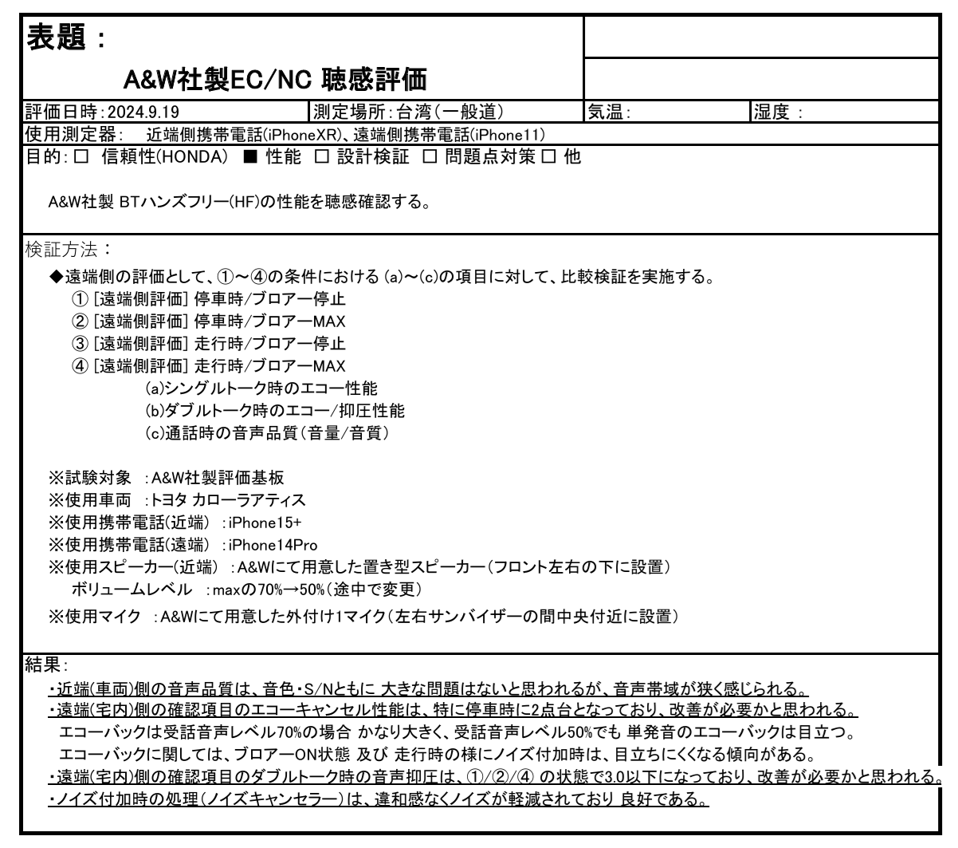
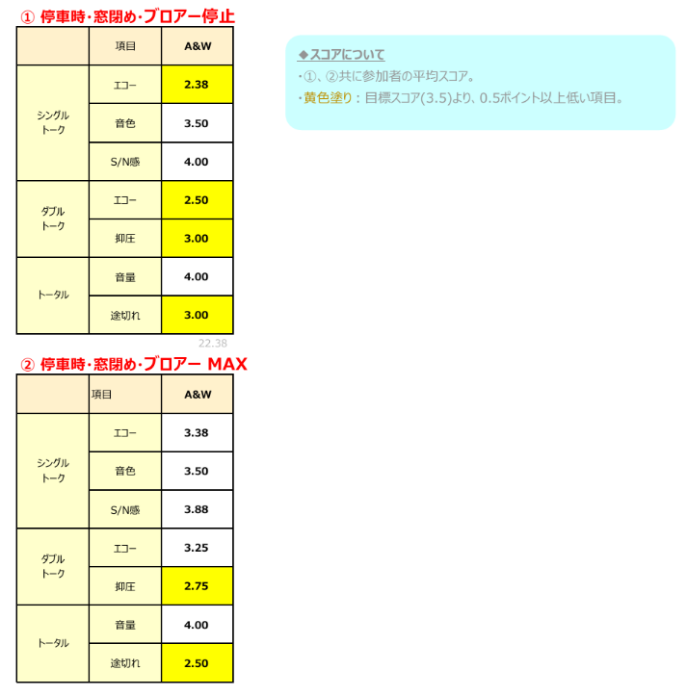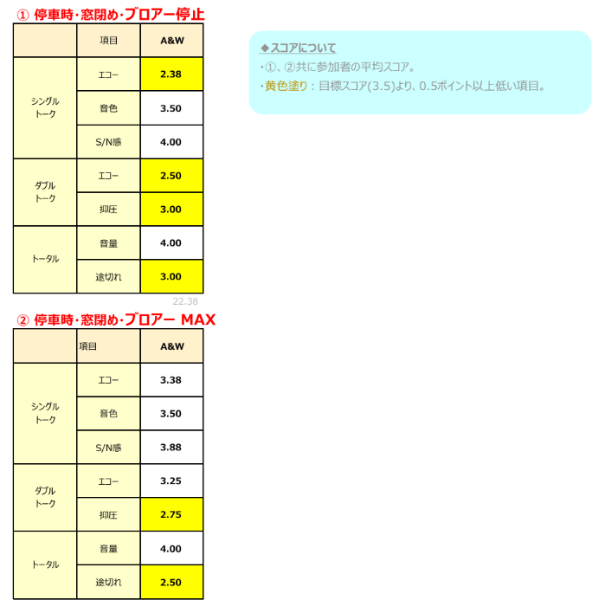
- Nureki-san explained each evaluation condition.
- He conducted a listening evaluation from Japan over the phone on a car provided by A&W in Taiwan.
- The evaluation was conducted under four conditions: stopped, driving, and with the air conditioning on max and stopped.
- Nureki-san said there were no particular issues with the tone or S/N ratio.
- However, the audio bandwidth felt narrow, but the reason for this is unknown.
- The echo cancellation needs improvement.
- He felt that the tendency was less noticeable when the air conditioning was on max.
- He said that the score was the average of three evaluators.
- The target is a PIO of 3.5 or above, but he said that items with yellow hatching that were more than 0.5 below 3.5 needed improvement.
- I asked about "suppression," not understanding what was meant by it.
- Nureki-san said that "suppression" is an evaluation during double talk, and that ideally, only the echo coming from the speaker would be removed, but that the echo cancellation was also effective, lowering the level of the person speaking in the car.
- In other words, when you speak, it becomes difficult to hear the other person's voice.
- Looking at the evaluation results, "Suppression" produced better results when driving.
- Nureki-san said that when PIO borrowed and evaluated the A&W SDK, it achieved a worse score than this.
- I understood Nureki-san's request and promised to consider a solution with HQ.

[Regarding progress after evaluation]
- I asked if there would be a time when ECNR would be changed.
- Nureki-san said that, generally, they wouldn't change it if there were no problems with the existing system.
- Nureki-san said that even if a change was technically possible, he doubted whether it was necessary to incur the cost of doing so.
- I had heard that AI was being introduced for voice recognition and that ECNR would also be changed as a set, but I asked about PIO.
- Nureki-san asked whether AI voice recognition would be done with or without cloud.
- I asked whether, regardless of whether cloud was used, the AI ​​voice recognition engine would ever specify ECNR.
- Nureki-san has already implemented cloud voice recognition supported by CP/AA.
- They also have experience developing products similar to Alexa (on Amazon's cloud).
- However, since the engine that recognizes "Alexa" is required on the edge, they asked me to introduce them to any A&W products they might have.
- Furthermore, in the past, the company developed its own engines for products that required source changes using voice recognition.
- I heard from a customer that there are cases where the speech recognition engine must use a specified ECNR.
- Nureki-san said that if the ECNR specified by the OEM, there is no choice but to use it.
- Nureki-san asked if minor specification changes or algorithm revisions would be possible at the request of PIO if A&W ECNR were adopted.
- I promised to check with headquarters and respond.
- I replied that if PIO had any requests, we could consider them, including whether they could be accommodated, if they were made now.
- Nureki-san understood that this was possible as long as the requests were not for PIO customization, but rather for improving ECNR performance.
- I mentioned that we had recently become able to provide various tools for A&W ECNR.
- I explained that if there were any requests, they could be written in English on the Q&A sheet I had answered previously.
- For some reason, Nureki-san asked if the above requests could be accommodated with BT Stack.
- I explained the A&W development flow and that specifications would be discussed with customers in the early stages of development, so requests could be discussed at that time.
- Nureki-san asked if A&W BT Stack was being used for the 8152 in PIO projects.
- I spoke with PIO Osawa and explained that they were considering adopting the A&W BT Stack for their Linux products and for their new Sunplus Android products.
- Nureki-san understood the situation.

Action Item:
- A&W
  - Compile questions received during the meeting into a Q&A sheet and receive answers from HQ.

