Customer: YAMAHA MOTOR CO., LTD.
Meeting Day : 2025.11.21
Meeting Method : Visit
Meeting Agenda : We visited Yamaha Motors to discuss promoting collaboration with A&W.
Meeting Purpose : Same as above
Whether the results of the meeting achieved the expected purpose: Yes

Participants:
- YAMAHA MOTOR CO., LTD.:
Mobility System Development Center, Advanced Development & Testing Div.
Advanced Development 3 Group
Hiroshi Shibuya : Group Manager
Tomohiro Takeuchi : Senior Chief
Daiki Kumagai : Chief

Summary:
- Explained A&W's BT Stack and other support services, which were not fully explained last time, and achieved understanding.
- Introduced the A&W Command Line Solution.
- Explained that even Tier 1s unfamiliar with BT specifications or control flow can easily control BT using A&W's control flow, which incorporates past know-how.
- Yamaha understood the benefits of implementing A&W and wanted to know the difference between royalty plans for the BT Stack alone and those including CP/AA.
- I asked about expected quantities, and Yamaha requested an answer for royalty images in the following cases. (For internal consideration)
- Case 1: High-end products including CP/AA are expected to start with tens of thousands of units per year and continue for several years.
- Case 2: BT Stack alone is also used in mid-range and popular products, so it starts with 200,000-500,000 units per year (1 million units in the happy story). Continue for several years.
- Yamaha said it would be easy to explain internally that A&W's royalties are negotiable depending on the volume of orders as the product is developed, etc.
- We explained that because we offer the best price, we would like to continue the royalties from the initial contract.
- We explained that the reason major customers continue to use our product is because we have taken the above measures.
- I asked whether A&W BTStack could be designated as Yamaha's standard stack and adopted by Tier 1.
- Yamaha said that while they could recommend it to Tier 1, they could not specify it.
- I asked if Yamaha would like to standardize the specifications of the BT Stack.
- Yamaha said that it was fine to discuss specifications with A&W, but that they wanted to unify the purchasing route and that Tier 1 would become A&W's customers.
- I asked whether they would be requesting RFQs for new products from Tier 1 in the near future, and Yamaha replied that they would not.
- However, Yamaha said that they will be promoting an improvement project from next year, and that the A&W BT Stack could be one of the agenda items.
- When asked if we had contact with YMRT (YAMAHA Taiwan), we replied that if we could receive an introduction from Yamaha Japan, we could visit and discuss the matter immediately.
- Yamaha said that they would have an opportunity to discuss improvement activities with YMRT next year, so if they decide to continue considering the project, they would contact A&W.

Detailed discussion:
[Regarding the previous Q&A]
- I have explained the Q&A answers below. 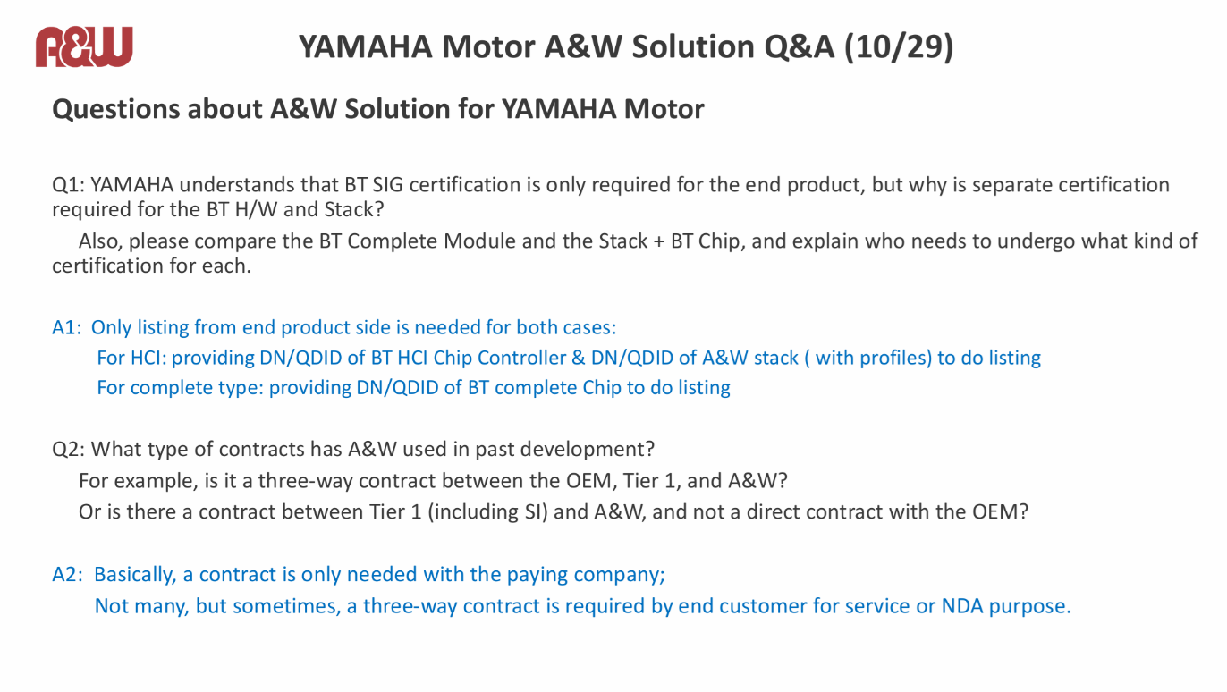
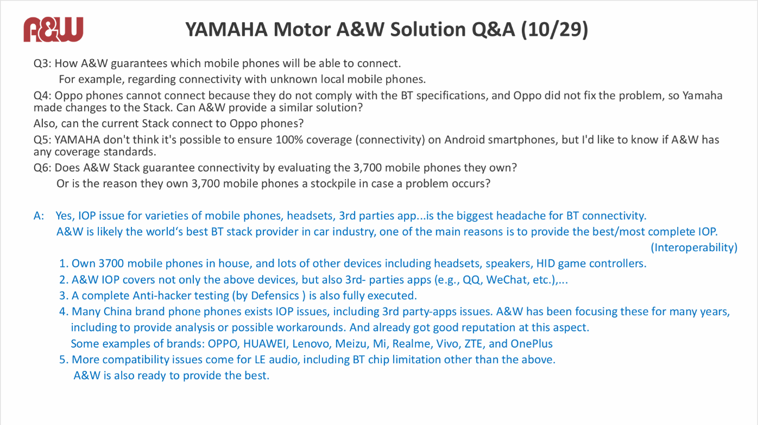
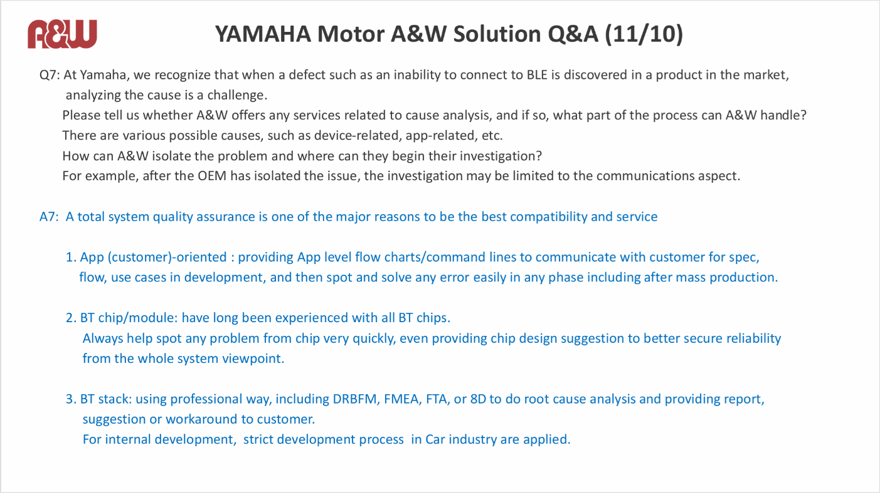
- YAMAHA has understood the Q&A from the previous response.
- Shibuya-san had previously heard that A&W owns 3,700 phones and purchases new phones every year, but asked if there were any internal regulations for the phones that are actually evaluated.
- Mingfa-san replied that the company's internal QA team conducts market research for each quark and selects and evaluates around 100 phones each year.
- Shibuya-san now understood why, based on the above results, they own a cumulative total of 3,700 phones.
- He explained that, for example, they also purchase and evaluate special phones for the Indian market.
- I explained that A&W POC is a tool that checks the functionality and performance of individual BT chips in advance.
- Kumagai-san said that he had no further questions about the explanation given so far.
- I introduced that A&W's 2Wheel Solution can provide solutions such as mirroring in addition to CP/AA.
- We showed the A&W 2Wheel Demo Video and promoted the fact that A&W can provide system support beyond the BT stack.
- I gave an overview of A&W's Command Line Solution.
- Mingfa-san pointed out that the Command Line Solution is an MCU solution targeting BLE, etc., and that it may not be suitable for Yamaha.
- I explained that A&W's Command Line Solution is effective for Tier 1s who are unfamiliar with BT specifications, as it can simplify development.
- I explained that the background to the development of the Command Line Solution was the benefits of providing vendors who use the BT complete module with BT control S/W in addition to the BT stack using an inexpensive HCI module.
- Shibuya-san wanted to know the approximate royalty cost so he could promote the benefits of adopting A&W Stack internally. He imagined that A&W BT Stack + HCI module would be cheaper than the BT complete module, but he wanted to know how much of a difference there would be.

[About ECNR]
- Mingfa-san asked if I needed to explain ECNR.
- I explained that Kaga FEI had already introduced AI ECNR during my previous visit, and that Yamaha was currently considering ECNR for natural language recognition like Siri.
- I asked Yamaha whether ECNR was necessary for mid-range and mass-market motorcycles.
- I explained that A&W ECNR does not have voice recognition functionality.
- Kumagai-san understood that A&W ECNR is targeted at improving call quality.
- Mingfa-san said that for two-wheel vehicles, EC is not necessary, only NR is.
- I explained that A&W ECNR is an NR function that can remove beamforming and window noise.
- I mentioned that during our previous meeting, Yamaha was concerned that, since helmet headsets also have NR functionality, applying NR twice on the device itself could have a negative impact.
- Kumagai-san understood that A&W ECNR was suitable for the CP/AA Solution.
- I have ECNR for voice recognition, but I asked if A&W ECNR is also necessary.
- Kumagai-san said that while it's not essential, CP/AA is a solution for four-wheel vehicles, and he's heard that the noise environment is even worse for two-wheel vehicles, resulting in a lower recognition rate.
- For that reason, he said that A&W ECNR might be a good idea.
- Mingfa-san recommended that, for the above system, a switch be attached to the headset or the device itself so that either could be selected.
- Mingfa-san explained that he thought the A&W ECNR on the device itself probably performed better than the headset.
- Shibuya-san agreed with Mingfa-san.
- Mingfa-san said that having ECNR on the device itself would also make sense in order to pass the CP/AA ITU-T test.
- Shibuya-san said that, if possible, he would like the device itself to automatically determine whether the headset has ECNR and set the switch automatically.
- Shibuya-san explained that the reason behind this request was that he assumed users would find it troublesome to switch between ECNR and NR.
- Given the above, he commented that it would be better if there was no option to turn ECNR on or off if possible.
- Mngfa-san understood the background to Yamaha's request and promised to consider whether it was possible to meet it.

[Business model discussion]
- I asked whether A&W's users would be Yamaha or Tier 1 if Yamaha were to adopt the A&W Solution.
- Kumagai-san said that Yamaha would recommend the solution to Tier 1, but that Yamaha would not become A&W's direct user.
- Kumagai-san said that Yamaha could communicate directly with A&W during development (technical aspects).
- However, he said that Tier 1 would always have to go through Tier 1 for transactional matters (procurement).
- Kumagai-san also said that Tier 1 would provide warranty coverage and deliver the product to Yamaha.
- I asked again about cost.
- Yamaha said that they would not discuss cost directly with A&W.
- I explained that depending on the Tier 1, the A&W Solution might require only the BT Stack, or it might also require CP/AA and ECNR, and that I was concerned that the cost estimates A&W would provide would differ in those cases.
- Specifically, meter vendors need CP/AA as well, while IVI vendors only need the BT Stack.
- Shibuya-san wanted to know the following image of loyalty:
Case 1: High-end products including CP/AA are expected to start with tens of thousands of units per year and continue for several years.
Case 2: BT Stack alone is also used in mid-range and popular products, so it starts with 200,000-500,000 units per year (1 million units in the happy story). Continue for several years.
- Shibuya-san said that if he received the above answer, he thought it would be possible to consider the matter internally.
- I asked Kumagai-san about his M/W cost estimate, and he said he didn't know because he had no examples.
- I explained that the biggest feature of A&W is that the royalty I was answering this time includes initial development costs and costs for specification changes.
- I explained that the warranty continues free of charge after the royalty expires.
- I explained that it was unclear whether a BT Varder like the one mentioned above exists in Japan.
- Shibuya-san asked whether the royalty would change if there was a significant increase or decrease in the initial production quantity.
- He replied that in the past, A&W would charge a royalty for the same number of units if there was a significant increase, and that it would remain the same if there was a significant decrease.
- Shibuya-san said he had heard that in other royalty projects, discounts are given if the cumulative quantity increases.
- However, he understood that A&W does not follow the above policy.
- I explained that if the SOC + BT Stack remains the same, the royalty will not change.
- However, he explained that this was a business model in which the royalty would be negotiated again if either or both of the COC and BT Chip were to change.
- Shibuya-san said that from Yamaha's perspective, a variable quantity royalty would be preferable.
- For example, if the contract initially started at 50,000 units and grew to 1 million units, a royalty of 50,000 would be high, and it would also be unfortunate if the contract was for 1 million units and the quantity was actually smaller, so he asked them to consider the above.
- Andrew-san said he wanted them to consider offering a good price from the early stages.
- Shibuya-san ultimately understood that A&W was flexible when it came to royalties.
- Andrew-san explained that the reason major IVI customers have continued to use A&W's products is because they value A&W's royalty.
- Mngfa-san emphasized that the company has a track record of being used by major Japanese customers for over 20 years.
- Mongfa-san showed a 2Wheel Demo Video and explained that A&W not only provides M/W but also has a system in place that allows them to provide support from a systems perspective.

[Future Prospects]
- I asked if there were any plans for the next product soon.
- Kumagai-san replied that next year's product plans have not yet been decided.
- Shibuya-san, however, said that there would be product improvement activities next year, and that A&W's BT Stack might be one of the themes.
- Kumagai-san asked if A&W had contact with Yamaha's Taiwan base (YMRT).
- Andrew said that he had tried in the past, but that while the Taiwan base was interested in hardware, there were few opportunities to have direct conversations about software.
- We said that if we could be introduced to YMRT, it would be no problem for A&W to contact them directly.
- Shibuya-san said that they had just started discussions with YMRT in Japan about next year's improvement activities, and that they would contact A&W if necessary.
- Kumagai-san said that he imagined the A&W BT Stack would be cheaper, but that it would depend on the response from Tier 1.

Action Item:
- A&W
  - Yamaha will add a royalty image to the Q&A sheet and respond.
  - We will continue to follow up with YAMAH Japan so that we can visit YMRT (Yamaha Taiwan) next year.

