Customer: Novoton Technology Japan Co., Ltd.
Meeting Day : 2025.12.15
Meeting Method : Visit
Meeting Agenda : Future support for Shimano MCU and joint development of the next Novoton MCU
Meeting Purpose : Same as above
Whether the results of the meeting achieved the expected purpose: Yes

Participants:
- Novoton Technology Japan Co., Ltd. :
MCU Product Development Department
Kazuki Yoshioka : MCU GM
Kiyoshi Nozu : MCU Manager
: MCU Engineer

Summary:
- Nuvoton introduced the product development schedule for this and the next round
【Shimano MCU: November 18: Beta version delivered】
- January 2026: ES1 after follow-up evaluation by December 2026
- February 2026: ES2 re-evaluation (but no software changes), March 2026 completion
- April 2026: ES2 provided
- January 2027: MP planned ＞Requests to A&W
1. 1 year of continued support for the above follow-up evaluation, ES2 verification, etc.
2. Specifications for custom profiles changed, etc.
【Next-generation standard MCU】
- FY2028 MP model (target: air conditioners, washing machines, refrigerators, etc)
- Q2 2026: Prototype ES Chip launched
- Q2 2027: Prototype ES2 Chip launch
- Limiting BLE functionality and reducing ROM/RAM size
【Requests to A&W】
1. GUI tool development support
2. Free RTOS support
3. Cooperation in feasibility testing of channel sounding and Matter functions
- *Intention to confirm functionality even with the addition of an external chip
- Perry-san introduced A&W's consumer roadmap.
- Nuvoton's Nozu-san's main interest was BT Stack 6.0 or higher support and channel sounding.
- Nozu-san mentioned that one application of channel sounding could be to use this function in place of an air conditioner's motion sensor, for example.
- Nozu-san strongly recommended that A&W take measures to secure ownership of custom profiles with Shimano, as Nuvoton cannot be involved in the ownership of such profiles.(This is to prevent Shimano from reusing custom profiles without permission.)
- Nozu-san has requested that Shimano respond to the issue of the beta version provided to them.
- Nozu-san has asked A&W, which prides itself on Automotive quality, evaluate the issue and provide guidance on how to prevent recurrence. (I will create a Q&A sheet at a later date and obtain responses from HQ.)
- Morishita-san has confirmed the background behind the current royalty request for cost reductions, and he will coordinate with HQ.
Detail:
【Meeting agenda and requests to A&W】
- Nozu-san from Nuvoton introduced the following meeting agenda:
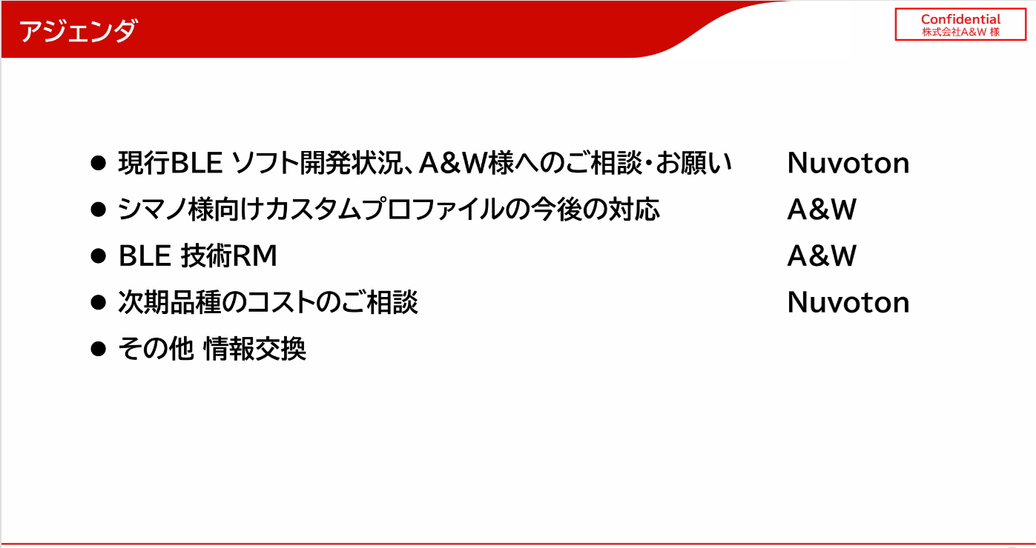
- Nozu-san expressed his gratitude for the current software development status of the BLE-equipped MCU and for submitting the beta version to Shimano on November 28th.
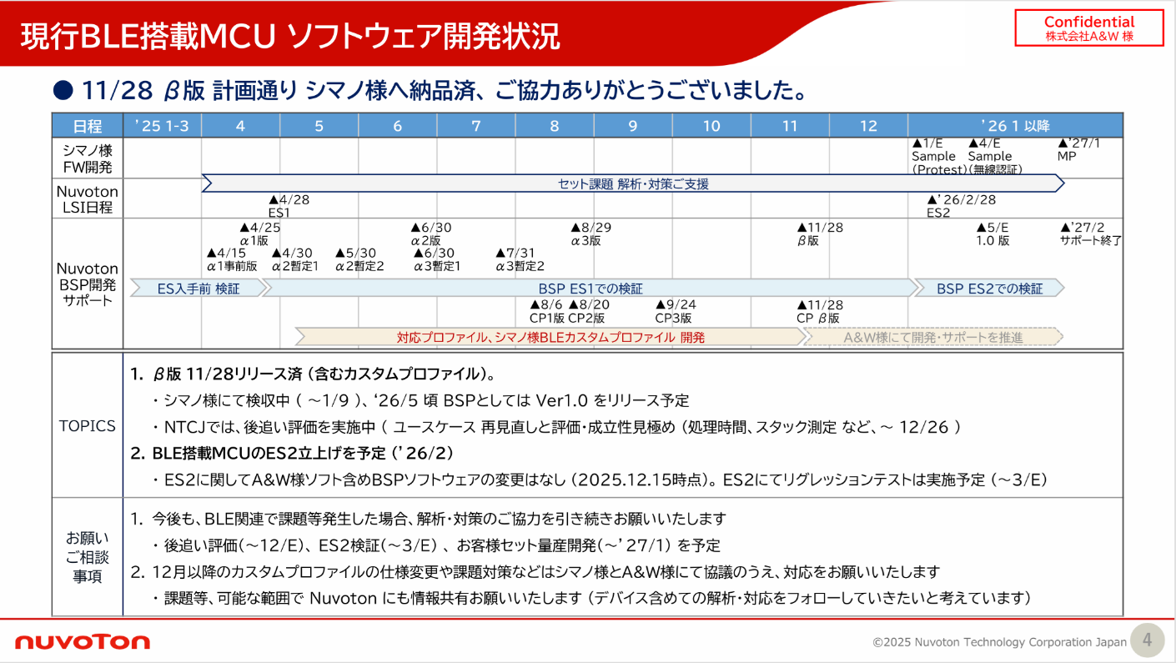
- Nozu-san outlined the following Shimano development schedule for next year:
>2026/1/E: Sample (ProTEST)
>2026/4/E: Sample (Wireless Certification)
>2027/4: MP
- Nozu-san introduced the following in terms of Novoton BSP support:
>2026/5/E: Version 1.0 released
>2027/5: End of support
- Nozu-san introduced the topics listed in the materials and the matters he wanted to discuss with A&W.
- In his consultation, Nozu-san requested that A&W continue to provide support for another year or so.
- Nozu-san said that it is unclear what kind of agreement Shimano and A&W will enter into regarding custom profiles, but that Nuvoton will cooperate, so he requested that information be shared to the extent possible.
- Nozu-san strongly recommended that Shimano and A&W enter into a licensing agreement.

【Development of next-generation BLE-equipped MCU】
- In the document below, Nozu-san explains their development plans for the next BLE-equipped MCU and their requests to A&W.
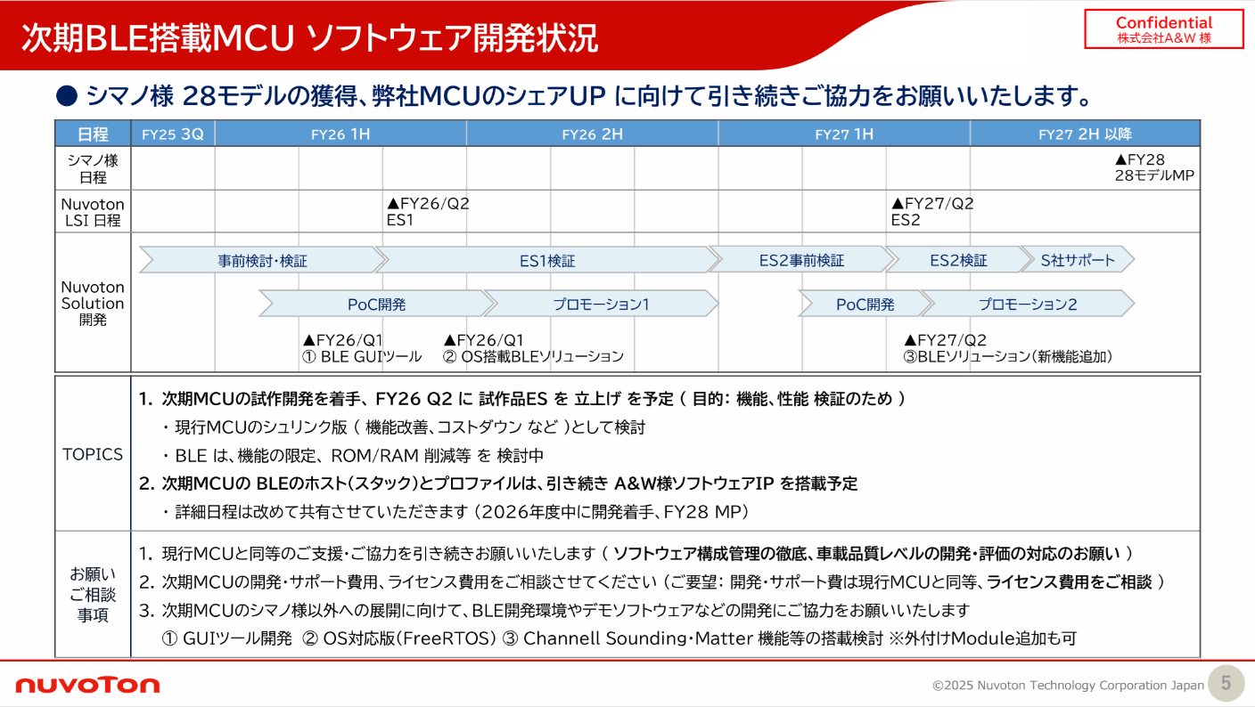
- Nozu-san requested A&W technical support for shrink products in order to continue receiving orders for Shimano products from fiscal year 2016 onwards.
- Nozu-san wants to proceed with POC development and promotion for the next MCU in parallel with chip development.
- Nozu-san introduced the topics listed in the materials and the matters he wanted to discuss with A&W.
- Nozu-san said that they plan to include the A&W BT Stack in their next-generation BLE Chip.
- However, they intend to discuss with A&W whether or not BLE 6.0 will be included.
- Nozu-san explained that he would like to request the following three things from A&W for the development of the next-generation BLE chip.
1. Nuvoton would like A&W to continue providing the same level of support and cooperation as with the current MCU (thorough software configuration management, development and evaluation at automotive quality level).
2. Nuvoton would like to discuss the development, support, and license fees for the next-generation MCU (request: development and support fees will be the same as for the current MCU, license fees will be negotiable).
3. In preparation for expanding the next-generation MCU beyond Shimano, he would like A&W to cooperate in the development of a BLE development environment and demo software.
- ① GUI tool development, ② OS-compatible version (FreeRTOS), ③ Consideration of incorporating Channel Sounding, Matter, and other features. *External modules are also acceptable.
- Nozu-san said that he thinks it would be difficult to support channel sounding and matter with the Nuvoton BLE MCU's BT5.2, but would like to implement it if it is possible to add external hardware and consider the technology.
- Nozu-san hopes that the above channel sounding and matter will align with A&W's technology roadmap.
- Nozu-san hopes that A&W's expertise in BT connectivity and performance will enable the product to have better specifications than its competitors.
【A&W Technology Roadmap Introduction】
- Perry-san explained the consumer A&W technology roadmap in the following document.
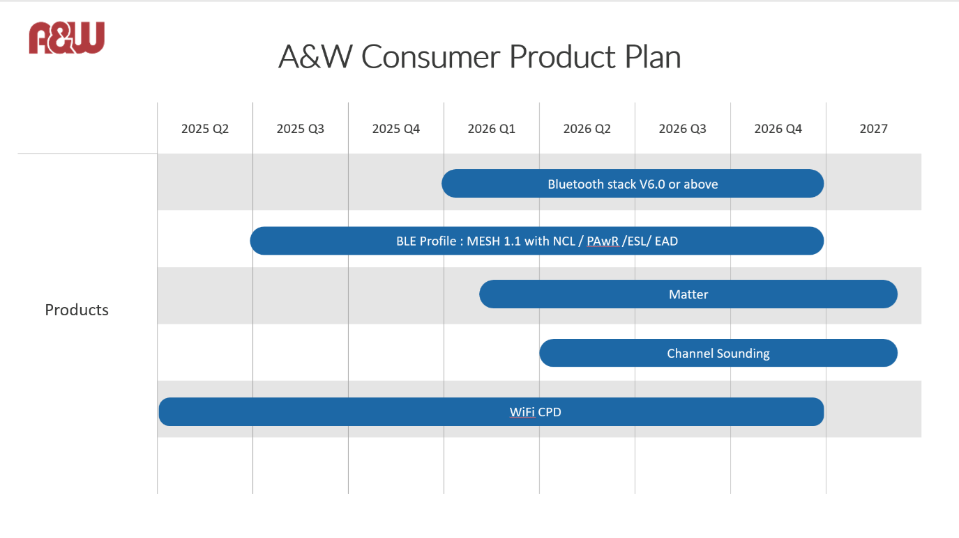
- Perry-san explained the details of the roadmap in Chinese, and Bi translated it into Japanese.
1. BLE 6.0/6.2 Stack Roadmap:
- AW explained its development plans for the Bluetooth 6.0/6.2 stack, sharing with Novoton that it plans to release version 6.0 or higher by 2026. Since major specification changes are expected if BLE 6.0 compatibility is required for the next-generation MCU, Novoton indicated that it will proceed in consultation with AW.
2. Detailed Discussion of Channel Sounding:
- A&W provided a detailed explanation of how to implement and evaluate channel sounding functions, the use of HCI-type and microcontroller-embedded chips, collaboration with external SOCs, and future technical verification and solution development.
- AW explained that currently, only microcontroller-embedded chips are available that support channel sounding, and that it plans to begin verification using Infineon's new chips from Q2 2026. AW explained that an HCI-type channel sounding-compatible chip is required, and that evaluation can be performed during the development phase using a PC simulator or external SOC/MCU.
- A&W explained its intention to investigate and verify methods for controlling the channel sounding function from an external SOC or MCU, and to utilize a vendor-provided SDK to investigate and verify the interface.
- Novoton expressed its intention to actively evaluate A&W's modules and solutions and collaborate on development in order to reflect the results of technical verification in the requirements for the next-generation MCU.
- AW will share information regarding channel sounding-compatible modules and technologies to the extent possible.
3. Examination of New Wi-Fi/BLE Functions and In-Vehicle Technology:
- Discussion included technical verification and prototype status of new Wi-Fi-based in-vehicle functions (CPD: child/pet detection, etc.), the BLE 6.0/6.2 stack roadmap, and potential integration with third-party modules.
- A&W is currently developing a prototype of a Wi-Fi-based child/pet detection function (CPD) for in-vehicle applications.
- While there are CPDs that utilize cameras, radar, and UWB, AW is developing a Wi-Fi-based CPD. Materials and videos of the CPD prototype will sent to Nuvoton.
4. Integration with Third-Party Modules and Technical Verification:
- -A&W also mentioned the possibility of connecting third-party Wi-Fi/BLE modules to its own microcontrollers for technical verification and the possibility of using A&W technology for demonstrations.
- Nuvoton requested information sharing regarding technologies developed for in-vehicle applications, expressing their intention to use them for evaluation and demonstrations at Nuvoton.

【A&W and Shimano contract for custom profiles for Shimano】
- Nozu-san strongly recommended that Shimano enter into a licensing agreement to prevent future use of the custom profile on other MCU Vendor Chips, since it was developed jointly by A&W and Shimano and does not have any ownership rights. (Since there are no restrictions on the custom profile.)
- He is concerned that development will end around May 2026, when the NDA between the three companies will expire.
- Morisita-san will consider the above and discuss how to respond with headquarters.
- Morisita-san explained to Perry-san that Shimano has requested additional custom profiles, which require urgent consideration.
- Nozu-san was concerned that if A&W provided Shimano with custom profiles in C source code, changing the API could make them applicable to other devices.
- Morisita-san promised to respond, but explained that discussions with Shimano had not progressed.
- Morisita-san said that the BLE Stack provided by Shimano via Nuvoton only granted Shimano the right to use it, and that Nuvoton retained ownership.
- However, custom profiles were requested by Shimano, and do not fall under the above category, so he pointed out that the situation would be unstable unless A&W signed a contract with Shimano.

【Request for cost reduction regarding royalties】
- Nozu-san said that due to fierce cost competition with competitors, he would like to request a royalty cost reduction from A&W.
- Nozu-san wanted A&W to present the terms of the cost reduction.
- Morisita-san conveyed Nuvoton's request to Perry-san and asked him to consider it.
- Nozu-san is awaiting A&W's response.
- I asked about the current royalty agreement and whether the cost reduction would affect price competition with competitors.
- Nozu-san said that Nuvoton has quoted a price including the BT Stack, but he doesn't know if competitors quote prices that include the stack.
- One idea for the next product is to outsource the BT Stack and consider doing business with the Nuvoton Chip alone.
- I explained that if the BT Stack were to be outsourced, the royalty would be significantly higher than the price currently offered by Nuvoton.
- Nozu-san understands that the current A&W royalty rate is exceptional, but he would like to request cooperation due to competition.

【GUI tool confirmation】
- I asked if the GUI tool Nuvoton envisioned was something like a tool that automatically generates drivers for peripheral functions provided by MCU vendors.
- Nozu-san said that my understanding was correct, and that what he expected from A&W was a tool that would automatically generate binary files by selecting BT stack functions.
- Nozu-san said it was something that customers could use without having to think about BT stack development.
- I asked if A&W had received the specific requirements from Nuvoton, and Nozu-san replied that they would like to consider A&W's proposal.
- I checked the specifications of a tool from Nuvoton's competitor, Silicon Lab.
- Nuvoton didn't provide specific details, but said that the idea was that it would automatically generate the stack that customers needed.
- Shimano had also previously told me that when developing multiple models, since BT functions differ depending on the model, if the functions were divided by model using the above tool, only the models that adopted those functions could be updated when the stack was updated.

Action Item:
- A&W
  - We will respond to the various requests received this time.
  - Separate meetings will be arranged for items that require detailed discussion.

