Customer: Silex Technology, Inc.
Meeting Day : 2025.12.16
Meeting Method : Visit
Meeting Agenda : The visit was to discuss reflections on past Silex projects and future collaborations.
Meeting Purpose : Same as above
Whether the results of the meeting achieved the expected purpose: Yes

Participants:
- Silex Technology, Inc. :
Global Marketing Center
Kiji Takahiro: Senior Product Manager
R&D Center Unit 1
Tetsuya Kuwana: Manager

Summary:
- Kiji-san from Silex learned that I had joined A&W in February and explained the past status of A&W and Silex's business.
- Currently, PFU and AlphaTheta are their largest customers.

<Regarding the PFU Project>
- Morisita-san apologized for the inconvenience caused by A&W in PFU's business and confirmed Silex's dissatisfaction in order to continue the business.
- Kuwana-san explained the following three points and requested future improvements:
(1) Silex would like you to thoroughly consider the technical requirements before deciding whether or not to respond to the technical requirements. (The FPU development took longer than originally planned.)
(2) Silex would like the project manager to assign someone with a strong technical background as their contact point. (The project manager who attended the regular technical meeting took all the matters home with him, making it impossible to make a decision at the meeting.)
(3) There was an atmosphere that answers could not be given without confirming with higher-level managers regarding M/W release dates, and I would like to see more internal collaboration.

<Collaboration Discussion for New Projects>
- Morisita-san requested that A&W accompany Silax to a BT custmer for a project.
- Prior to the custmer visit, Silax requested a summary of a presentation document to gauge the client's interest in the A&W Solution.
- Silax used this document to gauge the custamer's interest and, if interested, introduced A&W.

<Introduction of the A&W Industrial Roadmap>
- Perry-san introduced the A&W Industrial Roadmap, and I added additional comments in Japanese.
- Silex's biggest concerns were the next BT version 6.x and channel sounding.
- However, channel sounding is not yet supported by NXP's chips, so it depends on the chip release.
- Silex asked about specific application examples of channel sounding and WiFi CPD.
- If Silex customers show interest in Wifi CPD, we can introduce them to the A&W Solution.
- Perry-san explained in-vehicle application examples, and Silax understood.
- I gave an overview of the Command Line Solution as one of our new businesses.
- However, Silex commented that few Silex customers request the Command Line Solution.
- Finally, both parties agreed to continue their collaboration next year.

Detail:
【Self-introduction & Past relationship between A&W and Silex】
- I introduced myself and explained how I came to work at A&W.
- I explained that I had joined A&W in February and was not familiar with Silex's past history.
- Kiji-san kindly explained the past relationship between A&W and Silex.
- Silex previously sold Wi-Fi modules using Qualcomm chip sets to important customers.
- Due to the semiconductor crisis, chip sets became unavailable and Silex began handling NXP chips as a second source.
- A Silex customer was looking for an LE-Audio solution, and since NXP had the chip, Silex developed and sold modules using the NXP chip.
- Silex's weakness was in the Bluetooth department, so NXP introduced them to A&W, which developed their first company (PFU) and second company (AliFaTheta).
- Morishita-san apologized for the trouble A&W had caused in the past with its development.
- Morishita-san connected to HQ Perry-san via web conference and explained the situation.
- Morishita-san explained that HQ was on lunch break and that he would join in 30 minutes.

【Summary of PFU development projects】
- Morishita-san asked about Silex's complaints and requirements during the PFU development.
- PFU project had already begun when Morishita-san joined the company.
- Araki explained that when he left the company, he was handed over responsibility to be careful about this issue.
- Taiwan headquarters hadn't expected the workload to be so heavy.
- He also mentioned that he had heard that PFU was slow to disclose information.
- After joining the company, Morishita-san felt that A&W executives had agreed to everything from the beginning.
- As a result, Morishita-san warned A&W executives that if things continued as they were, it could lead to compensation issues.
- Taiwan headquarters believes that things have since improved.
- Morishita-san asked what improvements are needed to continue the collaboration.
- Morishita-san said that the problem last time was that A&W didn't fully understand the work involved.
- Morisita-san asked Kuwana-san for his honest opinion.
- Kuwana-san said that the biggest difference with A&W in this development was the following:
- PFU had insisted from the beginning that they wanted all the same interfaces as Bluesy.
- However, A&W had been of the opinion that only the necessary components were needed, and Kuwana-san recognized that this was contradictory to the above request.
- Incidentally, there was also a misunderstanding between PFU and Silex; initially, PFU had told him that there were applications that worked over Bluetooth, but in fact there were none.
- Kuwana-san said that due to the discrepancy in understanding between the above companies, A&W misunderstood that it was enough if certain functions worked.
- He also said that he thought that from the beginning, the discrepancy in understanding between the two companies led A&W to misunderstand that it was okay as long as certain functions worked.
- He also recognized from the beginning that Bluesy would be difficult, but after hearing from A&W that there would be no problems, he entrusted the development to them with peace of mind.
- However, in the end, Silex also ended up providing some support for the development.
- He said that if it had been clear from the beginning that the project would be difficult, they could have considered establishing a different development structure.
- According to Kuwana-san, A&W's strength is its in-house developed stack, and he was advised that in cases like this one, such as dealing with Bluesy, it would be better to consider having a Silex subsidiary handle the work.
- Morisita-san explained that Araki had told him to be careful because the workload was heavy.
- Head office did not understand this.
- Morisita-san was stationed at Silex for two weeks with JR, and described him as excellent.
- Morisita-san asked what the female project manager (Zinnia) was like.
- Kuwana-san said that they had held several technical meetings, but because she was not an engineer, decisions were not made at the meetings and everything had to be taken home, which he hoped would be improved.
- Of course, the contact person does not have to be an engineer, but he would like someone with the knowledge to participate in meetings to be assigned.
- Kuwana-san also said that he would like to request an improvement in the fact that there are matters that even JR cannot decide and that can only be decided by the executive Mihgfa.
- To put it bluntly, it seemed like there was a lack of coordination within A&W.
- Morisita-san also mentioned that Zinnia had sometimes not received a response by the promised deadline, which had led to complaints.
- Morisita-san said that if submissions were delayed, an announcement should be made to the customer in advance.
- Morisita-san said that A&W's track record is such that its automotive customers have a good reputation for its support when a good project manager is assigned.
- The management system of headquarters' executives is also an issue, but he said that this time the project manager had improved.
- Morisita-san explained that the development schedule is not decided by executives.
- Morisita-san explained that if the project manager had been different, the results would have been different.
- Kuwana-san said that Zinnia initially said he was feeling unwell and asked if he was okay, but Morisita-san refused to come to work and eventually left the office.
- Kuwana-san was worried that he might have caused trouble.
- Morisita-san asked if the sales performance was perfect.

【Future collaboration discussions】
- Morisita-san requested that A&W accompany the customer if there are any future BT projects with Silex customers.
- Kiji-san said that because Silex does not have BT know-how, there will be no change to the policy of introducing A&W first when there is a request for a stack for a Wifi/BT combo module equipped with an NXP chip.
- Kiji-san said that if there was a simple document outlining the A&W solution, Silex would be able to confirm the customer's requirements in advance, and if detailed discussions were necessary, he would like A&W to accompany them.
- In the previous project with PFU and AlphaTheta, Silex acted as an intermediary during the initial requirements definition, and he recognizes that there were some points where the detailed technical requirements were not communicated.
- For this reason, he requested that in the future, the three companies discuss and define the requirements at the kickoff.
- Morisita-san asked me to explain the possibility of a command line solution.

【Possibility of command line solution】
- Although I was skeptical about whether A&W's command line solution would be an advantage in expanding sales of Silex products, I gave an overview.
- I explained that the reason for this was that products without Wi-Fi, unlike the Alpha Theta, were being considered for a BT complete module.
- I asked if Silex had a BT-only module, and Kiji said they didn't.
- Silex said that Wi-Fi is its main focus, with BT being an accessory product for most products.
- Silex manufactures modules in Japan and prioritizes quality in its business, so they aren't good at cost-sensitive businesses like BT alone.
- Kiji said that Wi-Fi/BT combo modules are rare, and that while there are some customers who only use BT, they are not very common.
- If the customer's internal ROM/RAM does not provide enough functionality, they can handle it by installing a stack on the SOC side.
- However, I explained that the reason they wanted to adopt BT Complete this time was because they did not want to allocate engineering resources to host-side development.
- I also explained that they are currently introducing the command line solution.
- I gave an overview of the Command Line Solution.
- However, I explained that the Command Line Solution is limited by the performance of the Host Chip and the capacity of ROM/RAM.
- Kiji-san said that if customers could properly understand the Command Line Solution, there was a possibility that they would be interested.
- Kawana-san commented that there were not many Silex customers for whom the Command Line Solution would be advantageous.
- Kawana-san said that Silex customers were at either extreme, with some wanting to leave all BT development to the company, and others wanting to do it in-house.
- I asked whether the Silex Wifi/BT combo module has two built-in MCUs, one for Wifi and one for BT.
- Kiji-san answered that it has one built-in MCU.

【Introducing the A&W Industry Roadmap】
- Morisita-san invited HQ Perry-san to join the web conference, and I also joined online and asked him to share materials.
- I connected to the web conference and shared the roadmap.
- Perry-san introduced A&W's consumer roadmap in the following document.
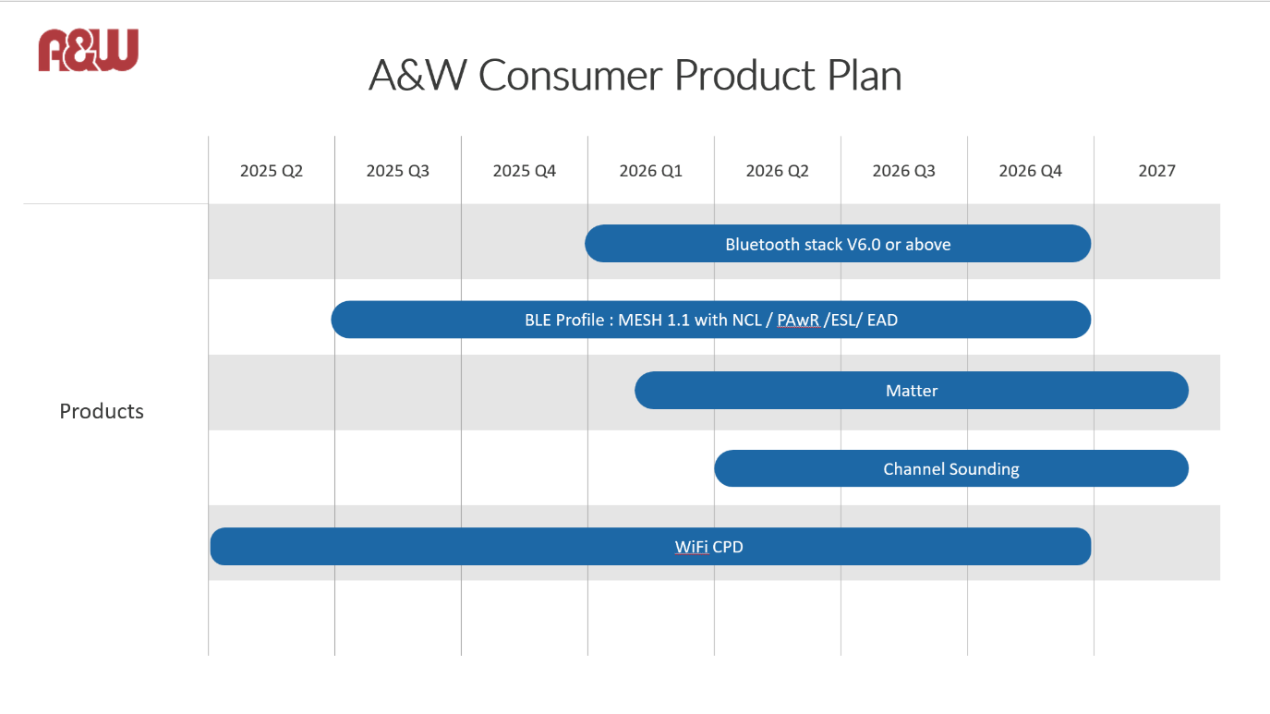
- Perry-san explained each item in detail.
- I added additional explanations in Japanese.
- Kiji-san said that Silex was interested in using channel sounding for the location function.
- However, they would only consider it if channel sounding (compatible with BT6.0) were currently released for the NXP Chip.
- Kiji-san said that if they were to implement the channel sounding function, they would like to request A&W's cooperation.
- I introduced a case study of a channel sounding inquiry in the automotive field.
- Perry-san explained that the target of the Wi-Fi CPD function was to detect abandoned children within the company.
- Perry-san explained that while the above function is currently implemented using cameras and UWB, A&W is aiming to implement it using Wi-Fi.
- I asked whether Silex was also considering developing a CPD function.
- Kiji-san replied that Silex's development style is to implement the application portion in collaboration with partners, and that Silex does not develop CPD functions itself.
- Silex said it would like to introduce A&W if its sensing technology meets customer requirements.
- Perry-san said that he wanted to introduce Silex to new technologies developed by A&W, not just CPD.
- He said that if Silex had any new technology requests, they should definitely contact A&W.
- I asked if Silex could prepare a one-page introduction document to introduce itself to customers.
- I asked if NXP had any plans to release an HCI-type channel sounding chip, to which Silex replied that they had not heard of it.
- I asked which solution in the current roadmap interested Silex the most.
- Kiji-san replied that first, he was most interested in the BT6.0 specification, followed by channel sounding.
- Silex said that they would not be able to support channel sounding unless NXP released the chip.
- Perry-san mentioned that there was talk that NXP would release a channel sounding chip at the end of next year.

【A&W support for small lot customers】
- Kuwana-san said that many Silex customers are small-lot orders, and asked if A&W could accommodate them.
- Kuwana-san commented that if A&W could accommodate small-lot orders, it would be easier to introduce them to the company.
- Morisita-san asked Perry-san in Chinese if A&W could support small-lot orders.
- Perry-san replied in Chinese, and Morisita-san explained that consultations were possible in Japanese.
- He also said that if the stack is not special, it can be considered as part of a whole and handled accordingly.
- I asked whether Silex products are sold as standard products for small-lot orders.
- Kiji-san replied that they do accommodate small-lot orders with some change requests.
- Kiji-san said he would like to discuss various customer requirements with A&W.
- Kiji-san values ​​face-to-face partners, so he said he would like to continue his relationship with A&W.

Action Item:
- A&W
  - Compile the questions raised during the meeting into a Q&A sheet and request answers from head office.
  - Confirm and respond to whether A&W can handle POC development before acquiring commercial rights to the OEM client.
  - At the next visit, show the CP/AA demo and discuss more specific collaboration.

