Customer: JVC KENWOOD
Meeting Day : 2026.01.09
Meeting Method : Visit
Meeting Agenda : We visited Ishibashi-san, a radio advanced technology developer introduced by JKC Tsuchida-san, to confirm the background of the EC introduction and introduce A&W EC.
Whether the results of the meeting achieved the expected purpose: Yes

Participants:
- JVCKENWOOD Corporation:
Engineering & Design Division,
Advanced Engineering Department 2 Group3
  - Jun Ishibashi : Expert

Summary:
- JKC is currently developing a professional transceiver according to the following schedule.
> March 2026/E: Fix system software and begin evaluation
> April 2026/E: Evaluation completed
> June 2026/E: Start mass production
*Planned number of units: Domestic: 82,170/6Y; Overseas: This is a new product. Past performance figures for North America have shown that the number of units sold is several times higher than that of Japan, but details are unknown.
- Product configuration: SOC: QCM2290 (with 4 ARM A53 cores), ROM: 1Gbit, RAM: 4Gbit.
- JKC initially planned to implement EC using the SOC's built-in DSP. However, during the EC evaluation phase last month, it was discovered that the EC provided by the SCO vendor did not meet customer specifications.
- JKC urgently needed to reselect an EC, and requested A&W to introduce an EC.
- JKC is not bound by Alngo ECNR and would be happy to adopt A&W ECNR if it meets the required specifications and the cost is not an issue.
- Due to the short development deadline, I strongly recommend A&W ECNR due to its comprehensive support.
- I would like to receive prompt responses to the following questions from JKC in order to finalize the adoption.
Q1: Are there any sampling frequency restrictions on A&W ECNR?
(Which frequencies are supported?: Hopefully an answer will be given by the 13th.)
Q2: Please provide a comparison table of A&W's specifications against the following specifications on the Alango website. (Hopefully an answer will be given by the 13th.)
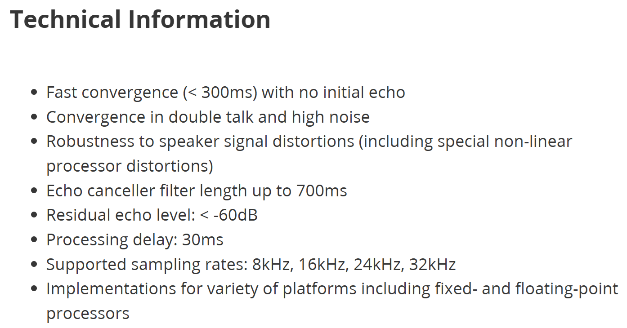
Q3: Quote response (Morishita-san will be interviewed for detailed requirements and will respond by the 15th.)
- JKC has already received an EC quote from one domestic company (obtained early in development).
- In addition to the above, the SOC vendor has introduced us to another domestic vendor, and we are planning a meeting next week.
- Both companies require NRE and royalties.
- I checked the EC track record for past products and found that JKC's previous products did not include two-way communication, so EC was not implemented.
- I confirmed the need for NR, and JKC replied that NR is achieved using the DSP built into the SOC.
- I checked the demand for BT, and JKC had a department considering BT, and they promised to introduce me to A&W if there was a need.
- This is a great opportunity to bring A&W ECNR into the JKC Professional Transceiver.
- Customer OS is Linux 5.4.

Detailed discussion:
[EC (M/W) equipped products & request confirmation]
- I asked what product was planned to feature EC (M/W).
- Ishibashi-san answered that it was a professional handheld transceiver.
- Ishibashi-san said that there were no existing products that used EC.
(Existing products do not transmit and receive simultaneously, so there is no echo.)
(This product has a function that allows you to hear your own voice from your own device.)
- Ishibashi-san replied that since this product has simultaneous communication functionality, they are considering EC.
- Ishibashi-san said that they initially planned to implement the function using EC (M/W) provided by the DSP within the SOC.
- However, earlier this year, it became clear that the built-in DSP could not meet the EC requirements.
- As a result, they said they were quickly considering implementing EC in the SOC's Core CPU.
- I asked whether it had NR functionality, and Ishibashi-san replied that it would be implemented using the built-in DSP's M/W.
- I then asked which SOC would be used in the professional handheld transceiver.
- Ishibashi-san replied that it was an SOC equipped with four CoreTX A53 chips.
- I checked the OS and Ishibashi-san answered Linux Ver5.4.
- I checked the development status, and Ishibashi-san said the design was almost complete, and the problem was discovered when EC evaluation began.
- I confirmed the development schedule, and Ishibashi-san replied as follows:
> March 2026: M/W implementation, evaluation begins
> April 2026: Design complete
> June 2026: Mass production begins
> Planned product volume: 82,170 units/6 years (Japan only); overseas expansion from 2027 onwards is planned but undetermined (the hardware configuration will be the same, with software adapted to each country).
- I then checked the production volume of standard commercial transceivers.
- Ishibashi-san said that North America produces far more units than Japan.
- Morisita-san asked if this radio was for leisure use.
- Ishibashi-san answered hotels, disaster prevention radios for local governments, railway companies, etc.
- Morisita-san heard that the reason JKC is doing well in North America is because of its surveillance cameras, but asked if the sales channels are the same, to which Ishibashi-san replied that they are not.

[A&W EC Introduction]
- I explained that JKC's automotive department adopted Alango ECNR at the recommendation of SI (Neusoft).
- I explained that A&W has commercialized its own ECNR, and that if Ishibashi-san wasn't too concerned, A&W ECNR would be superior to Alngo ECNR in the following ways:
>On-site support
>Loyalty
>Provision of various detailed tools and response to specification changes, etc.
- Ishibashi-san explained that the selection process was flat and that the required performance was unclear.
- I confirmed their requirements, and Ishibashi-san wanted to choose the solution that could be implemented as quickly as possible.
- I explained that A&W EC could provide the fastest solution because it handles everything in-house.
- I explained that Alango EC would likely take longer to implement because it would require sharing customer information and waiting for a response.
- I strongly recommended A&W EC as the fastest option.
- Ishibashi-san requested that, if possible, they proceed in parallel with Alango.
- Ihsibashi-san said he was also contacting competitors.
- I asked if there were any restrictions on the A53 CPU, such as a certain MHz at which the EC would need to operate for the system to function.
- Ihsibashi-san replied that he didn't know, as this was his first time installing it.
- Ihsibashi-san said that even if the EC worked, he didn't think it would have any impact on the system.
- I asked A&W EC to consider it if its performance was comparable to Alango EC.
- I would also provide an adjustment tool for A&W EC, but said that customization was also possible if necessary.
- I confirmed the possibility of implementing EC using the SOC's built-in DSP.
- Ishibashi-san said that using the built-in DSP would require a separate contract with the SOC vendor, so he decided not to use it this time.
- Ishibashi-san asked why he wanted to know the SOC information, and replied that he wanted to know because A&W's development style involves evaluating and supporting in the same environment as the customer.
- Ishibashi-san said that he did not want to carelessly disclose SOC information.
- I asked to be allowed to consult again if any necessary situation arose.
- Ishibashi-san said that he intended to fix the software and begin evaluation in March.
- I asked that the Taiwan headquarters be closed for the Lunar New Year in mid-February, so that the meeting and decision could be made early.
- I had also dispatched engineers from Taiwan to make adjustments to Alango ECNR, so I asked that if a similar response was necessary, a decision could be made as soon as possible.

[A&W business model introduction]
- I explained the details of A&W's business model.
- Ishibashi-san understood that A&W EC would provide various support services solely through royalty payments (unless the SOC was changed).
- Ishibashi-san requested a quote as soon as possible, and Morishita-san consulted with Pert-san online and promised to respond by Wednesday the 14th.
- Ishibashi-san explained that competitors offer NRE + royalty payments, but that royalty payments have a quantity table, and they would provide quotes that become cheaper as the quantity increases.
- He said that he didn't need A&W's NRE, but would like a royalty table response based on quantity requirements.
- Morishita-san explained that A&W offers various services free of charge.
- I explained that we also provided free ECNR adjustment support to the automotive department.
- I suggested that the automotive department could confirm the Alango ECNR royalty concept.
- I explained that we plan to introduce the A&W ECNR to the Advanced Development Division 1's automotive department next week.
[Q&A]
- Ishibashi-san asked if there were any restrictions on the audio sampling frequency of the A&W EC.
- I asked what the sampling frequency required for this product was.
- Ishibashi-san said that even if the desired sampling frequency is not currently supported, due to development period constraints, they are considering using a sampling rate converter to convert to a frequency supported by the EC.
- Competitor companies also have the same conditions.
- Ishibashi-san said that the performance of the Alango EC is listed on the website, but he wanted to compare the performance of the A&W EC using the same criteria, so he requested a table.
- Ishibashi-san said that since he is not an expert on ECs, the catalog values ​​are a rough guide for selection.
- Morishita-san again, at Perry-san's instruction, strongly requested to know the model name of the SOC.
- Ishibashi-san gave up and answered QCM2290.
- Ishibashi-san requested a quote as soon as possible, and Morishita-san promised to respond on Wednesday.
- Ihsibashi-san said that cost was also an important factor in the selection process.

[A&W Bluetooth Introduction]
- Ishibashi-san said he was also interested in A&W's Bluetooth solution.
- I explained that A&W is a specialized Bluetooth vendor.
- I said that the Bluetooth business model is the same as what I explained at the EC.
- Ishibashi-san understood the outline, and since there was a Bluetooth representative in the same department, he said he would check if the person was interested.
- Ishibashi-san thought A&W's BT came in headsets and audio gateways, and that Navi's BT was a headset, but asked if an audio gateway was also possible.
- Morishita-san replied that they had experience installing a BT stack in a walkie-talkie and connecting it to a headset.
- Ishibashi-san understood that the A&W BT stack was compatible with audio gateways.
- I asked if they could introduce me to a Bluetooth representative and introduce me to the A&W BT stack.
- Ishibashi-san said that someone in the same department was considering Bluetooth for headsets that connect to walkie-talkies.
- He thought they were considering a Bluetooth stack provided by an SOC vendor, but he promised to check.
- I confirmed that the stack provided by the SOC vendor was free, and emphasized that in the case of A&W, it could be provided with a warranty.
- Ishibashi-san said that the above was a major advantage.
[About NDA]
- Ishibashi-san had concerns about the NDAs with A&W and JKC, and wanted to confirm again whether the NDAs were valid.
- Ishibashi-san said that if the intended use was different, the NDAs might not be valid, so he asked for confirmation.

Action Item:
- A&W
  - Responses to questions from JKC
  - A&W EC's quotation response
  - A&W and JKC NDA validity confirmation

