Customer: JVC KENWOOD
Meeting Day : 2026.01.16
Meeting Method : Visit
Meeting Agenda : We visited the Kano-san Team, who had evaluated the Alango ECNR in the Honda DA project, to introduce the A&W ECNR.
Whether the results of the meeting achieved the expected purpose: Yes

Participants:
- JVCKENWOOD Corporation:
Engineering & Design Division,
Advanced Engineering Department 1 Group1
  - Tsuyoshi Funami : Manager
  - Satoru Hashimoto : Chief
  - Toshiaki Nagai : Chief
  - Tetsuo Tagaeto : Chief
  - Keisuke Oda : Chief

Summary:
- I confirmed their impressions of Alango ECNR with the department that previously evaluated it.
- Kano-san summarized their impressions and requests regarding Alango ECNR and promised to provide the materials at a later date.
- I introduced the overview of A&W ECNR and its support tools.
- I showed them the comparison document between Alango ECNR and A&W ECNR that I had previously provided to JKC Ishibashi-san and stated that their performance is comparable.
- JKC was very interested in A&W's autotuning tool and asked to check its detailed functions.
- If JKC were to adopt A&W ECNR, Kano-san's department would first evaluate its basic performance and usability before recommending it to the inside company.
- Based on the above, I was told that it would take some time to adopt A&W ECNR.
- Kano-san intends to evaluate A&W ECNR if they can secure the budget from next fiscal year onwards.
- I emphasized to JKC that in addition to its basic performance, the strengths of A&W ECNR lie in its various support tools and on-site support, and they understood this.

Detailed discussion:
[Background]
- We visited the Kano-san Team, who evaluated the Alango ECNR in the Honda DA project, to hear their requests for the Alango ECNR and to introduce the A&W ECNR.

[Confirming impressions and requests for Alango ECNR]
- I would like to thank Kano-sanTeam for the use and adjustment work of Alango ECNR.
- I asked Kano-san about his thoughts and requests regarding Alango ECNR.
- Kano-san is currently working on another project, so he promised to compile his requests for Alango ECNR into a document and respond to them at a later date.

[A&W ECNR Introduction]
- I confirmed that the Alango ECNR was adopted at the previous DA due to an introduction from SI's Nuesoft.
- I explained that A&W also has its own in-house developed ECNR, and explained an overview of the A&W ECNR and its differences and advantages over the Alango ECNR.
- I presented a comparison table between the Alango ECNR and the A&W ECNR that I had provided to the JKC Transceiver Department, and noted that there was no difference in performance.
- I also explained that the A&W ECNR is easier to use than the Alango ECNR tool (VCP).
- I explained that the Alango ECNR does not offer on-site support, but the A&W ECNR, like the previous one, offers comprehensive on-site support.
- I explained that customizing the A&W ECNR tool to customer requirements is possible, with the aim of shortening customers' ITU-T test times.
- I also mentioned that the A&W ECNR tool has an auto-tuning function.
- Kano-san asked what the target of this auto-tuning was.
- I promised to check the details and answer.
- Kano-san's expectation was that the parameters would be automatically adjusted and output in order to pass Apple's certification.
- I introduced an image of the settings screen in the detailed documentation for the configuration tool and auto-tuning as development tools for A&W ECNR.
- I will provide documentation for the two tools mentioned above, and will ask them to check the contents and request any questions or requests they may have.

[Alango vs A&W ECNR comparison table explanation]
- I have explained in the table below that Alango ECNR and A&W ECNR have comparable performance.
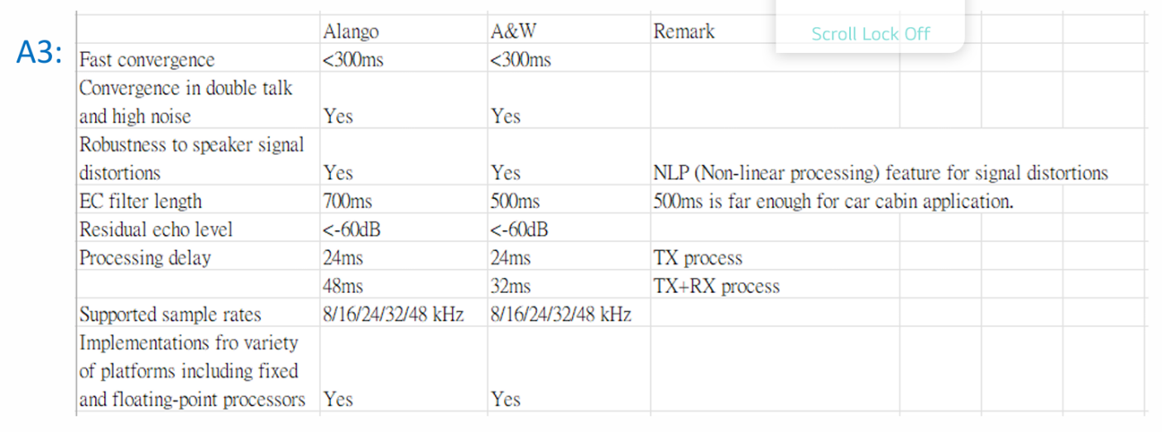
- JKC made the following comments in the table above:
>The EC filter length is longer in the Alango, but as the comment states, if 500msec is sufficient for automotive applications, then this is not a problem.
>The RX+TX process processing delay in the A&W is 32msec, which is shorter than the Alango, making it superior.

[Q&A]
- JKC asked me to tell them the conditions for the above specifications.
- For example, they wanted to know the sample frequency and the load factor on the same CPU when the EC filter length is 500 ms.
- The background to the above question was that they wanted to know what level of ECNR processing is possible with as inexpensive a CPU as possible.
- I asked whether a shorter RX+TX process processing delay meant better performance.
- I said that a shorter delay means faster responsiveness, so it is better.
- I said that if an EC filter length of 500 ms or less is sufficient, then A&W ECNR appears to be superior.
- I asked them to check the specifications of the A&W ECNR support tool and to point out any problems or requests they might have.
- JKC asked about A&W ECNR's track record (it has passed ITU-T TEST certification), and I explained that it has a proven track record with overseas products.
- I explained that domestic customers will also be participating in ITU-T TEST starting this month.
- I asked JKC to consider A&W ECNR.
- Kano-san said that first, JKC would need to make an internal decision on whether or not it was necessary to consider A&W ECNR.
- However, he was very interested in the auto-tuning function and other features that were introduced to him, and would like to evaluate them.
- Kano-san said that he would first like to get an idea of ​​what auto-tuning can do.
- I explained that if the current specifications were insufficient, adding new functions could be considered.
- Even if it was necessary, the Kano-san team would need to conduct a preliminary evaluation before incorporating it into mass-produced products.
- Tagaeto-san asked the following two questions.
>I'm very interested in the auto-tuning function. In what form can such a function be realized?
- I explained that a demonstration would be possible if he wanted more details.
>It would be very helpful if automatic adjustments to the pesca/polka score (audio quality) were possible. Is this possible?
- The materials included data that showed pesca/polka scores passed, so it would be great if the tool could make adjustments to achieve a passing score.
- Kono-san said that since the score on the receiving end is heavily dependent on the speaker, it would be great if this auto-tuning tool could make adjustments including speaker performance.
- For example, if it could be determined that a passing score was not possible with this speaker, there would be no need to make unnecessary adjustments.
- JKC said that flattening the frequency response does not necessarily mean a passing score, so I'm interested in it as it requires a lot of know-how.
- Funami-san said that he would like to improve the performance of his in-house ECNR, but promised to contact A&W again once his activity plans for next fiscal year had been clarified.
- I asked if there had been any sales pitches for ECNR other than from A&W, and he said that JKC had done one last year, but it wasn't for an automotive application.

Action Item:
- A&W
  - Responses to questions from JKC
  - Continue information exchange and promote A&W ECNR adoption.

