Customer: ALPS ALPINE
Meeting Day : 2026.01.21 : 09:30 – 17:00
Meeting Method : Visit
Meeting Agenda : On-site support for A&W ECNR ITU-T TEST for Aftermarket Display Audio (Day 1)
Whether the results of the meeting achieved the expected purpose: Yes.

Participants:
- ALPS ALPINE:
  - Masatoshi Konda – Engineer : Soft Engineering Deptment.2 (Product Manager)
  - Hidekazu Aoto – Manager : Soft Engineering Deptment.2
  - Yasuhiro Suzuki – Engineer : SI Deptment.2 (ITU-T TEST Manager)
  - Takahiro Matsumoto – Engineer : Infotainment Desige Deptment (ITU-T TEST Support)
  - 1 other ITU-T TEST support staff member

Summary:
- At ALPINE's request, we provided support using the configuration tool to fix failed sections of the BT & Carplay ITU-T TEST.
- Vehicle tested this time was the Vellfire.
- BT & Carplay adjustments were originally scheduled to take two days, but we completed the adjustments up to the Carplay WB today, and almost all tests passed.
<BT TEST>
>11.3.3(1):Spac(2±4): After adjustment: 3.72 (Pass)
>11.3.3(2):Spac(15≧): After adjustment: 15.91(Pass)
>11.4.1:Spac(0≧): After adjustment: 0.96 (Pass)
>11.3.2:Spac(3≧): After adjustment: 14.46 (Pass)
>11.5.1:Spac(13±4): After adjustment: 2.8 (ALPINE fine adjustment)
>11.11.1.2:Spac(50): After adjustment: 54(Pass)
>11.7.2(2):Spac(-30~10): Missed adjustment, check again tomorrow
<Carplay WB on Wireless >
> 11.4.2 (1): Spac (0 or greater): After adjustment: 2.23 (Pass)
> 11.7.2 (2): Spac (-30 to 10): After adjustment: 10.69 (ALPINE fine-tuning)
> 11.3.2: Spac (9 to 17): After adjustment: 16 (Pass)
> 11.4.1: Spac (0 or greater): After adjustment: 1.14 (Pass)
- ALPINE's test environment (lab) was well prepared and maintained, and we were able to pass almost all items using only the configuration tool without changing the vehicle environment.
- ALPINE also requested adjustments to the RTD, but we informed them that the A&W ECNR delay time was fixed at 64 msec.
- Finally, we retested all Bluetooth and CarPlay (WB) items and shared and reviewed the results with everyone.
- The phone and OS version used for the evaluation was iPhone 13 (iOS: 26.0.1).
- ALPINE requested support for tuning CarPlay (narrowband) tomorrow.
- After that, they requested a detailed lecture (training) on the A&W ITU-T TEST Tool, and we agreed.
- Since the Vellfire is the best-condition vehicle at ALPINE, ALPINE considered whether tuning could be performed on the Taft, which is in poor condition.
- We were able to complete both the "BT TEU-T TEST" scheduled for today and the "Carplay WB ITU-T TEST" scheduled for tomorrow by the end of the day.
- For the remaining tests, we informed RTD that the ECNR delay time is 64msec (fixed), and it was decided that any delay time reduction would be adjusted using a system other than ECNR.

Detailed discussion:
[Check the workshop schedule]
- We confirmed the content and timetable for the three-day workshop requested by ALPINE.

[VELLFIRE BT WD ITU-T TEST adjustment]
- On Day 1, we will make adjustments to pass the following NG items in the BT WB TEU-T TEST.
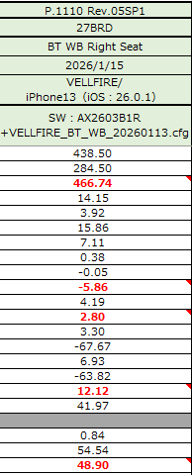
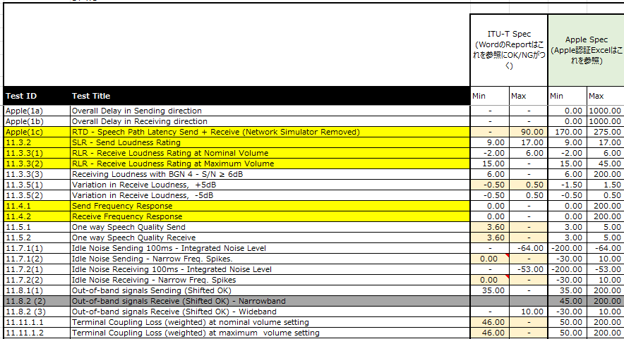
- MCH Report：VELLFIRE BT WB：Apple1a～11.8.1(1)

- Initially, we had planned to have training on the A&W config tool, but we decided it would be better to confirm it on the final day after practical training, and we have now begun making adjustments.
- As stated in the summary, we were able to make adjustments to pass the ITU-T test in all items except for RTD.

[VELLFIRE Carplay WD ITU-T TEST adjustment]
- Since we were able to complete the arrangements for the first day early, we have decided to move up the schedule for the second day.
- Schedule for the second day is as follows
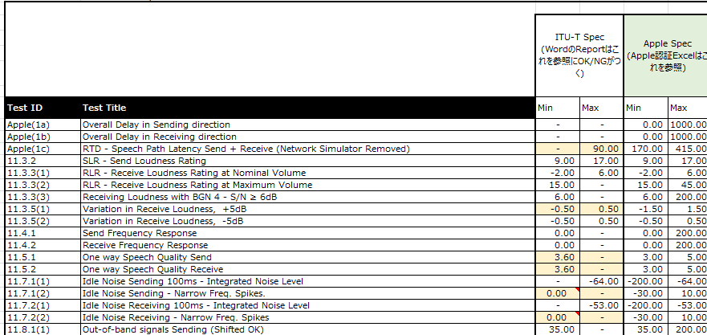
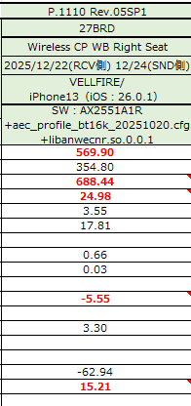
- MCH Report ：VELLFIRE CarPlay WB on Wireless Apple1a～11.8.1(1)

- As stated in the summary, we were able to make adjustments to pass the ITU-T test in all items except for RTD.

[Day 1 wrap-up meeting]
- After completing the adjustments in the lab, everyone gathered again in the conference room and ALPINE's Konda-san reported the results of Day 1 to his boss online.
- His boss at ALPINE thanked A&W for completing the adjustments ahead of schedule.
- It was agreed that tomorrow would be an unscheduled "Carplay NB ITU-T TEST parameter adjustment."
- An ALPINE executive requested that the adjustments be made to the "VELFIRE," a car model that is relatively easy to adjust, and asked whether it would be possible to make adjustments to the "TAFT (kei car)," which is the most difficult to adjust. However, Konda-san suggested that they prioritize training on the configuration tool over adjustments, and this was approved.

Action Item:
- A&W
  - ALPINE has requested the following documentation and development of an automatic adjustment tool for adjusting A&W ECNR.
R1: When adjusting A&W ECNR (using the configuration tool), we would like materials that explain each setting item and the expected effects of the adjustments.
R2: In addition to detailed explanations of each item above, we would like materials that describe the confirmation procedures and adjustment flow for each ITU-T TEST adjustment.
(Because customers want to know which items they need to evaluate and adjust first after obtaining the tool.)

