Customer: ALPS ALPINE
Meeting Day : 2026.01.21 : 09:30 – 17:00
Meeting Method : Visit
Meeting Agenda : On-site support for A&W ECNR ITU-T TEST for Aftermarket Display Audio (Day 1)
Whether the results of the meeting achieved the expected purpose: Yes.

Participants:
- ALPS ALPINE:
  - Masatoshi Konda – Engineer : Soft Engineering Deptment.2 (Product Manager)
  - Yasuhiro Suzuki – Engineer : SI Deptment.2 (ITU-T TEST Manager)
  - Takahiro Matsumoto – Engineer : Infotainment Design Deptment (ITU-T TEST Support)
  - 1 other ITU-T TEST support staff member

Summary:
- Carplay (NB) tuning was performed today. It was difficult to get both TCLnom and 3Quest (sce2) to pass the test, but ultimately, all but one item passed.
>SLR: 13±4 (Spec): 16.17 (Pass)
>SND Freq Response: ≧0 (Spac): 1.48 (Pass)
>TCL (nom:Vo4): ≧50 (Spac): 50.07 (Pass)
>TCL (MAX:Vo11): ≧50 (Spac): 50.03 (Pass)
>Double Talk (nom:Vo4): ≧50% (Spac): Word 100% (Pass), Send 97.78% (Pass)
>Double Talk (MAX: Vo11): ≧25% (Spac): Word 84.16% (Pass), Send 70.78% (Pass)
>3Quest(Sce1):G/N/S:-/3.0/3.0(Spac):3.9/4.9/3.6(Pass)
>3Quest(Sce2):G/N/S:-/3.0/3.0(Spac):2.9/3.6/3.0(Pass)
>3Quest(Sce3):G/N/S:-/2.5/2.5(Spac):2.4/2.9/2.6(Pass)
>3Quest(Sce4):G/N/S:-/2.5/2.5(Spac):2.3/2.8/2.6(Pass)
<Wireless Carplay NB Apple TEST＞
>11.3.5(1): -1.5 to 1.5(Spac): 0.65(Pass)
>11.3.5(2): -1.5 to 0.5(Spac): 0.34(Pass)
>11.8.1: 35-200 (Spac): 38.76 (Pass)
>11.8.2: 45-200 (Spac): 54.95 (Pass)
Apple 3a: Noise1: 0-120 (Spac): 11.48 (Pass)
Apple 3b: Noise2: 0-120 (Spac): 11.63 (Pass)
Apple 3c: Noise3: 0-120 (Spac): 11.45 (Pass)
Apple 3d: Noise4: 0-120 (Spacing): 11.21 (Pass)
>11.7.1(2): -30-10 (Spacing): 5.19 (Pass)
>11.7.2(2): -30-10 (Spacing): 16.40 (Adjusted with ALPINE)
<Additional Evaluation>
- HATS (mouth) ⇔ DUT MIC
>55cm: SLR (16.64): Frequency response (1.33): TMOS (2.9)
>50cm: SLR (16.34): Frequency response (0.33): TMOS (2.9)
>45cm: SLR (16.33): Frequency response (2.68): TMOS (3.0)
- I obtained the ITU-T test report from yesterday and shared it with headquarters, and have requested that today's report be provided tomorrow.
- Tomorrow, starting at 10:30, we will provide Konda-san with training on the A&W Config Tool.

Detailed discussion:
[Check the workshop Day2 schedule]
- As per the schedule of yesterday's wrap-up meeting, we conducted the first measurement of VELFIER's Carplay NB ITU-T TEST, and made adjustments to the NG items in the same way as with WB.

[VELLFIRE Carplay NB ITU-T TEST adjustment]
- As stated in the summary, first the SLR, SND, and TLC were adjusted on the Bluetooth NB and passed, then Double Talk and 3Quest were adjusted and passed.
- Then the Carplay NB Apple test was performed and passed.
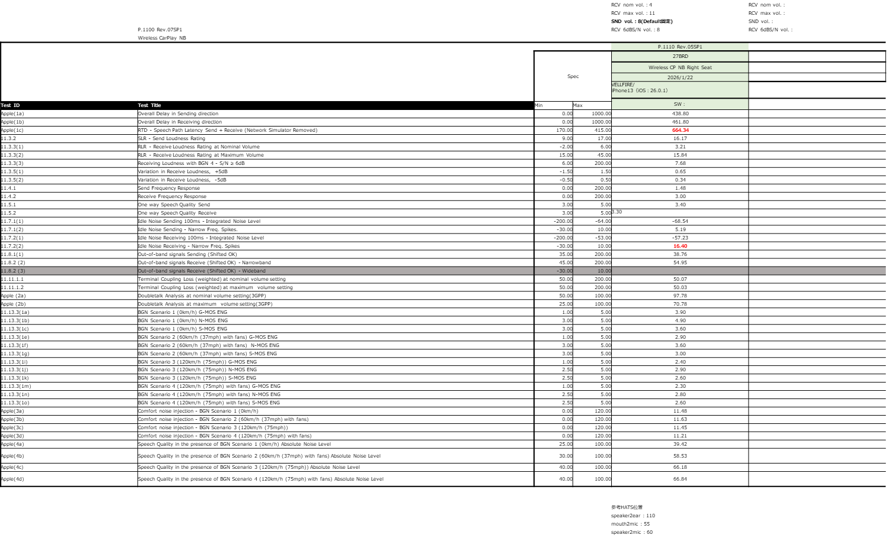
- Additionally, an experiment was conducted to check whether there was any change in SLR and TMOS with the distance between the HATS (mouth) and the DUT MIC, and it was confirmed that there was no significant change.
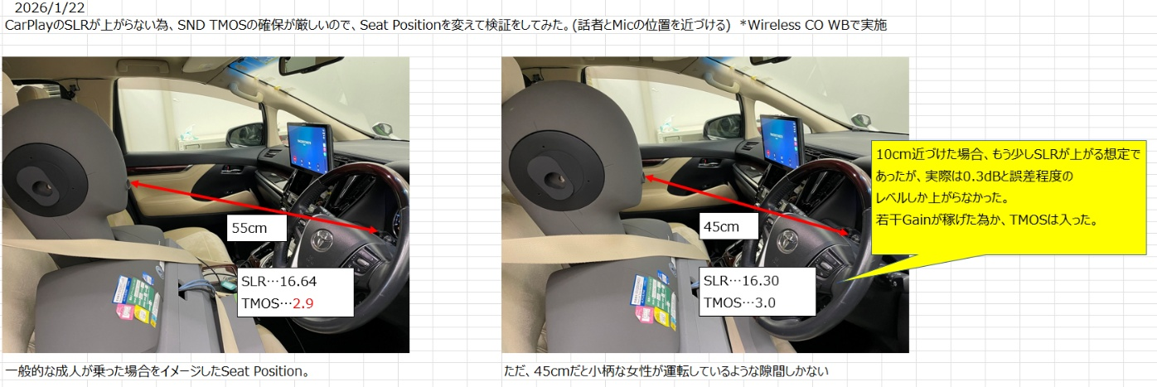

[Day 2 wrap-up meeting]
- After completing the adjustments in the lab, everyone gathered again in the conference room, where Konda-san from Alpine reported the results of the second day to his boss online.
- Alpine's boss expressed his gratitude that the adjustments were completed smoothly.
- It was agreed that "A&W ECNR Config Tool Training" would be held tomorrow.
- Evaluation manager Suzuki-san advised that it would be possible to change the evaluation environment so that adjustments could be made to the "Taft (kei car)" tomorrow, but Konda-san was more interested in learning how to adjust the config tool than making adjustments, so the training was prioritized.
- Tomorrow's start time will be 10:30 due to ALPINE's circumstances.

Action Item:
- A&W
  - Non

