Customer: ALPS ALPINE
Meeting Day : 2026.03.24 : 11:00 – 12:30
Meeting Method : Visited the ALPINE Training Center
Meeting Agenda : Discussions regarding the adoption of A&W BT Stack for Honda Mid CDC
Meeting Purpose : Same as above
Whether the results of the meeting achieved the expected purpose: Yes.

Participants:
- ALPS ALPINE:
  - Masayuki Yamato – Exective Specialist : Soft Engineering Deptment.2
  - Masafumi Kaneko – Manager : Soft Engineering Deptment.2
  - Many other related SI companies are participating via the web.

Summary:
- Visited ALPINE with HQ executives to discuss the A&W BT Stack under consideration for Honda Mid CDC. (This time, the cluster function will be integrated from CDC.)
- ALPINE intends to confirm the deliverables, development division, and scope of responsibility when adopting the A&W BT Stack + Android I/F.
- Mingfa-san explained the deliverables and support scope of the A&W BT Stack + Android I/F using block diagrams.
- ALPINE had some parts they didn't fully understand, so they will compile their questions into a Q&A sheet at a later date and request answers from A&W.
- After the Q&A sheet is answered, another technical web conference will be arranged.
- ALPINE mentioned that the first sample of Mid CDC is needed on June 26th.
- Due to time constraints, we requested the provision of Qualcomm Stack interface documentation.
- Simultaneously, we received the requirements specifications for this BT Stack, and agreed to continue discussions regarding the creation of a quotation and development contract.
- Alpine will sell CDC hardware and drivers under the Android OS to Honda.
- Honda will develop the higher-level application in-house.
- ERI and SKY will be responsible for communication-related software development on the Alpine side.
- We responded that we could arrange on-site training if necessary for the integration of the A&W BT Stack.

Detailed discussion:
[ALPINE Company Introduction and Overview of the Honda Project]
- Yamato-san explained ALPINE's company overview using a document.
- Yamato-san presented an overview of ALPINE's automotive business unit's organizational structure and product features.
- Yamato-san stated that his department is responsible for Honda's IVI and CDC projects.
- ALPINE has been jointly developing CDC with Honda since 2013, and has been jointly developing various IVI and CDC products with Honda for 10 years until 2023.
- Yamato-san explained that Honda develops all the application and HMI software, while ALPINE develops the hardware and BSPs such as drivers related to the hardware.
- Yamato-san also mentioned that GAS (Google Automotive Services) is already supported.
- From the 2026 CDC model onwards, the product will add cluster functionality to the IVI.
- And in 2028, Honda plans to incorporate NOA (Navigate on Autopilot) functionality into CDC Ver2, in addition to IVI + cluster.
- Yamato-san explained that Honda plans to implement various cost reductions and feature reductions in order to install the above CDC Ver2 in all of its mass-market vehicles.
- Yamato-san introduced the personnel structure of ALPINE in this CDC Ver2 project.
- Yamato-san also mentioned that ALPINE was responsible for the development of the product that uses the GAS system in the Honda Accord, as described in the following article.

[Discussions regarding the development of Honda CDC Ver2]
- Yamato-san introduced that mass production of the Honda CDC Ver2 will begin in November 2027, an extremely short development period compared to normal.
- Yamato-san stated that the Honda CDC Ver2 is a product that will continue for seven years and will be deployed worldwide outside of China.
- He said that Honda's strategy is to develop Chinese products on a different platform.
- Yamato-san introduced the system configuration of the Honda CDC Ver2.
- Yamato-san stated that the Honda CDC Ver2 will use Qualcomm's 8255 as its SOC.
- It will use the QNX hypervisor and Android GVM as the TOP.
- Yamato-san said that a separate system MCU will be installed to support the functional safety of the above system.
- Yamato-san introduced the schedule for the Honda CDC Ver2.
- The 1st SOP is November 2027.
- Pre-production of the 1st test vehicle is in April 2026, but since CDC Ver2 will not be ready in time, Ver1.2 (minimal functionality only) will be provided to Honda.
- Alpine plans to provide its 2nd hardware to August for Honda.
- The rest of the explanation will be given by sharing Yamato-san's screen on Teams.
- I asked him to share this schedule, and Yamato-san agreed.
- Yamato-san introduced the members of the development team.
- Regarding BT, Kaneko-san stated that he would be in charge of the connectivity team, and that ERI and SKY would participate in the SI (System Integration) and be responsible for developing the connectivity portion.
- I inquired whether the BT Stack also needed to be provided around the same time, as the first sample appears to be needed in June 2026 according to this schedule.
- I also requested that the specifications required for the BT Stack be provided as soon as possible, as they are not yet available.
- Before discussing the BT Stack specifications, Yamato-san wanted to know the extent of A&W's support.
- He also wanted to discuss the division of responsibilities and support structure between NXP and A&W in case of any problems.
- Yamato-san said he wanted to discuss the above today.

[Checking the latest status of the review]
- I asked if they were considering adopting the A&W BT Stack based on the following information confirmed during our last web conference:
- Is Alpine planning to use the full A&W BT Stack, but with the interface changed to a Qualcomm interface?
- Yamato-san stated that this understanding represents the current concept.
- Perry-san requested API documentation and references because he was unfamiliar with the details of the Qualcomm API.
- Perry-san said he needed to learn about APIs added at Honda's request and support them in the A&W BT Stack.
- Perry-san then asked which profiles were needed and whether there were any profiles for additional features.
- Perry-san asked to confirm the current Android version.
- Perry-san explained that he had no problem communicating closely with NXP (regarding both Bluetooth and Wi-Fi).

[A&W BT Stack Advantages]
- Kaneko-san said he wanted to discuss again which of the following options ALPINE should adopt:
Case 1: Adopt the Android Free Stack, and A&W will only support its maintenance.
Case 2: Adopt A&W's PhoneLink Solution as is.
- Kaneko-san requested an explanation of the comparison document for the above cases that was introduced last time.
- Perry-san asked if the comparison document had already been explained last time, and I replied that it had already been explained.
- I explained that Case 1 was a request from ALPINE, and Case 2 was a recommendation from A&S.
- However, I explained that Case 2 would involve A&W's API, and that ALPINE wanted to reuse existing API assets, and that the API could be provided using the Android API.
- Kaneko-san's question stemmed from his desire to discuss which option would be best for ALPINE, and to discuss development, responsibility sharing, etc., if that case were chosen.
- Mingfa-san then explained the comparison document again.
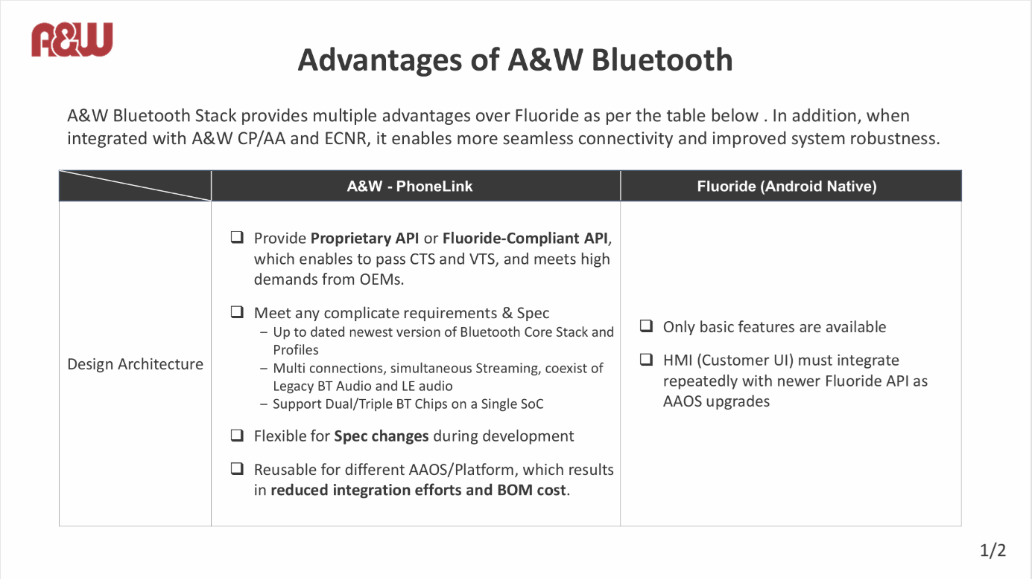
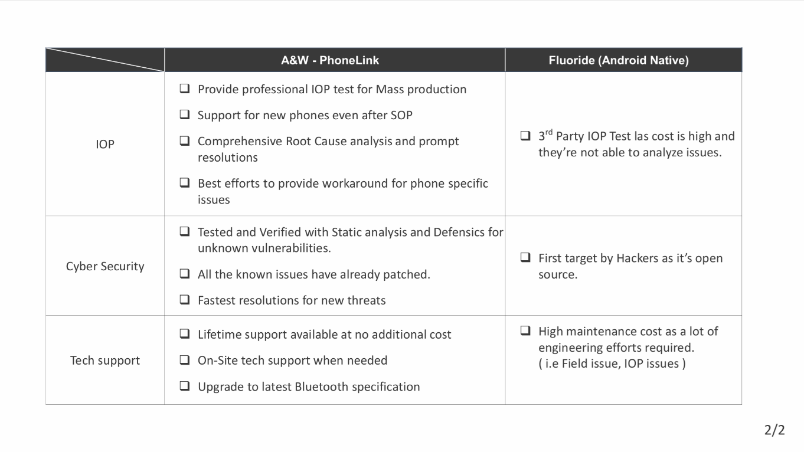
- Kaneko-san requested that the comparison between Cases 1 and 2 be explained using block diagrams, etc.
- Yamato-san mentioned that Mingfa-san's explanation was based on the "ANW SDK for Android" concept.
- Based on this premise, he explained the background behind ALPINE needing Qualcomm to obtain a sublicense from Qualcomm to A&W in order to acquire Qualcomm's API specifications.
- Perry-san reiterated that A&W is flexible in handling API changes, OS version upgrades, specification changes, and additions.
- Kaneko-san understood from the above explanation that A&W is indeed flexible.
- I asked whether the Android Free Stack was intended for Floodride or Qualcomm.
- Yamato-san said it was Qualcomm, and that Qualcomm Stack is guaranteed by Qualcomm.
- Yamato-san said that ALPINE believes Qualcomm Stack has customization specifications, and he was curious how A&W would handle that aspect when adopting it.
- I asked if the Qualcomm Stack customization specifications could be disclosed.
- Yamato-san replied that he believed the interface could be disclosed.
- Kaneko-san was speaking with the company's development team, discussing whether ALPINE could provide customized specifications and APIs for the Qualcomm Stack.
- I explained the above information, which I had confirmed in Japanese, to Mingfa-san.
- Mingfa-san explained the differences using the following materials.
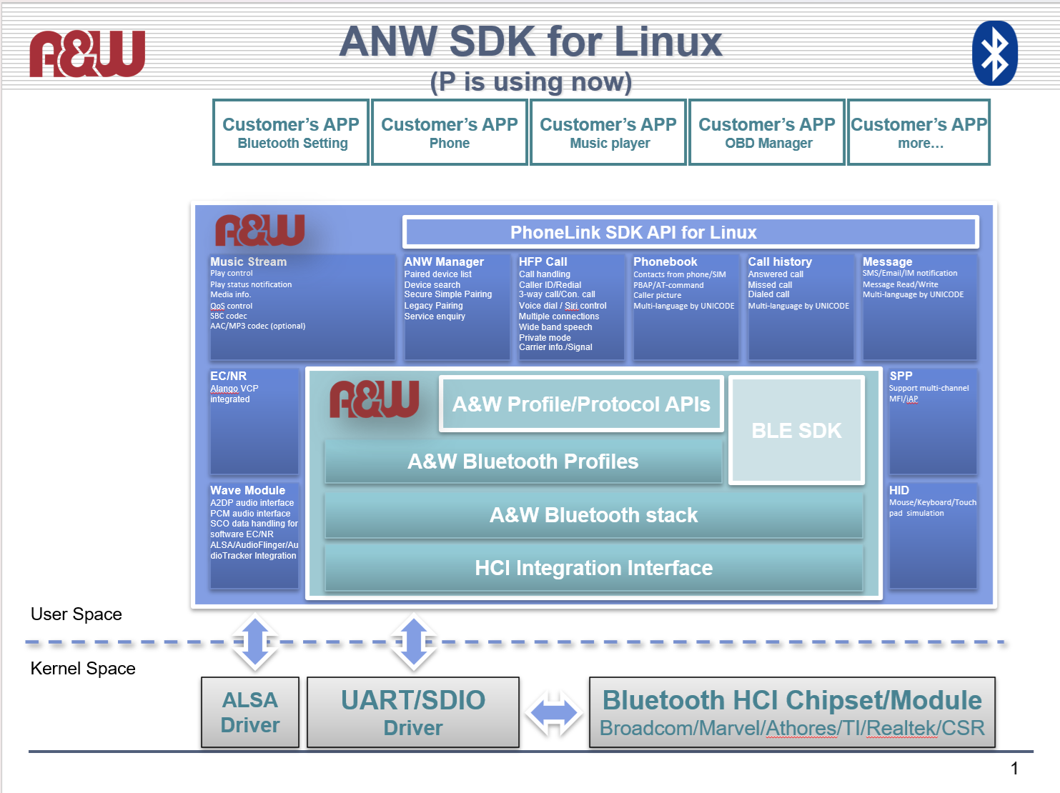
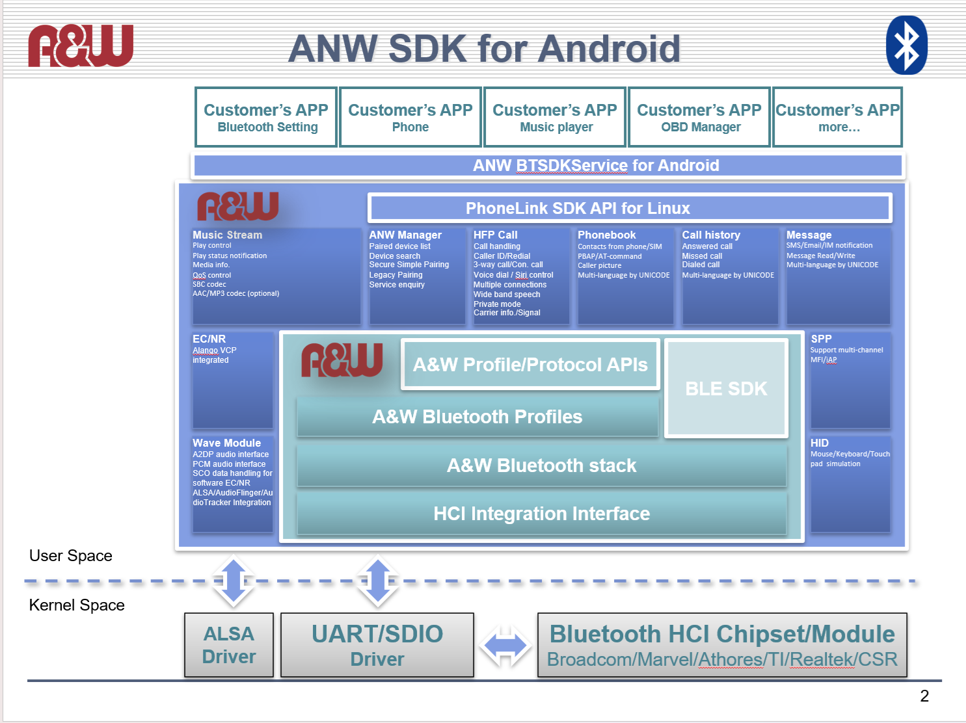
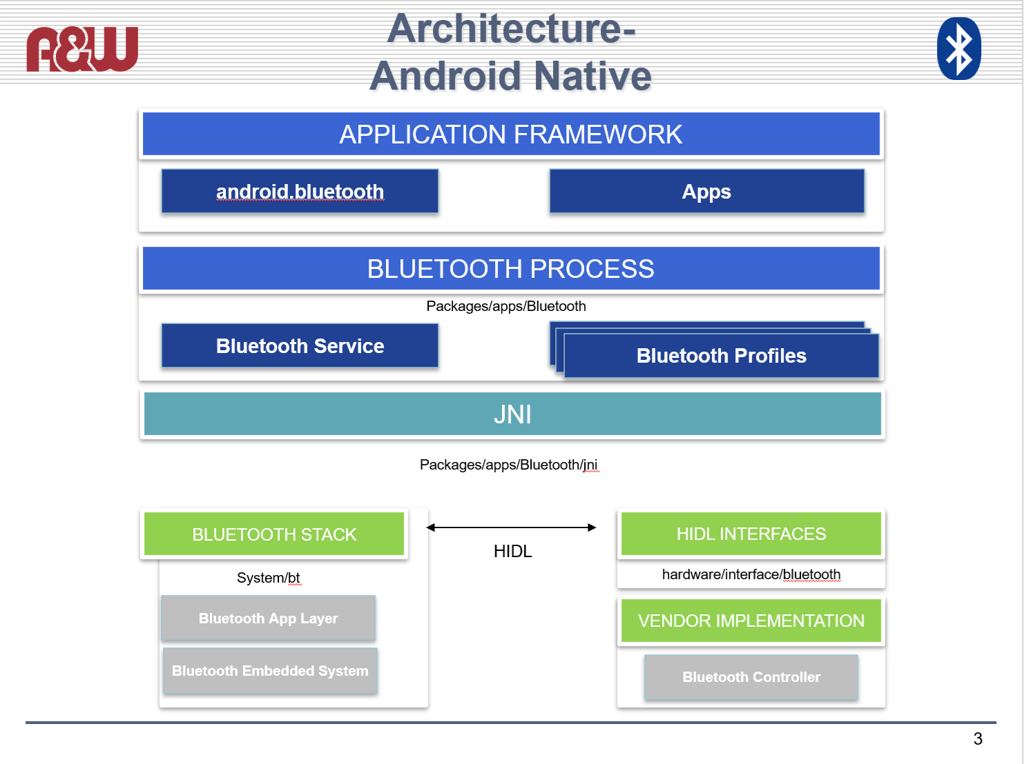
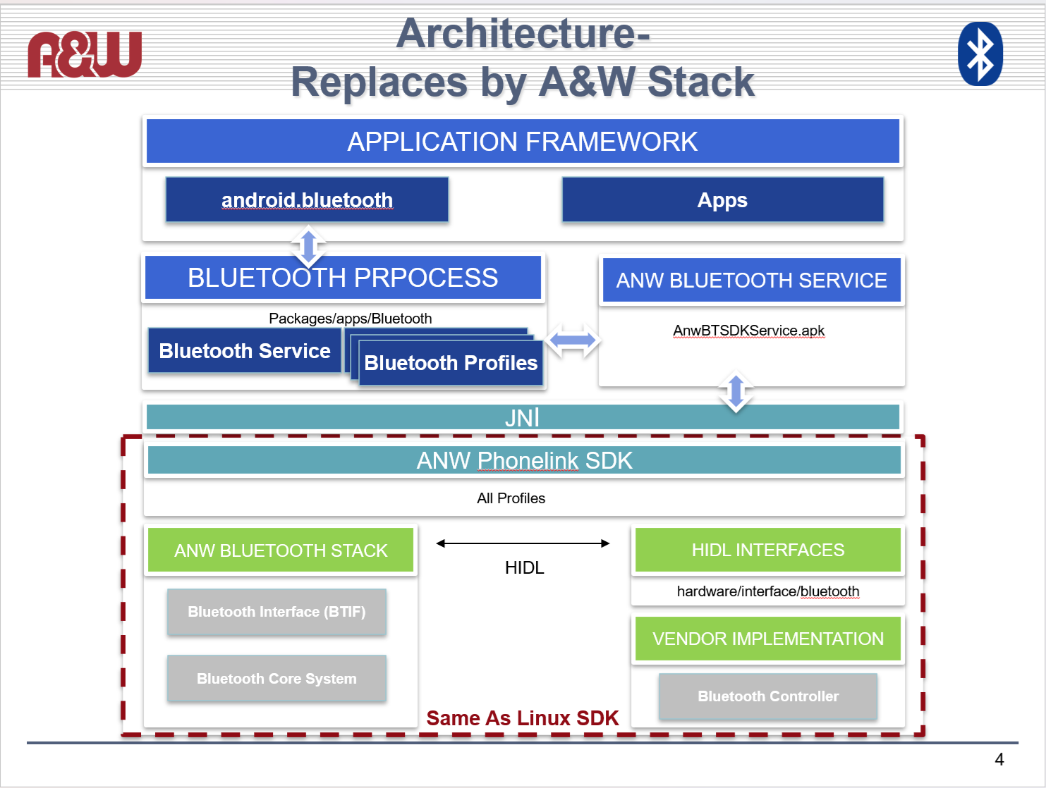
- Perry-san introduced A&W's BT Stack as a proven stack that also supports IOP testing and has been tested on a cumulative total of 3700 mobile devices.
- Perry-san mentioned that he thinks the number of devices tested this year will probably reach 4000.
- Migfa-san introduced that A&W's BT Stack has a proven track record of supporting various Android versions.
- Migfa-san explained that if customers do not need the Android API, accessing the A&W API directly will result in higher performance.
- Migfa-san explained that if Qualcomm provides its API, A&W can compare it to its own API and support any shortcomings.
- Kaneko-san asked if A&W guarantees everything enclosed by the dotted line in the "Architecture - Replaces by A&W Stack" diagram.
- Migfa-san answered YES.
- Yamato-san asked whether, if ALPINE selected Qualcomm's API, the "A&W Bluetooth Service" section of the "Architecture - Replaces by A&W Stack" diagram would handle API changes and OS version upgrades.
- Migfa-san answered YES.
- Migfa-san explained that the dotted line in the diagram indicates that the specification supports all specifications except custom specifications.
- Migfa-san explained that A&W provides not only the ANW Phone Link SDK, but also the parts shown above in the diagram.
- Kaneko-san asked which parts would be modified if the Android OS was updated.
- Migfa-san explained that if the OS was updated from version 14 to 15, etc., the "ANW Bluetooth Service" would be modified to accommodate the change.
- Kaneko-san confirmed with Yamashita-san, who was also at the meeting, whether this understanding was correct.
- Yamashita-san asked if the JNI part would be different from the standard Android JNI if the ANW Phone Link Solution was adopted.
- Migfa-san confirmed with Taylor-san and was told that the JNI would be the same as the standard Android JNI.
- Kaneko-san understood that even if the ANW Phone Link Solution was adopted, the JNI would be the same as the standard Android JNI.
- Kaneko-san asked if “AnwBTSDKService.apk” listed within the ANW Bluetooth Service was application software.
- Migfa-san confirmed with Taylor-san and was told it was a service application.
- Yamashita-san asked what the purpose of “ANW Bluetooth Service” was.
- Migfa-san answered that it exists to convert Android APIs to A&W APIs.
- Kaneko-san understood it as the part that converts to A&W APIs.
- Migfa-san explained that, for example, the APIs for realizing a certain function differ between Android APIs and A&W APIs, so it's the part that performs that conversion.
- Migfa-san gave an example to explain in detail.
- Yamashita-san understood that if ALPINE selects the Fluoride API, “ANW Bluetooth Service” is the part that converts to the A&W API.
- Migfa-san explained that even if the Android OS is updated, users don't need to worry about API specification changes.
- Yamashita-san understood that "ANW Bluetooth Service" changes the Android API to the A&W API, and Kaneko-san had the same understanding.
- Mingfa-san explained that customers don't need to worry about "ANW Bluetooth Service" and can access it using only the Android API.

[Discussion after the 5-minute break]
- Kaneko-san expressed gratitude for A&W's technical explanation.
- Kaneko-san requested to discuss future technical details.
- Kaneko-san said that they wanted to discuss development assignments and responsibilities today, but were unable to.
- Kaneko-san confirmed whether the ANW Bluetooth Service and ANW Phone Link SDK were covered under A&W's warranty, and Migfa-san answered yes.
- I confirmed who would guarantee the Bluetooth PROCESS.
- Kaneko-san said they wanted to discuss the above next time.
- Kaneko-san also said they wanted to discuss work procedures, etc.
- Kaneko-san also wanted to discuss the detailed schedule, but requested that the points that were not discussed sufficiently or that needed clarification be documented and that A&W provide a response.
- We agreed to the above and promised to provide a response as soon as we received the document.
- Kaneko-san said they wanted to start the next technical discussion as soon as they received the response.

[Estimates, contracts, and other discussions]
- I confirmed ALPINE's requirements regarding the next steps, including the estimate, contract, and technical documentation.
- Yamato-san said that while confirmation with Qualcomm was necessary, providing API documentation was not a problem. However, since the behavior wasn't documented, they needed to discuss how to address that.
- Yamato-san said that they would contact me after internal discussions at ALPINE, including the necessary modifications from Qualcomm.
- Yamato-san explained that Honda would request additional specifications for BT from ALPINE, and Yamato-san would provide the specifications to A&W. (Qualcomm Stack is not involved.)
- I explained that if Honda requested additional specifications based on the additional features of the Qualcomm Stack, A&W's development would begin after the Qualcomm Stack specifications were released, potentially causing delays.
- Yamato-san understood and agreed to the above.
- I confirmed whether they could submit the specifications for the formal estimate.
- Yamato-san promised to contact me regarding the following items:
>Disclosure of Qualcomm's customized specifications
>Which API to choose: Qualcomm or A&W?
>Disclosure of Android OS version
>Contact regarding required BT support profile
- I requested that once the above information is disclosed, I will send a quote and ask for any necessary adjustments.
- I also stated that if the first sample must be available by June 26th, I would like to request an urgent meeting and formal order.
- I asked whether ERI or SKY would handle the BT Stack integration.
- Kaneko-san replied that both companies would handle it.
- I said that since the product's app would be developed by Honda, ALPINE would collaborate with ERI and SKY to develop the Android OS portion.
- We mentioned that if training was needed to accelerate development, Taiwanese engineers could provide it.
- I reviewed today's summary.
- Yamato-san said that using A&W's PhoneLink Solution and changing the API to Qualcomm was the most likely option.
- Yamashita-san asked if the "Bluetooth process" in the "Architecture Replaces by A&W Stack" diagram also needed to be changed to match the "ANW Bluetooth Service."
- Mingfa-san said that the "Bluetooth process" did not need to be changed, and that A&W could make changes if there were requests for new features.
- I recommended that all questions be reviewed on the Q&A sheet.
- Incidentally, I was told that the ALPINE development team is located in Utsunomiya and ERI in northern Japan, and SKY is in Osaka.
- I explained that a contract exists with ALPINE's aftermarket division and asked for confirmation that the current contract is equivalent to that one.
- ALPINE received the entire order for the Mid CDC 8000K/7Y.
- Yamato-san said that the Android OS version update will continue up to version 21 for this product.
- Perry-san said that there would be no problem because A&W has long experience with the Android OS.
- Honda is also considering not supporting all versions of the Android OS, but rather skipping versions with short lifecycles.

Action Item:
- A&W
  - Obtain technical Q&A from ALPINE, respond promptly, and arrange the next technical meeting.
  - Obtain the specifications and necessary information for the BT Stack for formal quotation, and proceed with the order process to ensure it is placed quickly.

