Customer: JVC KENWOOD
Meeting Day : 2026.03.27
Meeting Method : Visit
Meeting Agenda : I visited A&W executives and the CP/AA development department to introduce the A&W CP/AA Solution.
Meeting Purpose : Same as above
Whether the results of the meeting achieved the expected purpose: Yes

Participants:
- JVCKENWOOD Corporation:
Technology Headquarters, IVI Product Technology Department Division 1, Group 3
  - Yuichi Mori: Group Manager
  - Yuji Munegumi – Assistant Manager/ Advanced Engineering Department 1 (AA Responsible)

Summary:
- Mori-san and Munagumi-san are developing and providing CP/AA on JKC's proprietary Linux platform.
- Android platform is not a target for the Mori-san Team; development of the Android platform will be based on OEM requirements.
(Neusoft developed the CP/AA for the Android platform used in Honda's DOP)
- A&W presented the A&W technology roadmap and the latest status of CP/AA.
- Mori-san Team is interested in video streaming for CarPlay R19 and CarPlay Ultra.
- A&W explained that while they are awaiting official specification releases from Apple, the video streaming functionality is already under development.
- JKC will implement another organizational change in April.
- The organization will be significantly restructured into three divisions: Software, Electrical, and Mechanical.
- However, there will be no integration of the automotive and non-automotive departments this time, so CP/AA will continue to be developed by the Mori-san Team as before.
- Perry-san mentioned that royalty images for A&W CP/AA, ECNR, and BT Stack are priced at under $1.50.

Detailed discussion:
[JKC organizational changes confirmed on April 1st]
- I checked the organizational changes within JKC starting next month.
- Mori-san said that the engineers in the Technical Headquarters have been consolidated into one department.
- However, the department has been divided into three main sections: Software, Electrical, and Mechanical.
- This time, the automotive and non-automotive departments will not be merged, and it was announced that CP/AA will continue to be handled by Mori-san's team, and BT will continue to be handled by Sakamao-san's team.

[Introduction to A&W Technology Roadmap]
- Mingfa-san presented the following A&W technology roadmap.
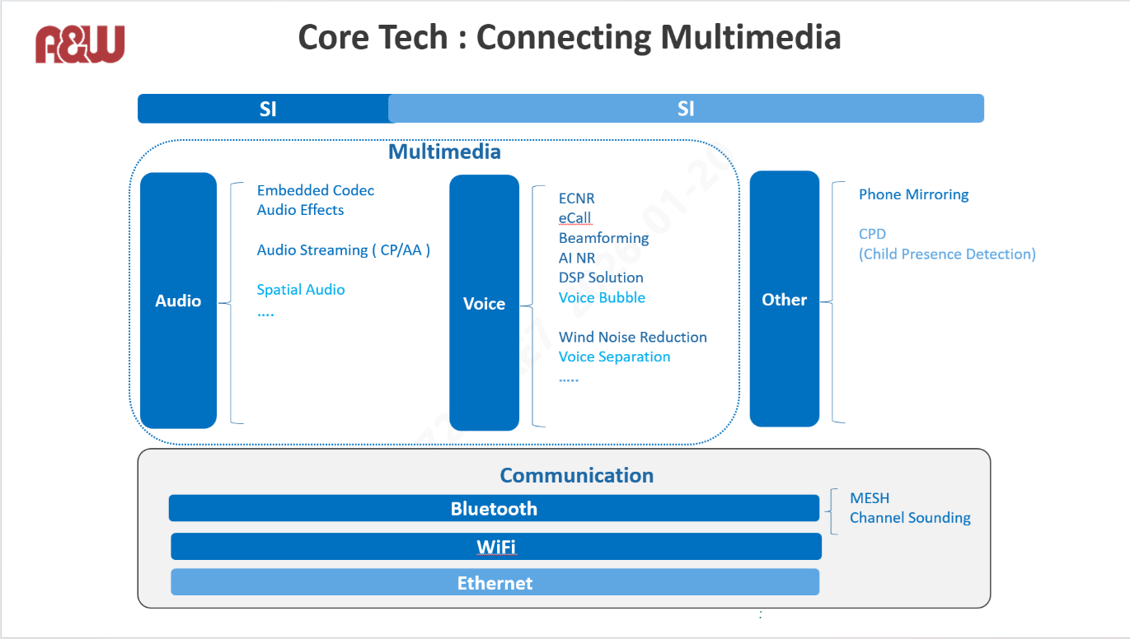
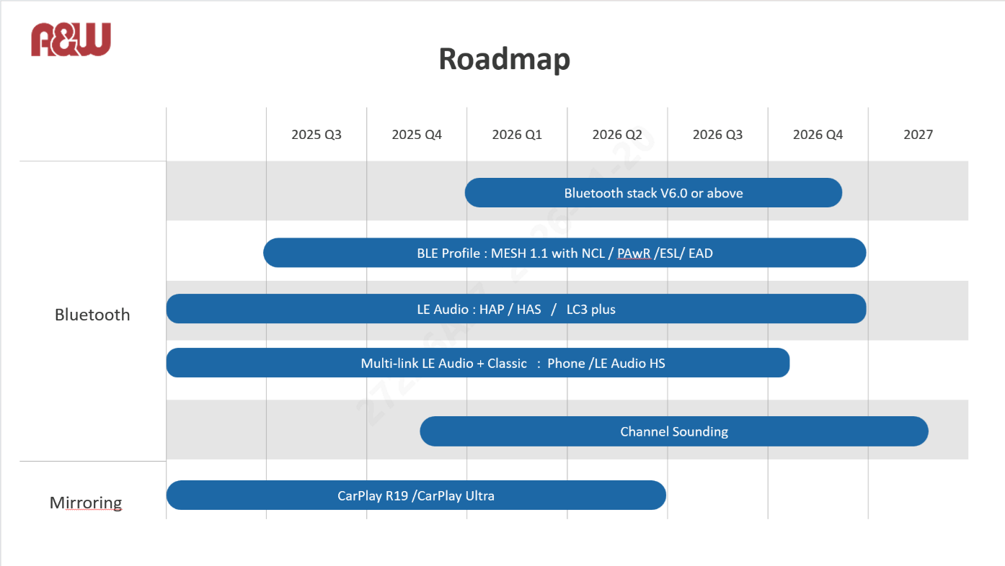
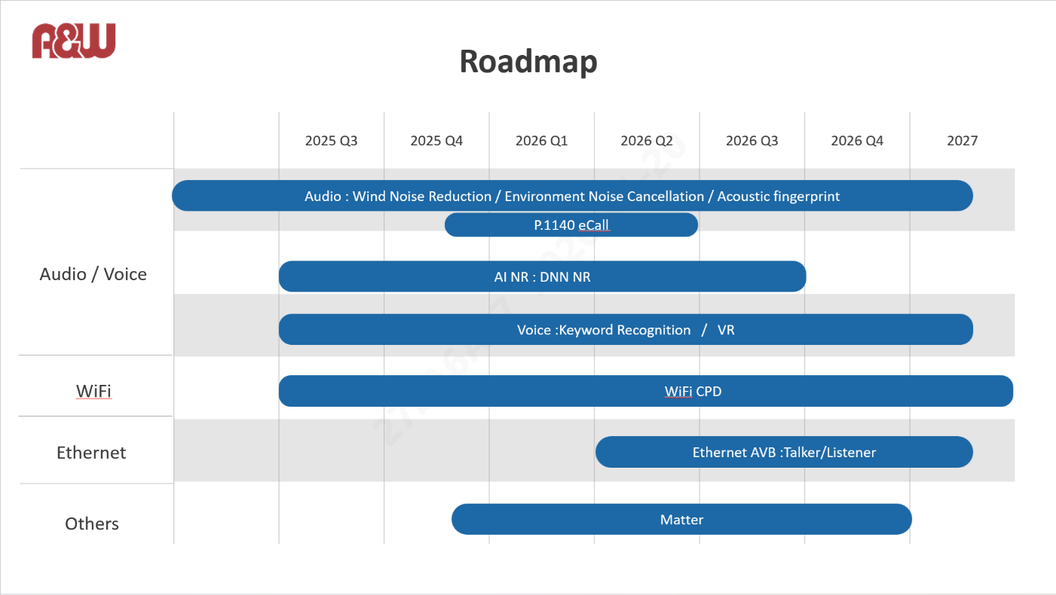
- Mingfa-san provided details on each item in the A&W technology roadmap below:
>Considering a future Ethernet AVB solution
>Technologies such as LC3, AEC, and audio streaming
>Special audio (Dolby and Dolby Astemo)
>Echo and beamforming
>AI NR (Porting ECNR with DSP (Hifi4,5))
>Voice bubble
>ECNR for open spaces
>Phone mirroring solution (using Wi-Fi)
>CPD (a solution using Wi-Fi)
- Mingfa-san explained that the above solutions are currently in prototype status and are aiming for mass production by the end of the year.
- Mori-san asked if the dark blue on the roadmap above represents mass production and the light blue represents development.
- Mingfa-san answered yes.
- Mori-san then asked what other special audio options there are besides Dolby.
- Mingfa-san replied that there are surround sound solutions such as Dolby Atmos.
- Mori-san asked if his understanding of voice bubbles was correct, as it's a technology that separates different areas within the car.
- Mingfa-san answered yes.
- I asked Mingfa-san how the four speakers in the car separate the areas.
- Mingfa-san said that a speaker and microphone are needed for each area.
- Mingfa-san explained this to Morishita-san in Chinese, and Morishita-san said it was the same technology as noise cancellation.
- Mori-san then asked if it was a technology that filters out sounds from other areas except for the sound in the area being focused on.
- Morisita-san asked Mingfa-san a question in Chinese, and Mingfa-san replied that Mori-san's understanding was correct.
- Mori-san then asked about the completion status of the voice bubble.
- Mingfa-san replied that it was about 30% complete and in prototype status.
- Mingfa-san explained that it would depend on how many speakers and microphones the OEM would place inside the vehicle.
- Request originated in China and was described as a request to ensure that Siri accurately recognizes voice commands when controlling windows and air conditioners.
- Mingfa-san explained the background and details of each item in the roadmap document.
- Perry-san stated that while they are waiting for video streaming to be specified in Apple's CarPlay, development itself is already complete.
- He explained that CarPlay Ultra will support Display specifications (such as Cluster) defined by OEMs other than IVI.
- However, Apple cannot define the CarPlay Ultra specifications unless OEMs release their specifications.
- Perry-san stated that, given the above background, CarPlay R19, which does not require OEM involvement, will be defined first.
- Mingfa-san mentioned that discussions have begun with European company S regarding Ethernet AVB.
- Mingfa-san explained that Ethernet AVB targets Talker/Listener.
- Perry-san explained that, in addition to Talker/Listener, A&W does not need to support transceivers as bridge functions for Ethernet AVB.

[Introduction to A&W CP/AA Solution]
- Mingfa-san explained that A&W's CP/AA provides M/W that supports CP/AA switching, music source switching, mobile switching, etc.
- Mingfa-san said that the biggest challenge for customers with CP/AA is passing the certification.
- Mingfa-san explained that, for example, passing the RTD specification requires adjustment of the entire system.
- Therefore, A&W introduced that they can provide a system optimization tool.
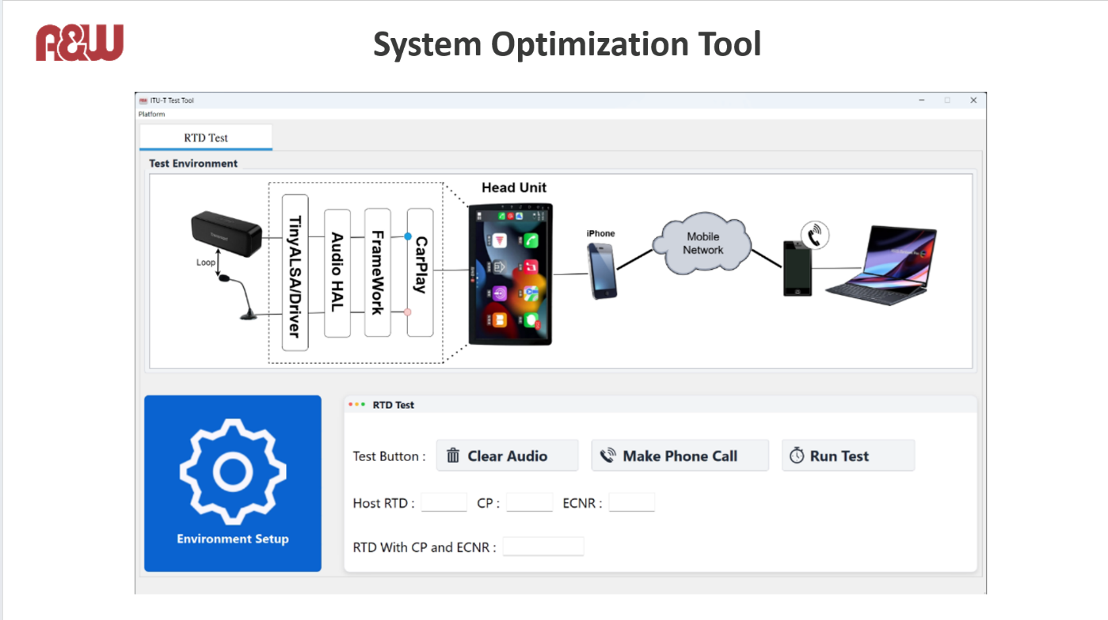
- Mingfa-san explained that this tool allows customers to perform a pre-certification evaluation before visiting the certification test lab.
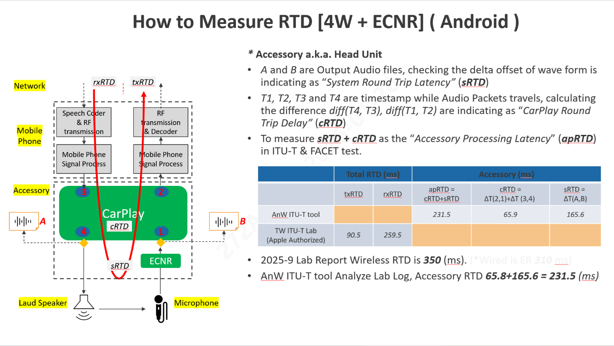
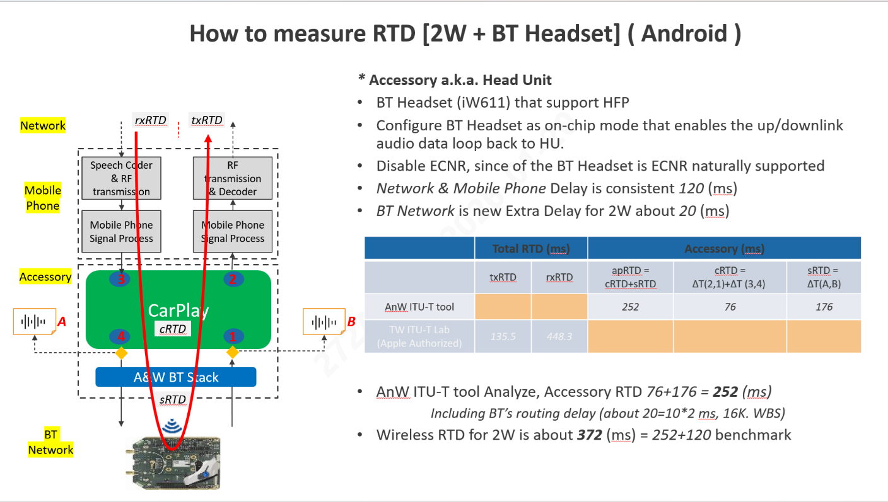
- Mingfa-san stated that A&W's CP/AA solution not only provides libraries but also offers a total system service.
- For example, he explained that while the handling of CP/AA audio data differs between the Telechips and MTK SDKs, A&W can modify it to the optimal system configuration.
- Perry-san explained that because A&W has experience porting CP/AA total solutions to Telechips and MTK BSPs, they can provide similar support when other SOCs are selected.
- Mingfa-san introduced that the royalty image for customers adopting all of A&W's solutions (CP/AA, ECNR, BT Stack) is less than $1.50, explaining that this can reduce the customer's overall development costs.
- Perry-san asked if there were any plans to develop CP/AA for Android OS, given that JKC's in-house developed CP/AA currently supports Linux.
- Mori-san replied that JKC's in-house developed CP/AA currently only supports Linux. Mori-san said that the first Android OS CP/AA was developed by Neusoft for Honda's DOP last year.
- I asked if there were any plans to deploy the above platform or for JKC to develop it in-house.
- Mori-san said that there are no plans for JKC to develop Android OS CP/AA in-house.
- Mori-san's department is focusing on Linux CP/AA, and that significant changes are difficult due to cost considerations.
- Mori-san said that for domestic OEMs other than Honda DOP, Linux is sufficient at JKC.
- I asked about any 2-wheel projects within JKC, and Mori-san said there are no specific projects at the moment.
- I asked Mori-san if there was a department within the JKC dedicated to the development of 2-wheel vendors.
- Mori-san replied that there was no department for 2-wheel vendors.
Action Item:
- A&W
  - JKC is interested in CP/AA video streaming and Ethernet AVB, and will report on progress next time.

