Customer: PIONEER CORPORATION
Meeting Day : 2026.04.10
Meeting Method : Visit
Meeting Agenda : I visited AZW (AzureWave) to introduce them to Ohno-san, the PIO.
Meeting Purpose : Same as above
Whether the results of the meeting achieved the expected purpose: Yes

Participants:
- PIONEER CORPORATION:
Global Technology Development HQ’s, Technology Development Division
Software Development Group, Automotive Systems Development Department (GSS)
Kohei Ohno : Engineer

Summary:
- I introduced AzureWave to Mr. Ohno at PIO.
- AzureWave's BT/Wi-Fi combo module has a large market share in Japan for Sony games.
- AzureWave's automotive track record is limited to Tesla battery chargers, CHERY, and Kawasaki (2Wheel), and this was their first visit to PIO.
- PIO's Ohno-san made the following questions and requests to AzureWave:
Q1: Is it possible to handle the production of automotive BT/Wi-Fi combo modules at the Vietnam factory?
- The reason is that currently, automotive BT/Wi-Fi combo modules are only produced at the Shanghai factory, and PIO cannot use Shanghai-made BT/Wi-Fi combo modules due to North American connected car regulations.
- A1: They replied that the Vietnam factory is scheduled to obtain ISO16949 certification by the end of this year, and that the transfer of automotive parts will be possible.
Q2: Is it possible to provide an in-vehicle BT-only module?
- Currently, AzureWave's only in-vehicle BT-only module is the BTA-03 (built-in chip is CYW89072).
- PIO is interested in whether this is a complete module or an HCI module.
(He would like to consider this for our next 2-Wheel POC)
- A2: AzureWave promised to answer the above at a later date.
- AzureWave's experience with non-in-vehicle cameras is limited to PC built-in camera modules; they have no experience with general-purpose cameras.
- AzureWave checked PIO's existing BT/Wifi combo modules, and Ohno-san replied that they frequently use Infineon chips.
- AzureWave strongly recommended the AW-XHA01, which uses an Infineon chip and supports Wifi sensing and surrounding functions.
- AzureWave hope to continue working with A&W to penetrate the Japanese in-vehicle market.
Detailed discussion:
[Background explanation]
- Last month, when A&W executives visited PIO Takeda-san, they introduced me to Ohno-san as someone interested in AZW.
- Therefore, today I will be introducing AZW to Ohno-san.

[AZW Company Introduction]
- AZW introduced the following three individuals and one person from their Vietnam factory who participated via web today:
- Teresa Wang: Sales Manager
- Ruby Tsai: Account Manager (Located at Tokyo)
- Chehsien Lin: FAE (Located at Tokyo)
- Renton Tao: WiFi team RD leader (Call from web)
- Teresa Wang (Sales Manager) introduced AZW's company profile, organizational chart, and production facilities.
- Teresa-san had been instructed by headquarters to expand the Japanese business, and A&W's introduction to PIO aligned with AZW's intention to enter the automotive business, so she expressed her gratitude.
- Teresa-san introduced that the Japanese market is supported by three people (their Japanese conversation skills are at a level where they have no problems).
- Teresa-san introduced that AZW has factories in Shanghai and Vietnam, and that if a problem occurs at one factory, production will be covered at the other factory.
- Teresa-san described the location of AZW's factories in Shanghai and Vietnam from the airports.
- Ohno-san said that he has visited Shanghai but not Vietnam.
- Teresa-san introduced that AZW's Shanghai factory has a production capacity of 11 million.
- Teresa-san introduced that AZW has shipped 10 million units to Japanese customers, mainly game equipment.
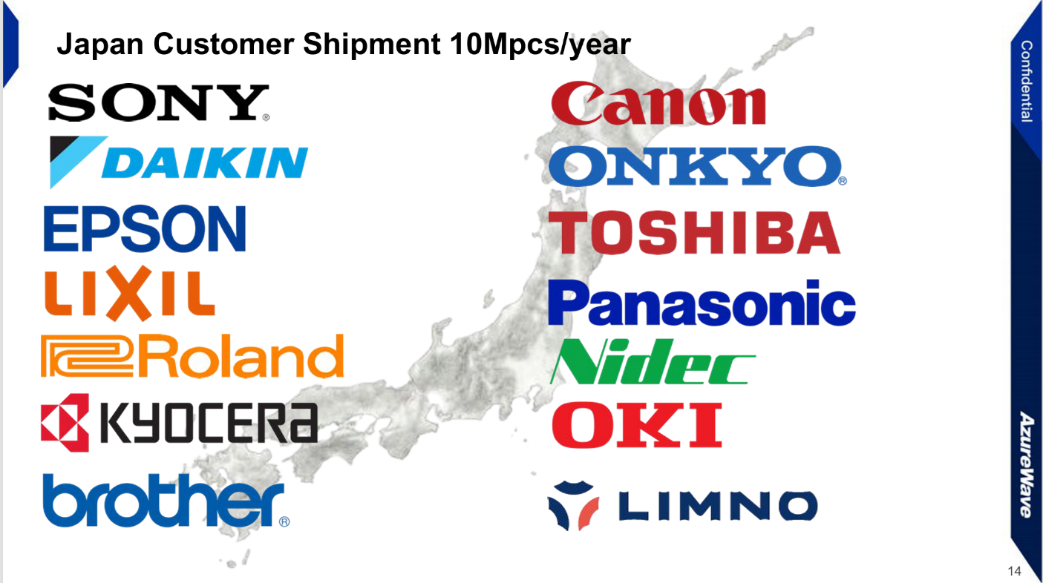
- Teresa-san introduced AZW's automotive product track record.
- She mentioned that their OEM business involves Tier 1 suppliers, with modules such as battery chargers being adopted.
- Teresa-san also mentioned that AZW's automotive track record in Japan includes the adoption of their modules in Kawasaki motorcycles via Tier 2 suppliers.
- Teresa-san then outlined the markets AZW wants to focus on in the future, stating that this PIO visit was highly rated by headquarters in terms of KPIs.
- Teresa-san introduced the BT/Wifi chip partners used in AZW's modules.
- She explained that Infineon MediaTek chips are frequently shipped in automotive modules.
- Teresa-san mentioned that AZW executives have a dinner scheduled with the NXP president next week.
- Teresa-san also mentioned that if any delivery issues arise, it's possible to contact AZW executives directly by phone.

[AZW Automotive Products Roadmap Introduction]
- Teresa-san first explained how to read AZW's automotive product roadmap.
>Red: Infineon
>Green: NXP
>Orange: MTK
>Black: Infineon's Sip
- FAE's Lin then introduced the features of individual products in the automotive roadmap below.
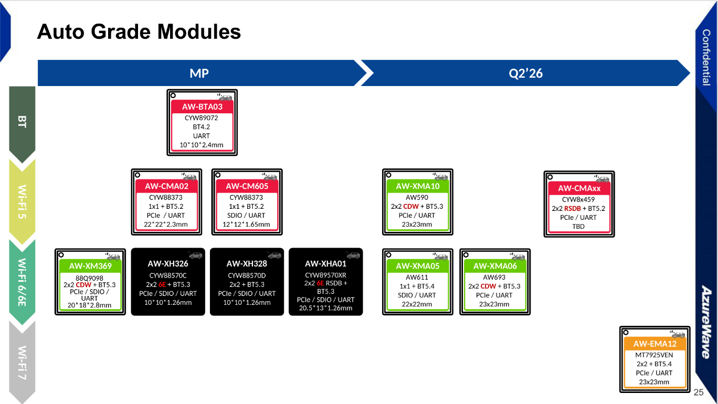
- Lin-san introduced the "AW-CMA02" as the most widely used module in automotive products.
- This module features an Infineon chip and is widely adopted by Chinese manufacturers.
- Lin-san recommended the "AW-XH326" and "AW-XH328" for Wi-Fi 6 support.
- Lin-san explained that the reason for recommending these two is their small size as Sipmodules.
- Lin-san also recommended the "AW-XAM10" for 2x2 functionality, highlighting its ability to simultaneously transmit and receive data.
- Lin-san stated that the most widely used module in automotive products is the "AW-CMA02."
- He introduced this module, which features an Infineon chip, as it is widely adopted by Chinese manufacturers.
- Lin-san recommended the "AW-XH326" and "AW-XH328" for those requiring Wi-Fi 6.
- Lin-san explained that the reason for recommending these two is their small size as Sipmodules.
- Lin-san explained that if 2x2 functionality is needed, he recommends the AW-XAM10.
- He introduced this module as being capable of simultaneous transmission and reception.
- Teresa-san explained that AZW's automotive modules, even if the chips are industrial-grade, have achieved automotive quality (AEC-Q104) as modules.
- Of course, some products also use automotive-quality chips.
- Lin-san introduced that AZW can also provide the BT-only automotive module "AW-BTA03".
- Lin-san explained that the "AW-BTA03" is often added to Wifi/BT combo modules to increase the number of BT channels in a product.
- Lin-san introduced the "AW-XHA10" as the most powerful in-car module.
- He mentioned that the built-in chip is Infineon's "CYW89570XR" and that it has two chips internally.
- He explained that it has many simultaneous connection points, can connect to 5GHz simultaneously, and also has a built-in Wi-Fi sounding function.

[Questions and requests from PIO]
- PIO's Ohno-san made the following questions and requests to AzureWave:
Q1: Is it possible to handle the production of automotive BT/Wi-Fi combo modules at the Vietnam factory?
- The reason is that currently, automotive BT/Wi-Fi combo modules are only produced at the Shanghai factory, and PIO cannot use Shanghai-made BT/Wi-Fi combo modules due to North American connected car regulations.
- AZW was unaware of North American connected car regulations.
- Teresa-san said that the module uses capacitors and other components manufactured in China.
- Teresa-san stated that production for Tesla is carried out in Vietnam.
- Tao-san added the following:
- Currently, automotive products are shipped from the Shanghai factory, which has obtained ISO16949 certification.
- Products destined for North America are scheduled to obtain ISO16949 certification by the end of this year.
A1: They replied that the Vietnam factory is scheduled to obtain ISO16949 certification by the end of this year, and that the transfer of automotive parts will be possible.
- Teresa-san understood that PIO products are manufactured in Thailand, not Vietnam.
- Ohno-san explained that car navigation and audio systems are manufactured in Thailand and Japan.
- Ohno-san said that only speakers are manufactured in Vietnam.

Q2: Is it possible to provide an in-vehicle BT-only module?
- Currently, AzureWave's only in-vehicle BT-only module is the AW-BTA03 (built-in chip is CYW89072).
- PIO is interested in whether this is a complete module or an HCI module.
(Meybe he would like to consider this for our next 2-Wheel POC)
A2: AzureWave promised to answer the above at a later date.
- Ohno-san asked if there were any other Bluetooth-only product plans besides "AW-BTA03".
- Lin-san replied that this was the latest roadmap and there were no new product plans.
- Teresa-san said that AZW has little experience in automotive applications, so its lineup of automotive products is small, but development consideration is possible if there is customer demand.
- Teresa-san said that the current product roadmap is a product lineup based on AZW's predictions.
- He said that in the future, if PIO shares information that AZW doesn't know, it can be reflected in product planning.
- Tao-san said that there is a demand for Bluetooth-only modules from the 2-wheel sector.
- However, since the demand cannot be met with the 4-wheel package, it would require custom development, but it is possible.
- Ohno-san understood the situation.
- Ohno-san said that PIO uses Wifi/Bluetooth modules extensively, but is looking for an inexpensive Bluetooth-only module.
- Teresa-san said that Bluetooth-only modules are too cheap, so they don't want to be a vendor.
- Ohno-san asked if a BT-only module was cheaper than a Wi-Fi/BT combo module, and Teresa-san answered yes.
- Teresa-san said that for both 2-wheel and 4-wheel vehicles, BT-only would not provide sufficient performance for connecting to a mobile phone.
- Teresa-san then asked if there was any demand for a BT-only module at PIO.
- Ohno-san replied that there was demand for it for 2-wheel vehicles.
- Ohno-san then mentioned that PIO is considering expanding its 2-wheel business.
- Teresa-san asked PIO to request a quote from AZW once the specifications for the 2-wheel BT-only module were finalized.
- Morishita-san asked if it was for scooters, and Ohno-san said that it was also for small motorcycles under 125cc.
- Teresa-san introduced a Taiwanese e-bike where BT is used for mobile phone communication during parking lot registration.
- Ohno-san mentioned that OEMs have been requesting Wifi 6 since last year.
- In that case, he said that "AW-XMA05" and "AW-XMA06" would be candidates.
- Teresa-san asked about the mass production year for the next product, and Ohno-san replied that it would be the 2028/29 model.
- He said that since the above product requires Wifi 6, AZW has a chance.
- However, Ohno-san said that if they were to consider adopting it, production at the Vietnamese factory would be essential.
- Teresa-san explained that the automation rate at AZW's factories is over 90%.
- She said the Shanghai factory is almost 100% automated.

[About AW-BTA03 (BT-only module)]
- Ohno-san asked whether the AW-BTA03 was an HCI type or a combo module type.
- AZW didn't understand the meaning of the above, and Tao-san promised to check and answer later.
- Ohno-san said that if the BT Stack is built-in, then it would mean he asked A&W a strange question.
- I asked if PIO had any experience using NXP BT chips.
- Ohno-san said they didn't have much experience and that Infineon was their main supplier.
- Ohno-san said that for 2-wheel products, the MCU is the main component and it's RTOS-based, so a complete BT module is easier to use.
- Ohno-san said that a Wifi/BT combo module is good for high-end 4-wheel and 2-wheel products, but for mass-market motorcycles, BT only is better.
- Ohno-san explained that since prototyping for this year's 4-wheel products has already begun, it would be difficult for AZW to enter the market.

Action Item:
- AZW
  - AZW will respond whether the AW-BTA03 is an HCI type or a complete module type.
- A&W
  - Regarding A&W's support for 2Wheel POC, we will arrange a separate meeting next week and visit the PIO.

